|  |
| --- |
|  |
| Capstone Project Document |

SUPER SHIPPER SYSTEM

Software Requirement Specification

|  |  |  |
| --- | --- | --- |
| **Super Shipper System** | | |
| **Group Members** | Le Van Quy Hoang | SE90184 |
| Tran Dinh Hoang Huy | SE90201 |
| Nguyen Khac Hoang | SE02564 |
| Kieu Cao Khanh | SE02960 |
| Nguyen Van Quyen | SE02884 |
| Nguyen Thi Hong Nhung | SE02437 |
| **Supervisor** | Mr. Tran Binh Duong | |
| **Project code** | 3S | |

**- Hanoi, 09/2015 -**

TABLE OF CONTENTS

1. FUNCTIONAL REQUIREMENTS 2

1.1. Web application for Admin 2

1.1.1. User Case Diagram 2

1.1.2. Functions 3

*UC- 101: Admin Login* 3

*UC- 103: Admin Change Password* 5

*UC- 104: Admin Forgot Password* 6

*UC- 105: Accept Store* 6

*UC- 106: Search Store* 7

*UC- 107:* *View Store’s list* 8

*UC- 108:* *Block store* 9

*UC- 109:* *View Store’s details* 10

*UC- 110:* *Send message to Store* 11

*UC- 111:* *Confirm Store’s payment* 13

*UC- 112:* *View transaction history of Store* 14

*UC- 113:* *Add Shipper* 15

*UC- 114:* *View Shipper’s list* 17

*UC- 115:* *View Order’s list* 17

*UC- 117:* *Search Shipper* 18

*UC- 117:* *Search Order* 19

*UC- 118:* *View Shipper’s profile* 20

*UC- 119:* *View Order’s details* 21

*UC- 120:* *Update Shipper* 22

*UC- 121:* *Update Order* 24

*UC- 122:* *Add new Order* 25

*UC- 123:* Export transaction 26

*UC- 124:* *Assign Task* 27

1.2. Web application for Store 29

1.2.1. User Case Diagram 29

1.2.2. Function 30

*UC-201:* *Register* 30

*UC-202:* *Login* 33

*UC-203:* *Logout* 35

*UC-205:* *Forgot password* 38

*UC-206:* *View profile* 40

*UC-207:* *Edit profile* 41

*UC-208:* *Create order* 44

*UC-209:* *View order’s list* 45

*UC-210:* *Search orders* 46

*UC-211:* *Cancel order* 48

*UC-212:* *Edit Order* 50

*UC- 213:* *Order’s details* 52

*UC-216:* *Rate shipper* 53

*UC-217:* *Send feedback* 55

*UC-218:* *View Homepage* 57

1.3. Mobile application for Shipper 59

1.3.1. User Case Diagram 59

1.3.2. Function 60

*UC-301:* *Login* 60

*UC-302:* *Logout* 61

*UC-303:* *Forgot password* 62

*UC-304:* *Change password* 64

*UC-305:* *View Profile* 65

*UC-306:* *Update Profile* 67

*UC-307:* *Confirm Code* 68

*UC-308:* *Grab order* 70

*UC309: View Orders List* 73

*UC310: Search Order* 74

*UC311: View Order’s Detail* 76

*UC312: Find Best Way* 78

*UC313 Send Issue’s Information* 80

*UC314 Change Working Status* 82

*UC315 View History* 84

**ACRONYMS & ABBREVIATIONS**

| Abbreviations | Description | Note |
| --- | --- | --- |
|  |  |  |
|  |  |  |
|  |  |  |
|  |  |  |
|  |  |  |
|  |  |  |
|  |  |  |
|  |  |  |
|  |  |  |
|  |  |  |
|  |  |  |
|  |  |  |
|  |  |  |
|  |  |  |
|  |  |  |
|  |  |  |
|  |  |  |
|  |  |  |
|  |  |  |
|  |  |  |
|  |  |  |
|  |  |  |
|  |  |  |

# 1. FUNCTIONAL REQUIREMENTS

## 1.1. Web application for Admin

### 1.1.1. User Case Diagram

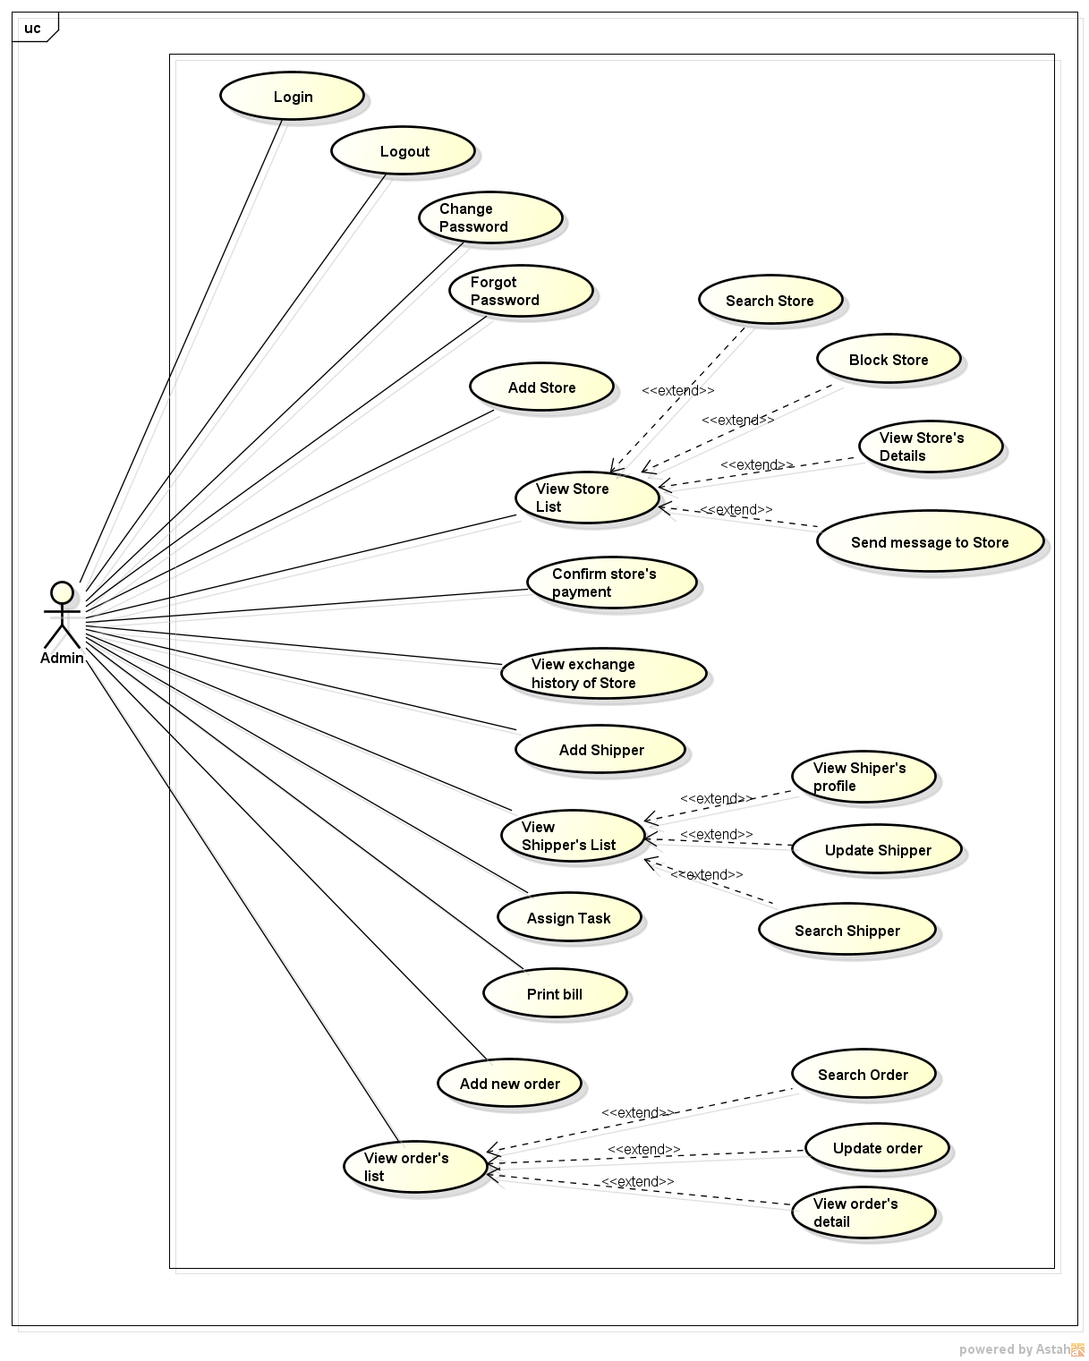

*Figure 11: User case diagram of Web Application for Admin*

### 1.1.2. Functions

###### *UC- 101: Admin Login*

|  |  |  |  |  |
| --- | --- | --- | --- | --- |
| **Use Case ID:** | | UC-101 | | |
| **Use Case Name:** | | Admin Login | | |
| **Created By:** | | HuyTDH | **Last Updated By:** | HuyTDH |
| **Date Created:** | | 20/09/2015 | **Date Last updated:** | 20/09/2015 |
| **Actor:** | | Admin | | |
| **Description:** | | Admin logs in to system | | |
| **Preconditions:** | | Admin not yet logged in | | |
| **Post conditions:** | | Admin logged into system | | |
| **Priority:** | | High | | |
| **Frequency of Use:** | | Always | | |
| **Main flow** | | | | |
| Step | Actor | Action | | |
|  | Admin | Enters **Admin 3S** website address into web browser | | |
|  | System | Shows “Log in” screen, includes:   * Email text box * Password text box * Log in button * Forgot password hyperlink | | |
|  | Admin | Enters email and password | | |
|  | Admin | Clicks on “Log in” button | | |
|  | System | Accepts log in and redirect to “Admin homepage” | | |
| **Alternative Flows: N/A** | | | | |
| **Exceptions:** | | | | |
| EC1 | In step 3 admin enters wrong email or password | | | |
| Step | Actor | Action | | |
| 3.1 | Admin | Enters wrong email or password | | |
| 3.2 | System | Displays message “Wrong email or password” | | |
| 3.3 |  | Return to step 3 of main flow | | |
| **Includes:** | | N/A | | |
| **Special Requirements:** | | N/A | | |
| **Assumptions:** | | N/A | | |
| **Notes and Issues:** | | N/A | | |

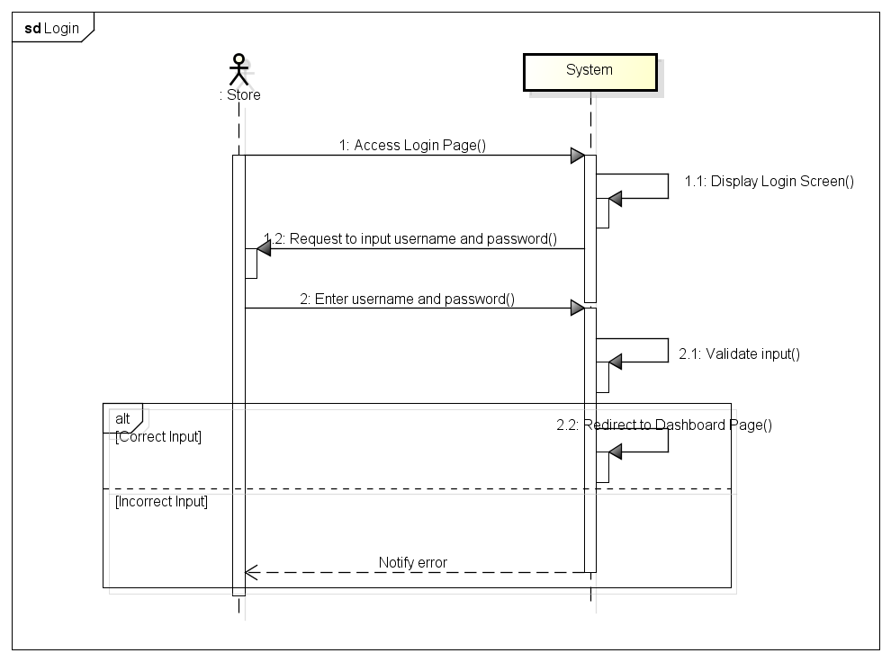

*UC- 102: Admin Logout*

|  |  |  |  |  |
| --- | --- | --- | --- | --- |
| **Use Case ID:** | | UC-102 | | |
| **Use Case Name:** | | Admin Log out | | |
| **Created By:** | | HuyTDH | **Last Updated By:** | HuyTDH |
| **Date Created:** | | 20/09/2015 | **Date Last updated:** | 20/09/2015 |
| **Actor:** | | Admin | | |
| **Description:** | | Admin Logs out of the system | | |
| **Preconditions:** | | Admin logged in | | |
| **Post conditions:** | | Admin logged out of the system | | |
| **Priority:** | | High | | |
| **Frequency of Use:** | | Often | | |
| **Main flow** | | | | |
| Step | Actor | Action | | |
|  | Admin | Clicks on admin name in the top right of the screen | | |
|  | System | Displays menu box | | |
|  | Admin | Chooses “Log out” from menu box | | |
|  | System | Logs admin out and go to “Admin Log in” screen (refer to UC-101) | | |
| **Alternative Flows:** | | | | |
| N/A | | | | |
| **Exceptions:** | | | | |
| N/A | | | | |
| **Includes:** | | N/A | | |
| **Special Requirements:** | | N/A | | |
| **Assumptions:** | | N/A | | |
| **Notes and Issues:** | | N/A | | |

###### *UC- 103: Admin Change Password*

|  |  |  |  |  |
| --- | --- | --- | --- | --- |
| **Use Case ID:** | | UC-103 | | |
| **Use Case Name:** | | Admin Change Password | | |
| **Created By:** | | HuyTDH | **Last Updated By:** | HuyTDH |
| **Date Created:** | | 20/09/2015 | **Date Last updated:** | 20/09/2015 |
| **Actor:** | | Admin | | |
| **Description:** | | Admin change his password | | |
| **Preconditions:** | | Admin logged in | | |
| **Post conditions:** | | Admin’s password is changed | | |
| **Priority:** | | Normal | | |
| **Frequency of Use:** | | Sometimes | | |
| **Main flow** | | | | |
| Step | Actor | Action | | |
|  | Admin | Clicks on admin name in the top right of the screen | | |
|  | System | Displays menu box | | |
|  | Admin | Chooses “Change password” from menu box | | |
|  | System | Displays “Change password” screen | | |
|  | Admin | Enter old password, new password and re-password | | |
|  | Admin | Clicks on “Change” button | | |
|  | System | Display message “Your password has been changed” and go to “Admin Homepage” screen | | |
| **Alternative Flows:** | | | | |
| **Exceptions:** | | | | |
| EC1 | In step 5 admin enters wrong old password | | | |
| Step | Actor | Action | | |
| 5.1 | Admin | Enters wrong old password | | |
| 5.2 | Admin | Enters new password and re-password | | |
| 5.3 | Admin | Clicks on “Change” | | |
| 5.4 | System | Displays message “Wrong old password” | | |
| 5.5 |  | Return to step 5 of main flow | | |
| **Includes:** | | N/A | | |
| **Special Requirements:** | | N/A | | |
| **Assumptions:** | | N/A | | |
| **Notes and Issues:** | | N/A | | |

###### *UC- 104: Admin Forgot Password*

|  |  |  |  |  |
| --- | --- | --- | --- | --- |
| **Use Case ID:** | | UC-104 | | |
| **Use Case Name:** | | Admin Forgot Password | | |
| **Created By:** | | HuyTDH | **Last Updated By:** | HuyTDH |
| **Date Created:** | | 20/09/2015 | **Date Last updated:** | 20/09/2015 |
| **Actor:** | | Admin | | |
| **Description:** | | Admin forgot his password and use this function to receive new one via registered email | | |
| **Preconditions:** | | Admin not yet log in | | |
| **Post conditions:** | | New password is sent to admin’s email | | |
| **Priority:** | | Normal | | |
| **Frequency of Use:** | | Sometimes | | |
| **Main flow** | | | | |
| Step | Actor | Action | | |
|  | Admin | Goes to “Log in” screen (refer to UC-101) | | |
|  | Admin | Clicks on “Forgot password” hyperlink | | |
|  | System | Displays “Forgot password” screen | | |
|  | Admin | Enter registered email and click “Send new password” | | |
|  | System | Displays message “New password has been sent to your email” | | |
| **Alternative Flows:** | | | | |
| N/A | | | | |
| **Exceptions:** | | | | |
| EC1 | In step 4 admin enter wrong email | | | |
| Step | Actor | Action | | |
| 4.1 | Admin | Enters registered email and click “Send new password” | | |
| 4.2 | System | Displays message “Wrong email! Retry!” | | |
| 4.3 |  | Return to step 4 of main flow | | |
| **Includes:** | | N/A | | |
| **Special Requirements:** | | N/A | | |
| **Assumptions:** | | N/A | | |
| **Notes and Issues:** | | N/A | | |

###### *UC- 105: Accept Store*

|  |  |  |  |  |
| --- | --- | --- | --- | --- |
| **Use Case ID:** | | UC-105 | | |
| **Use Case Name:** | | Accept Store’s adding request | | |
| **Created By:** | | HoangNK | **Last Updated By:** | HoangNK |
| **Date Created:** | | 19/09/2015 | **Date Last updated:** | 24/09/2015 |
| **Actor:** | | Admin | | |
| **Description:** | | Admin views list of Store’s adding request then accept or reject to add the Store | | |
| **Triggering Event:** | | Admin accepts adding request of Store | | |
| **Preconditions:** | | Admin logged in to system | | |
| **Post conditions:** | | New Store is added to database | | |
| **Priority:** | | High | | |
| **Frequency of Use:** | | Sometime | | |
| **Main flow** | | | | |
| Step | Actor | Action | | |
|  | Admin | Click “Store” button in left navigate bar | | |
|  | System | Display “Store” menu | | |
|  | Admin | Click “Accept new Store” button | | |
|  | System | Load data of Store's Adding Request and display in “Accept new Store” screen | | |
|  | Admin | Click “Accept” button to accept to add new Store | | |
|  | System | Display confirm popup includes “Yes” and “No” button | | |
|  | Admin | Confirm by clicking “Yes” button | | |
|  | System | Close popup and hide this store from list | | |
|  | System | Add new Store to database of System | | |
| **Alternative Flows:** | | N/A | | |
| **Exceptions:** | | | | |
| EC1 | At step 5, Admin reject by clicking “Reject” button | | | |
| Step | Actor | Action | | |
| 5.1 | System | Delete this store from list and this Store isn’t added to System | | |
| EC2 | At step 7, Admin click on “No” button | | | |
| Step | Actor | Action | | |
| 7.1 | System | Close popup and proceed to step 4 | | |
| **Includes:** | | N/A | | |
| **Special Requirements:** | | N/A | | |
| **Notes and Issues:** | | N/A | | |

###### *UC- 106: Search Store*

|  |  |  |  |  |
| --- | --- | --- | --- | --- |
| **Use Case ID:** | | UC-106 | | |
| **Use Case Name:** | | Search Store | | |
| **Created By:** | | HoangNK | **Last Updated By:** | HoangNK |
| **Date Created:** | | 19/09/2015 | **Date Last updated:** | 24/09/2015 |
| **Actor:** | | Admin | | |
| **Description:** | | Admin wants the system to list all Stores related to a specific keyword. | | |
| **Triggering Event:** | | Admin searches store | | |
| **Preconditions:** | | Admin is in view store’s list page ( refer case UC-107 ) | | |
| **Post conditions:** | | Display Store as result of search | | |
| **Priority:** | | High | | |
| **Frequency of Use:** | | Always | | |
| **Main flow** | | | | |
| Step | Actor | Action | | |
|  | Admin | Choose type of searching: Name, Address or Type | | |
|  | Admin | Enter text to “Search” text box | | |
|  | Admin | Click “Search” button or press “Enter” | | |
|  | System | Get Store’s data from data base and display result on screen | | |
| **Alternative Flows:** | | N/A | | |
| **Exceptions:** | | N/A | | |
| EC1 | At step 1, Admin doesn’t choose any type | | | |
| Step | Actor | Action | | |
| 1.1 | System | Set Name is default type | | |
| **Includes:** | | N/A | | |
| **Special Requirements:** | | * Result of search is case insensitive | | |
| **Notes and Issues:** | | N/A | | |

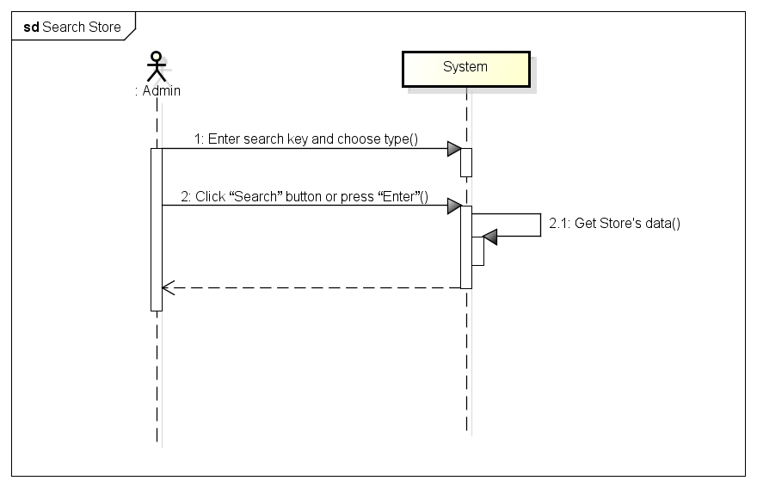

###### *UC- 107:* *View Store’s list*

|  |  |  |  |  |
| --- | --- | --- | --- | --- |
| **Use Case ID:** | | UC-107 | | |
| **Use Case Name:** | | View Stores List | | |
| **Created By:** | | HoangNK | **Last Updated By:** | HoangNK |
| **Date Created:** | | 19/09/2015 | **Date Last updated:** | 19/09/2015 |
| **Actor:** | | Admin | | |
| **Description:** | | Admin wants to view all of Store | | |
| **Triggering Event:** | | Admin views list of Store | | |
| **Preconditions:** | | Admin logged in to system | | |
| **Post conditions:** | | List of store is displayed to screen | | |
| **Priority:** | | High | | |
| **Frequency of Use:** | | Always | | |
| **Main flow** | | | | |
| Step | Actor | Action | | |
|  | Admin | Click “Store” button in left navigate bar | | |
|  | System | Display “Store” menu in left navigate bar | | |
|  | Admin | Click “Store’s list” button | | |
|  | System | Display “Store’s List” screen | | |
| **Alternative Flows:** | | N/A | | |
| **Exceptions:** | | N/A | | |
| **Includes:** | | N/A | | |
| **Special Requirements:** | | N/A | | |
| **Notes and Issues:** | | N/A | | |

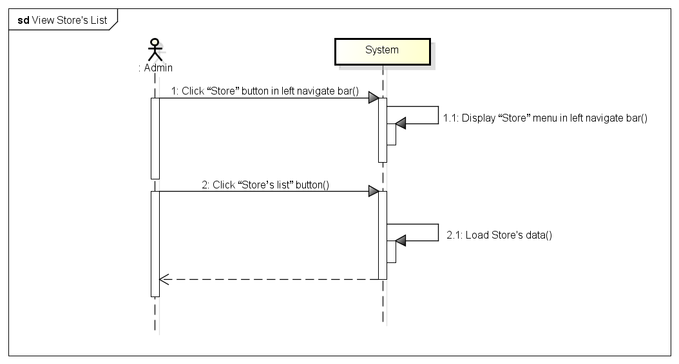

###### *UC- 108:* *Block store*

|  |  |  |  |  |
| --- | --- | --- | --- | --- |
| **Use Case ID:** | | UC-108 | | |
| **Use Case Name:** | | Block and Unblock store | | |
| **Created By:** | | HoangNK | **Last Updated By:** | HoangNK |
| **Date Created:** | | 19/09/2015 | **Date Last updated:** | 24/09/2015 |
| **Actor:** | | Admin | | |
| **Description:** | | Admin want to ban or unban the store from system, so they can’t do any function of system if they were banned | | |
| **Triggering Event:** | | Admin blocks or unblocks store | | |
| **Preconditions:** | | Admin is in view store’s list page ( refer case UC-107 ) | | |
| **Post conditions:** | | Store is blocked or unblocked | | |
| **Priority:** | | Normal | | |
| **Frequency of Use:** | | Sometime | | |
| **Main flow** | | | | |
| Step | Actor | Action | | |
|  | Admin | Click “Block”(“Unblock”) button | | |
|  | System | Display confirm popup includes “Yes” and “No” button | | |
|  | Admin | Click “Yes” button | | |
|  | System | Hide popup and change store’s status of blocking | | |
|  | System | Store is blocked or unblocked | | |
| **Alternative Flows:** | |  | | |
| AT1 | At step 1, if admin click “View store’s details” | | | |
| Step | Actor | Action | | |
| 1 | Admin | Click Store’s name in row (hyperlink) | | |
| 2 | System | Display “View Store’s details” screen | | |
| 3 | Admin | Click “Block” (“Unblock”) button below avatar | | |
| 4 | System | Go to step 2 of main flow and continue | | |
| **Exceptions:** | | | | |
| EC1 | At step 2, Admin click on “No” button | | | |
| Step | Actor | Action | | |
| 2.1 | System | Close popup | | |
| **Includes:** | | N/A | | |
| **Special Requirements:** | | N/A | | |
| **Notes and Issues:** | | N/A | | |

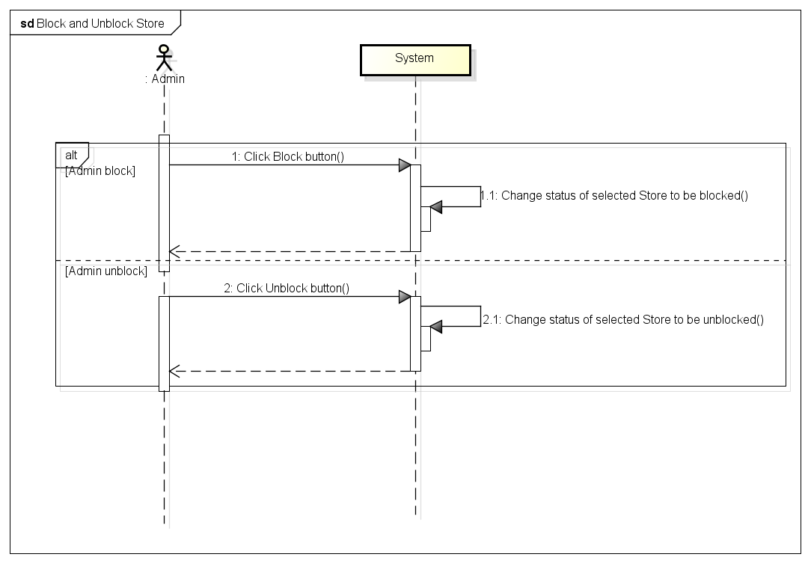

###### *UC- 109:* *View Store’s details*

|  |  |  |  |  |
| --- | --- | --- | --- | --- |
| **Use Case ID:** | | UC-109 | | |
| **Use Case Name:** | | View Store’s details | | |
| **Created By:** | | HoangNK | **Last Updated By:** | HoangNK |
| **Date Created:** | | 19/09/2015 | **Date Last updated:** | 24/09/2015 |
| **Actor:** | | Admin | | |
| **Description:** | | Admin wants to view all information of a Store | | |
| **Triggering Event:** | | Admin views details of a Store | | |
| **Preconditions:** | | Admin is in view store’s list page ( refer case UC-107 ) | | |
| **Post conditions:** | | Details of Store are displayed | | |
| **Priority:** | | Normal | | |
| **Frequency of Use:** | | Sometime | | |
| **Main flow** | | | | |
| Step | Actor | Action | | |
|  | Admin | Click Store’s name in row (hyperlink) | | |
|  | System | Load data of selected Store and display “View Store’s details” screen includes store’s details | | |
| **Alternative Flows:** | | N/A | | |
| **Exceptions:** | | N/A | | |
| **Includes:** | | N/A | | |
| **Special Requirements:** | | N/A | | |
| **Notes and Issues:** | | N/A | | |

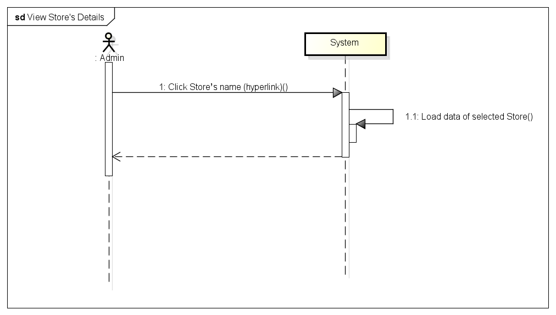

###### *UC- 110:* *Send message to Store*

|  |  |  |  |  |
| --- | --- | --- | --- | --- |
| **Use Case ID:** | | UC-110 | | |
| **Use Case Name:** | | Send message to Store | | |
| **Created By:** | | HoangNK | **Last Updated By:** | HoangNK |
| **Date Created:** | | 19/09/2015 | **Date Last updated:** | 19/09/2015 |
| **Actor:** | | Admin | | |
| **Description:** | | Admin wants to send message to the Store to notify of something | | |
| **Triggering Event:** | | Admin sends message to Store | | |
| **Preconditions:** | | Admin is in view store’s list page ( refer case UC-107 ) | | |
| **Post conditions:** | | A message is sent to the Store | | |
| **Priority:** | | Normal | | |
| **Frequency of Use:** | | Sometime | | |
| **Main flow** | | | | |
| Step | Actor | Action | | |
|  | Admin | Click “Send message” button | | |
|  | System | Display “Send message” screen with send message form | | |
|  | Admin | Fill information in textbox | | |
|  | Admin | Click “Send” button | | |
|  | System | Validate input | | |
|  | System | Send this message to store | | |
| **Alternative Flows:** | |  | | |
| AT1 | At step 1, if admin click “View store’s details” | | | |
| Step | Actor | Action | | |
| 1 | Admin | Click Store’s name in row (hyperlink) | | |
| 2 | System | Display “View Store’s details” screen | | |
| 3 | Admin | Click “Send message” button below avatar | | |
| 4 | System | Go to step 2 of main flow and continue | | |
| **Exceptions:** | | | | |
| EC1 | At step 5, if admin doesn’t type anything in Subject textbox or Content textbox | | | |
| Step | Actor | Action | | |
| 5.1 | System | Notify by error message in screen “*is require” | | |
| **Includes:** | | N/A | | |
| **Special Requirements:** | | * Message content must be longer than 20 characters * The field with ‘*’ can’t be blank | | |
| **Notes and Issues:** | | N/A | | |

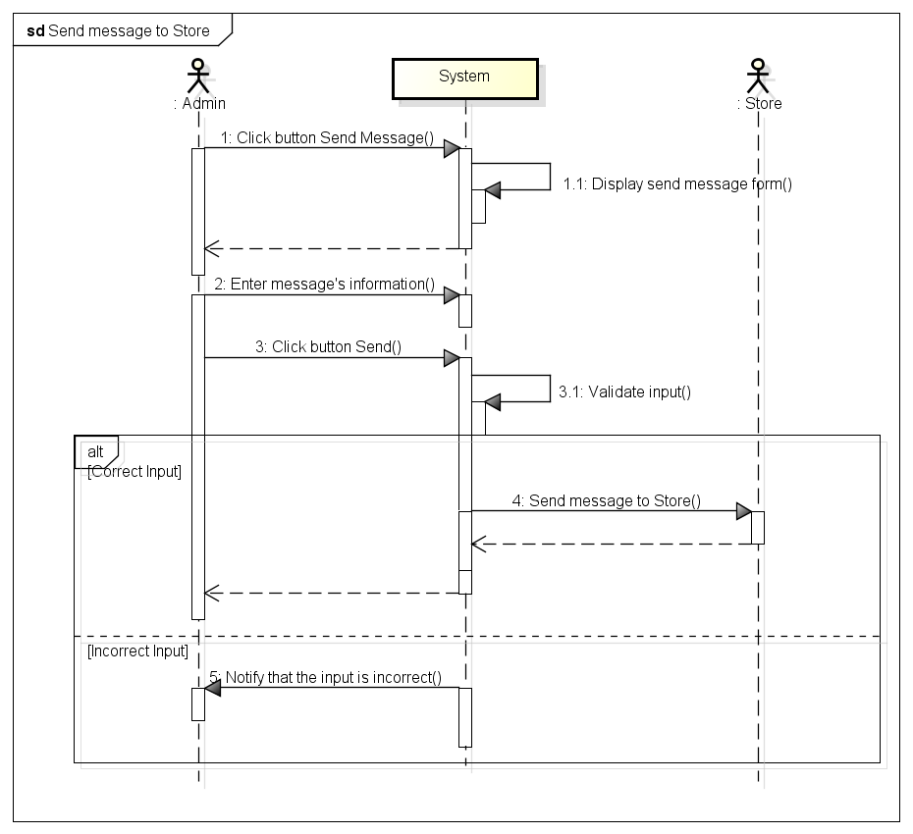

###### *UC- 111:* *Confirm Store’s payment*

|  |  |  |  |  |
| --- | --- | --- | --- | --- |
| **Use Case ID:** | | UC-111 | | |
| **Use Case Name:** | | Confirm Store’s payment | | |
| **Created By:** | | HoangNK | **Last Updated By:** | HoangNK |
| **Date Created:** | | 19/09/2015 | **Date Last updated:** | 24/09/2015 |
| **Actor:** | | Admin | | |
| **Description:** | | After receiving and sending money to the Store, admin updates Store’s payment | | |
| **Triggering Event:** | | Admin confirms store’s payment | | |
| **Preconditions:** | | Admin logged in to system | | |
| **Post conditions:** | | Payment of this store is updated in database | | |
| **Priority:** | | High | | |
| **Frequency of Use:** | | Always | | |
| **Main flow** | | | | |
| Step | Actor | Action | | |
|  | Admin | Click “Store” button in left navigate bar | | |
|  | System | Display “Store” menu in left navigate bar | | |
|  | Admin | Click “Confirm store’s payment” button | | |
|  | System | Display “Confirm store’s payment” popup | | |
|  | Admin | Enter payment in “Payment” textbox | | |
|  | Admin | Click “Confirm” button | | |
|  | System | Give confirm by displaying confirm popup includes “Yes” and “No” button | | |
|  | Admin | Click “Yes” button | | |
|  | System | Update payment of this store to database | | |
| **Alternative Flows:** | |  | | |
| AT1 | At step 3, if admin click “Store’s list” button | | | |
| Step | Actor | Action | | |
| 3 | Admin | Click “Store’s list” button | | |
| 4 | System | Display “View Store’s details” screen | | |
| 5 | System | Display “Store’s List” screen | | |
| 6 | Admin | Click Store’s name in row (hyperlink) | | |
| 7 | System | Display “View Store’s details” screen includes store’s details | | |
| 8 | Admin | Click “Confirm store’s payment” button | | |
| 9 | System | Go to step 4 of main flow | | |
| **Exceptions:** | | N/A | | |
| **Includes:** | | N/A | | |
| **Special Requirements:** | | * When Admin clicks Store’s name (hyperlink), some rows will be displayed below with incomplete transaction * If the payment is negative, this is payment that the system needs to pay for the Store * If the payment is positive, this is payment that the Store needs to pay for the system * Default value of textbox is 0 | | |
| **Notes and Issues:** | | N/A | | |

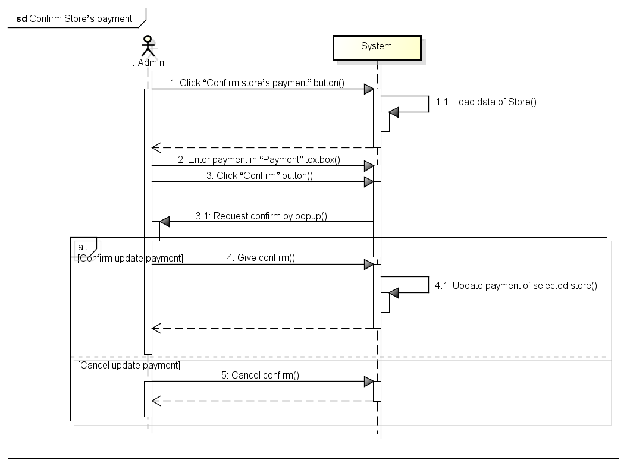

###### *UC- 112:* *View transaction history of Store*

|  |  |  |  |  |
| --- | --- | --- | --- | --- |
| **Use Case ID:** | | UC-112 | | |
| **Use Case Name:** | | View transaction history of Store | | |
| **Created By:** | | HoangNK | **Last Updated By:** | HoangNK |
| **Date Created:** | | 19/09/2015 | **Date Last updated:** | 19/09/2015 |
| **Actor:** | | Admin | | |
| **Description:** | | Admin wants to view transaction history of Store | | |
| **Triggering Event:** | | Admin views transaction history of Store | | |
| **Preconditions:** | | Admin logged in to system | | |
| **Post conditions:** | | List of transaction history of Store is displayed | | |
| **Priority:** | | Normal | | |
| **Frequency of Use:** | | Sometime | | |
| **Main flow** | | | | |
| Step | Actor | Action | | |
|  | Admin | Click “Store” button in left navigate bar | | |
|  | System | Display “Store” menu in left navigate bar | | |
|  | Admin | Click “Transaction history” button | | |
|  | System | Load data of transaction and display “Transaction history” screen | | |
| **Alternative Flows:** | | | | |
| AT1 | At step 3, if admin click “Store’s list” button | | | |
| Step | Actor | Action | | |
| 3 | Admin | Click “Store’s list” button | | |
| 4 | System | Display “View Store’s details” screen | | |
| 5 | System | Display “Store’s List” screen | | |
| 6 | Admin | Click Store’s name in row (hyperlink) | | |
| 7 | System | Display “View Store’s details” screen includes store’s details | | |
| 8 | Admin | Click “Transaction history” button | | |
| 9 | System | Go to step 4 of main flow | | |
| **Exceptions:** | | N/A | | |
| **Includes:** | | N/A | | |
| **Special Requirements:** | | N/A | | |
| **Notes and Issues:** | | N/A | | |

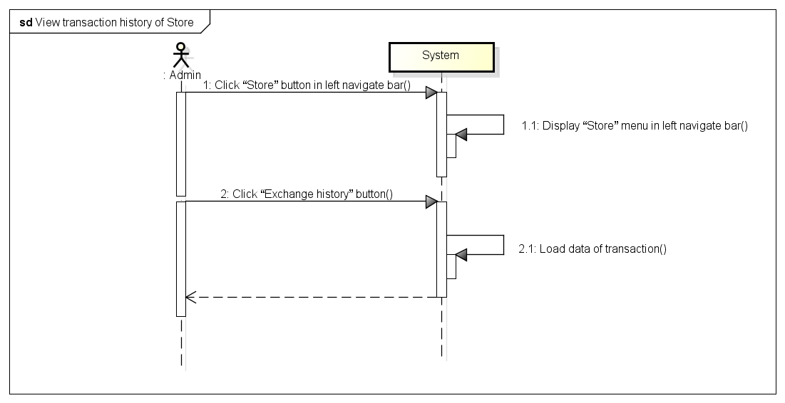

###### *UC- 113:* *Add Shipper*

|  |  |  |  |  |
| --- | --- | --- | --- | --- |
| **Use Case ID:** | | UC-113 | | |
| **Use Case Name:** | | Add Shipper | | |
| **Created By:** | | HoangNK | **Last Updated By:** | HoangNK |
| **Date Created:** | | 19/09/2015 | **Date Last updated:** | 19/09/2015 |
| **Actor:** | | Admin | | |
| **Description:** | | New Shipper wants to join in system then Admin adds new Shipper to system with related information | | |
| **Triggering Event:** | | Admin adds a new Shipper to system | | |
| **Preconditions:** | | Admin logged in to system | | |
| **Post conditions:** | | New Shipper and new account for this Shipper are added to database | | |
| **Priority:** | | High | | |
| **Frequency of Use:** | | Often | | |
| **Main flow** | | | | |
| Step | Actor | Action | | |
|  | Admin | Click “Shipper” button in left navigate bar | | |
|  | System | Display “Shipper” menu | | |
|  | Admin | Click “Add new Shipper” button | | |
|  | System | Display “Add new Shipper” form | | |
|  | Admin | Enter new Shipper’s information into fields | | |
|  | Admin | Click “Add” button | | |
|  | System | Validate input | | |
|  | System | Add new Shipper and new account of this Shipper to database then redirect to “Shipper’s List” page | | |
| **Alternative Flows:** | | N/A | | |
| **Exceptions:** | | | | |
| EC1 | At step 7, if any required field is not entered | | | |
| Step | Actor | Action | | |
| 7.1 | System | Notify in screen by error message “*is require” | | |
| EC2 | At step 7, if any required field is incorrect format | | | |
| Step | Actor | Action | | |
| 7.1 | System | Notify in screen by error message “*is incorrect format” | | |
| **Includes:** | | N/A | | |
| **Special Requirements:** | | * ShipperID will be generated automatically by system * Default account and password for new Shipper is shipperID, Shipper can change them by mobile app later * The field with ‘*’ can’t be blank | | |
| **Notes and Issues:** | | N/A | | |

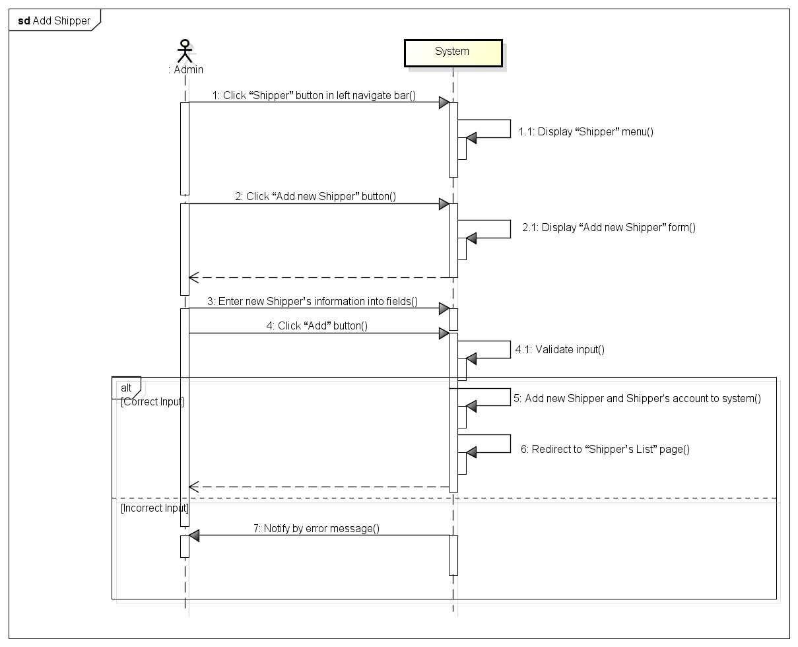

###### *UC- 114:* *View Shipper’s list*

|  |  |  |  |  |
| --- | --- | --- | --- | --- |
| **Use Case ID:** | | UC-114 | | |
| **Use Case Name:** | | View Shipper’s list | | |
| **Created By:** | | HoangNK | **Last Updated By:** | HoangNK |
| **Date Created:** | | 19/09/2015 | **Date Last updated:** | 19/09/2015 |
| **Actor:** | | Admin | | |
| **Description:** | | Admin wants to view all Shipper | | |
| **Triggering Event:** | | Admin views list of Shipper | | |
| **Preconditions:** | | Admin logged in to system | | |
| **Post conditions:** | | List of shipper is displayed | | |
| **Priority:** | | High | | |
| **Frequency of Use:** | | Always | | |
| **Main flow** | | | | |
| Step | Actor | Action | | |
|  | Admin | Click “Shipper” button in left navigate bar | | |
|  | System | Display “Shipper” menu in left navigate bar | | |
|  | Admin | Click “Shipper’s list” button | | |
|  | System | Load Shipper's data and display “Shipper’s List” screen | | |
| **Alternative Flows:** | | **N/A** | | |
| **Exceptions:** | | **N/A** | | |
| **Includes:** | | N/A | | |
| **Special Requirements:** | | * The default Shipper’s list is ordered by Name | | |
| **Notes and Issues:** | | N/A | | |

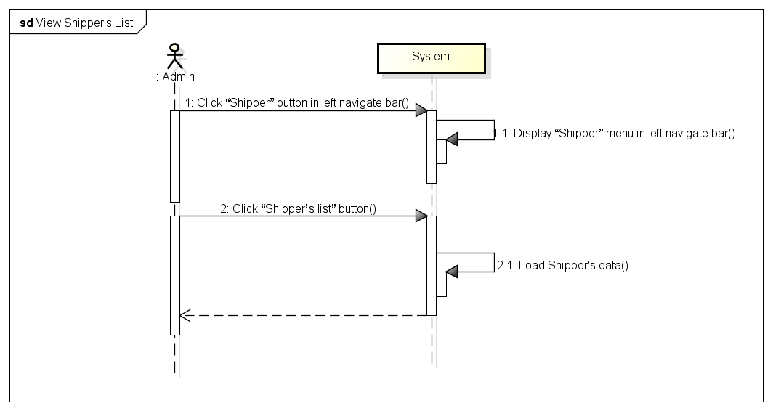

###### *UC- 115:* *View Order’s list*

|  |  |  |  |  |
| --- | --- | --- | --- | --- |
| **Use Case ID:** | | UC-115 | | |
| **Use Case Name:** | | View Order’s list | | |
| **Created By:** | | HoangNK | **Last Updated By:** | HoangNK |
| **Date Created:** | | 19/09/2015 | **Date Last updated:** | 19/09/2015 |
| **Actor:** | | Admin | | |
| **Description:** | | Admin want to view all Orders | | |
| **Triggering Event:** | | Admin views Order’s list | | |
| **Preconditions:** | | Admin logged in to system | | |
| **Post conditions:** | | List of order is displayed | | |
| **Priority:** | | High | | |
| **Frequency of Use:** | | Always | | |
| **Main flow** | | | | |
| Step | Actor | Action | | |
|  | Admin | Click “Order” button in left navigate bar | | |
|  | System | Display “Order” menu in left navigate bar | | |
|  | Admin | Click “Order’s list” button | | |
|  | System | Load Order's data and display “Order’s List” screen | | |
| **Alternative Flows:** | | **N/A** | | |
| **Exceptions:** | | **N/A** | | |
| **Includes:** | | N/A | | |
| **Special Requirements:** | | * The default Order’s list is ordered by Date | | |
| **Notes and Issues:** | | N/A | | |

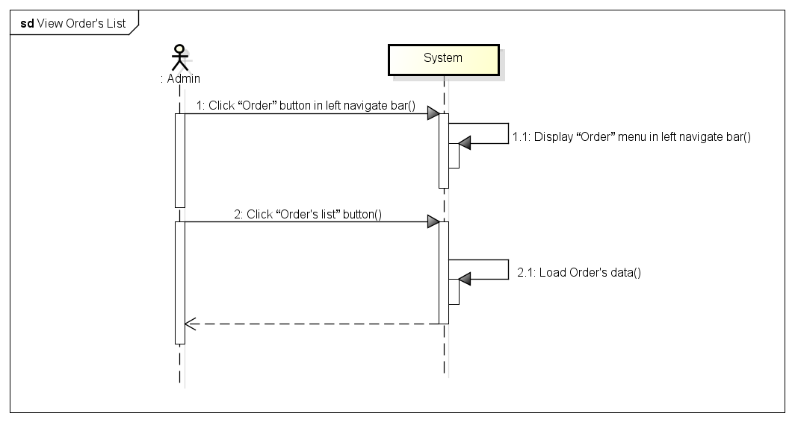

###### *UC- 117:* *Search Shipper*

|  |  |  |  |  |
| --- | --- | --- | --- | --- |
| **Use Case ID:** | | UC-116 | | |
| **Use Case Name:** | | Search Shipper | | |
| **Created By:** | | HoangNK | **Last Updated By:** | HoangNK |
| **Date Created:** | | 19/09/2015 | **Date Last updated:** | 19/09/2015 |
| **Actor:** | | Admin | | |
| **Description:** | | Admin wants the system to list all Shippers related to a specific keyword. | | |
| **Triggering Event:** | | Admin searches Shipper | | |
| **Preconditions:** | | Admin is in view shipper’s list page ( refer case UC-114 ) | | |
| **Post conditions:** | | Display Shipper as result of search | | |
| **Priority:** | | High | | |
| **Frequency of Use:** | | Always | | |
| **Main flow** | | | | |
| Step | Actor | Action | | |
|  | Admin | Choose type of Shipper: Name, Address or ID | | |
|  | Admin | Enter text to “Search” text box | | |
|  | Admin | Click “Search” button or press “Enter” | | |
|  | System | Get Shipper's data and display result on screen | | |
| **Alternative Flows:** | | N/A | | |
| **Exceptions:** | | N/A | | |
| EC1 | At step 3, Admin doesn’t choose any type | | | |
| Step | Actor | Action | | |
| 3.1 | System | Set Name is default type | | |
| **Includes:** | | N/A | | |
| **Special Requirements:** | | * Result of search is case insensitive * Types of search are Name, Address and ID | | |
| **Notes and Issues:** | | N/A | | |

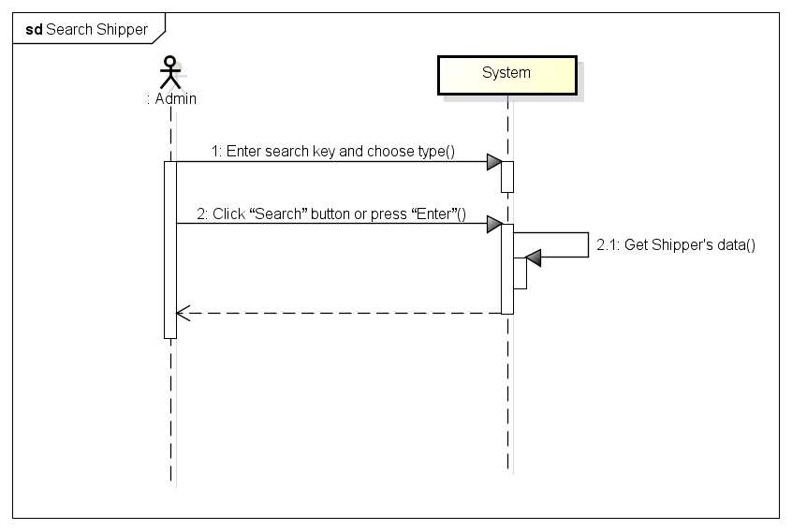

###### *UC- 117:* *Search Order*

|  |  |  |  |  |
| --- | --- | --- | --- | --- |
| **Use Case ID:** | | UC-117 | | |
| **Use Case Name:** | | Search Order | | |
| **Created By:** | | HoangNK | **Last Updated By:** | HoangNK |
| **Date Created:** | | 19/09/2015 | **Date Last updated:** | 19/09/2015 |
| **Actor:** | | Admin | | |
| **Description:** | | Admin wants the system to list all Orders related to a specific keyword. | | |
| **Triggering Event:** | | Admin searches Order | | |
| **Preconditions:** | | Admin is in view order’s list page ( refer case UC-115 ) | | |
| **Post conditions:** | | Display Order as result of search | | |
| **Priority:** | | High | | |
| **Frequency of Use:** | | Always | | |
| **Main flow** | | | | |
| Step | Actor | Action | | |
|  | Admin | Choose type of Order: Type, Address, Date, Store’s name or Shipper’s name | | |
|  | Admin | Enter text to “Order” text box | | |
|  | Admin | Click “Order” button or press “Enter” | | |
|  | System | Get Shipper's data and display result on screen | | |
| **Alternative Flows:** | | N/A | | |
| **Exceptions:** | | N/A | | |
| EC1 | At step 3, Admin doesn’t choose any type | | | |
| Step | Actor | Action | | |
| 3.1 | System | Set All is default type | | |
| **Includes:** | | N/A | | |
| **Special Requirements:** | | * Result of search is case insensitive * Types of search are Name, Address and ID | | |
| **Notes and Issues:** | | N/A | | |

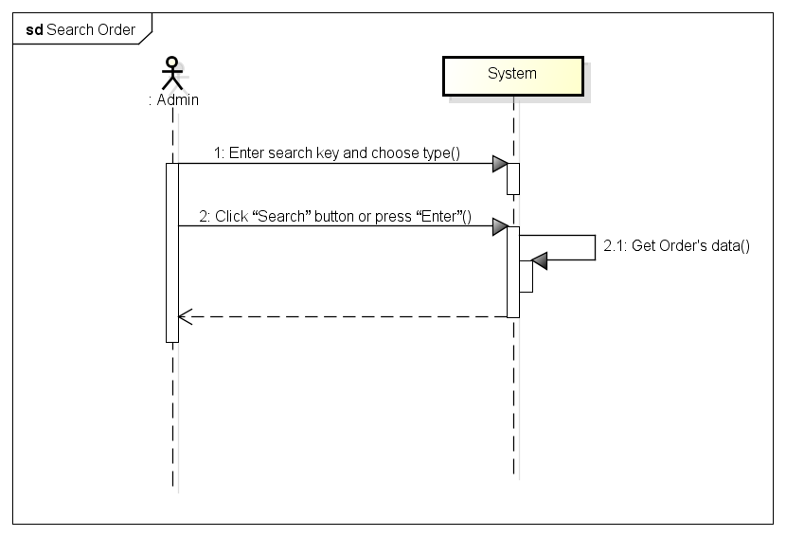

###### *UC- 118:* *View Shipper’s profile*

|  |  |  |  |  |
| --- | --- | --- | --- | --- |
| **Use Case ID:** | | UC-118 | | |
| **Use Case Name:** | | View Shipper’s profile | | |
| **Created By:** | | HoangNK | **Last Updated By:** | HoangNK |
| **Date Created:** | | 19/09/2015 | **Date Last updated:** | 24/09/2015 |
| **Actor:** | | Admin | | |
| **Description:** | | Admin wants to view all information of the Shipper | | |
| **Triggering Event:** | | Admin views profile of a Shipper | | |
| **Preconditions:** | | Admin is in view shipper’s list page ( refer case UC-114 ) | | |
| **Post conditions:** | | Profile of Shipper is displayed | | |
| **Priority:** | | Normal | | |
| **Frequency of Use:** | | Sometime | | |
| **Main flow** | | | | |
| Step | Actor | Action | | |
|  | Admin | Click Shipper’s name in row (hyperlink) | | |
|  | System | Load data of selected Shipper and display “View Shipper’s profile” screen | | |
| **Alternative Flows:** | | N/A | | |
| **Exceptions:** | | N/A | | |
| **Includes:** | | N/A | | |
| **Special Requirements:** | | N/A | | |
| **Notes and Issues:** | | N/A | | |

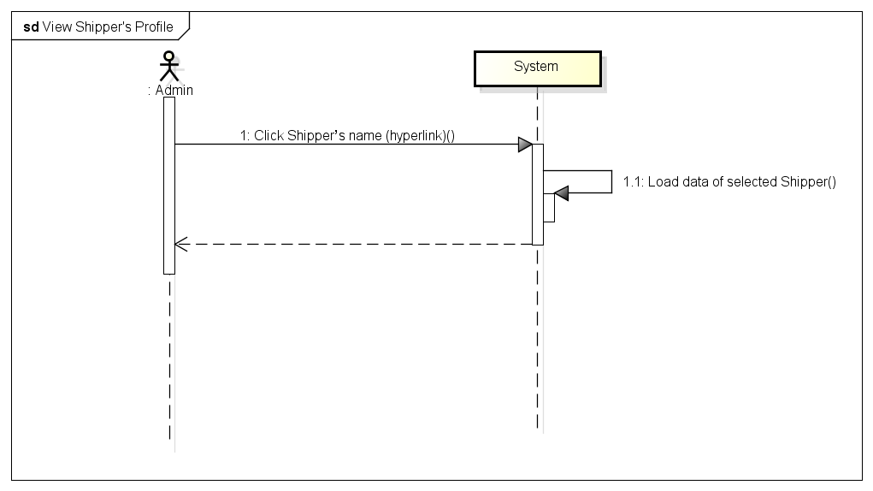

###### *UC- 119:* *View Order’s details*

|  |  |  |  |  |
| --- | --- | --- | --- | --- |
| **Use Case ID:** | | UC-119 | | |
| **Use Case Name:** | | View Order’s details | | |
| **Created By:** | | HoangNK | **Last Updated By:** | HoangNK |
| **Date Created:** | | 19/09/2015 | **Date Last updated:** | 19/09/2015 |
| **Actor:** | | Admin | | |
| **Description:** | | Admin wants to view all information of the Order | | |
| **Triggering Event:** | | Admin views details of Order | | |
| **Preconditions:** | | Admin is in view shipper’s list page ( refer case UC-115) | | |
| **Post conditions:** | | Details of Order is displayed | | |
| **Priority:** | | Normal | | |
| **Frequency of Use:** | | Sometime | | |
| **Main flow** | | | | |
| Step | Actor | Action | | |
|  | Admin | Click Order’s name in row (hyperlink) | | |
|  | System | Load data of selected Order and display to “View Order’s details” screen | | |
| **Alternative Flows:** | | N/A | | |
| **Exceptions:** | | N/A | | |
| **Includes:** | | N/A | | |
| **Special Requirements:** | | N/A | | |
| **Notes and Issues:** | | N/A | | |

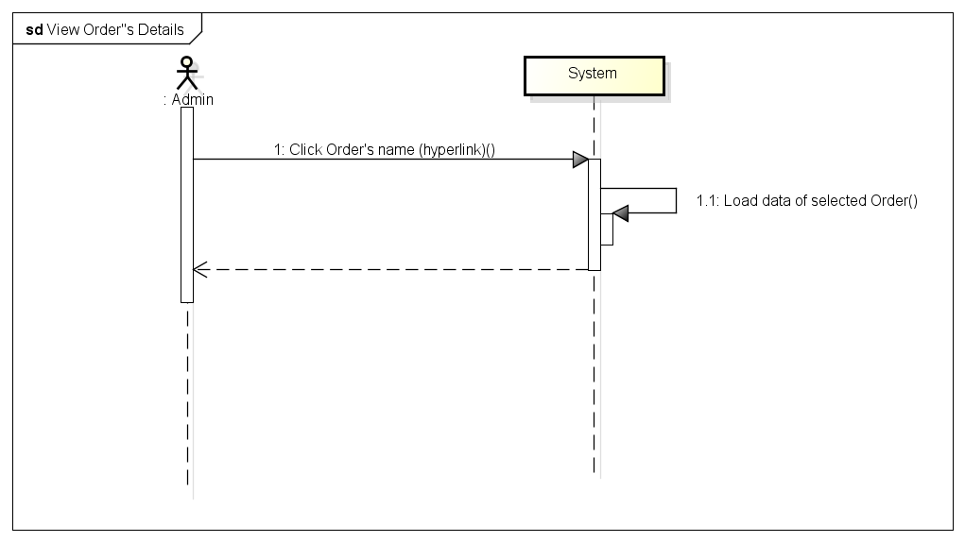

###### *UC- 120:* *Update Shipper*

|  |  |  |  |  |
| --- | --- | --- | --- | --- |
| **Use Case ID:** | | UC-120 | | |
| **Use Case Name:** | | Update Shipper | | |
| **Created By:** | | HoangNK | **Last Updated By:** | HoangNK |
| **Date Created:** | | 19/09/2015 | **Date Last updated:** | 19/09/2015 |
| **Actor:** | | Admin | | |
| **Description:** | | Admin modifies an existed Shipper with related information | | |
| **Triggering Event:** | | Admin updates Shipper’s information | | |
| **Preconditions:** | | Admin is in view shipper’s list page ( refer case UC-114) | | |
| **Post conditions:** | | Information of Shipper is updated in database | | |
| **Priority:** | | Normal | | |
| **Frequency of Use:** | | Sometime | | |
| **Main flow** | | | | |
| Step | Actor | Action | | |
|  | Admin | Click “Update” button | | |
|  | System | Get data of selected Shipper and display “Update Shipper” screen | | |
|  | Admin | Enter new information to fields then click “Update” button | | |
|  | System | Validate input | | |
|  | System | Update Shipper’s new information to database then redirect to Shipper’s profile page | | |
| **Alternative Flows:** | |  | | |
| AT1 | At step 1, if admin click “View Shipper’s profile” | | | |
| Step | Actor | Action | | |
| 1 | Admin | Click Shipper’s name in row (hyperlink) | | |
| 2 | System | Display “View Shipper’s profile” screen | | |
| 3 | Admin | Click “Update” button below avatar | | |
| 4 | System | Go to step 6 of main flow and continue | | |
| **Exceptions:** | | | | |
| EC1 | At step 4, if any required field is not entered | | | |
| Step | Actor | Action | | |
| 4.1 | System | Notify by error message in screen | | |
| EC2 | At step 4, if any entered field is incorrect format | | | |
| Step | Actor | Action | | |
| 4.1 | System | Notify by error message in screen | | |
| **Includes:** | | N/A | | |
| **Special Requirements:** | | * The field with ‘*’ can’t be blank | | |
| **Notes and Issues:** | | N/A | | |

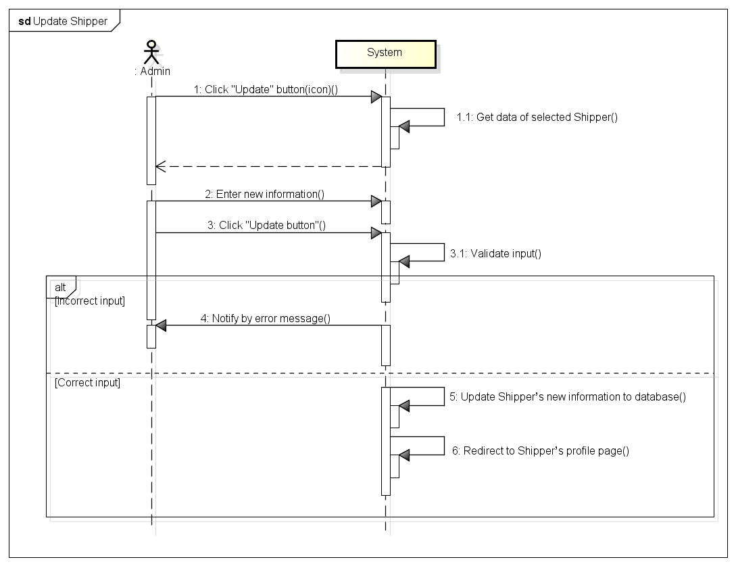

###### *UC- 121:* *Update Order*

|  |  |  |  |  |
| --- | --- | --- | --- | --- |
| **Use Case ID:** | | UC-121 | | |
| **Use Case Name:** | | Update Order | | |
| **Created By:** | | HoangNK | **Last Updated By:** | HoangNK |
| **Date Created:** | | 19/09/2015 | **Date Last updated:** | 19/09/2015 |
| **Actor:** | | Admin | | |
| **Description:** | | Admin modifies an existed Order with related information | | |
| **Triggering Event:** | | Admin updates Order’s information | | |
| **Preconditions:** | | Admin is in view shipper’s list page ( refer case UC-115) | | |
| **Post conditions:** | | Information of Order is updated | | |
| **Priority:** | | Normal | | |
| **Frequency of Use:** | | Sometime | | |
| **Main flow** | | | | |
| Step | Actor | Action | | |
|  | Admin | Click “Update” button | | |
|  | System | Get data of selected Order and display “Update Order” screen | | |
|  | Admin | Enter new information to fields then click “Update” button | | |
|  | System | Validate input | | |
|  | System | Update Order’s new information to database then redirect to Order’s details page | | |
| **Alternative Flows:** | |  | | |
| AT1 | At step 1, if admin click “View Order’s details” | | | |
| Step | Actor | Action | | |
| 1 | Admin | Click Order’s name in row (hyperlink) | | |
| 2 | System | Display “View Order’s details” screen | | |
| 3 | Admin | Click “Update” button below avatar | | |
| 4 | System | Go to step 6 of main flow and continue | | |
| **Exceptions:** | | | | |
| EC1 | At step 4, if any required field is not entered | | | |
| Step | Actor | Action | | |
| 4.1 | System | Notify by error message in screen | | |
| EC2 | At step 4, if any entered field is incorrect format | | | |
| Step | Actor | Action | | |
| 4.1 | System | Notify by error message in screen | | |
| **Includes:** | | N/A | | |
| **Special Requirements:** | | * The field with ‘*’ can’t be blank | | |
| **Notes and Issues:** | | N/A | | |

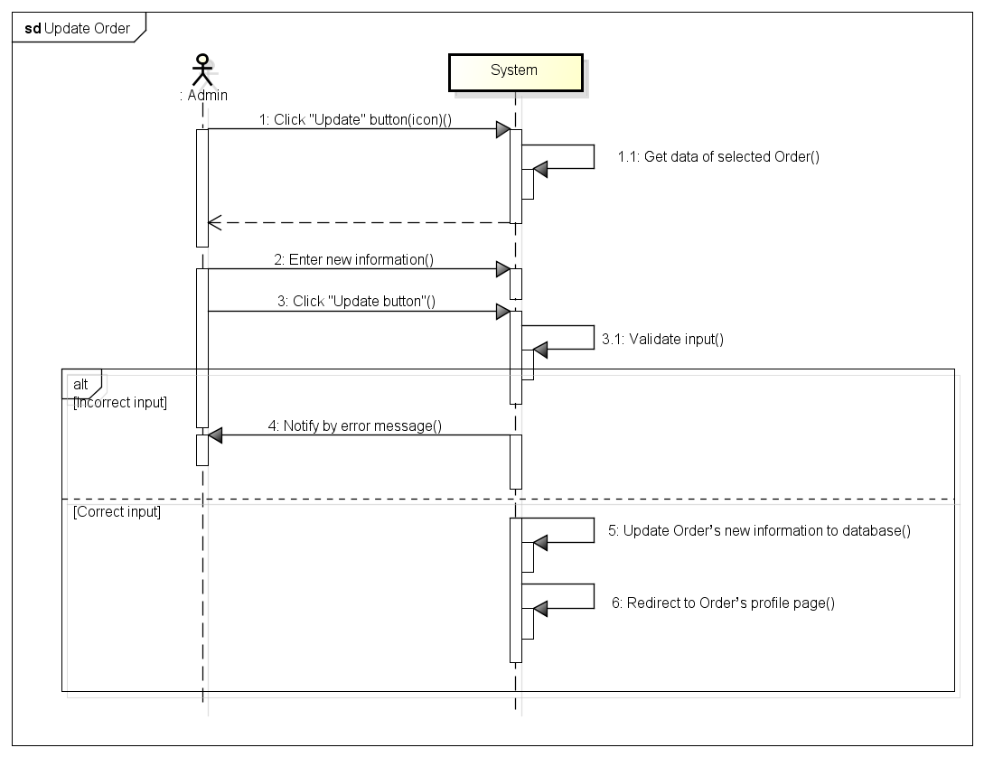

###### *UC- 122:* *Add new Order*

|  |  |  |  |  |
| --- | --- | --- | --- | --- |
| **Use Case ID:** | | UC-122 | | |
| **Use Case Name:** | | Add new Order | | |
| **Created By:** | | HoangNK | **Last Updated By:** | HoangNK |
| **Date Created:** | | 19/09/2015 | **Date Last updated:** | 19/09/2015 |
| **Actor:** | | Admin | | |
| **Description:** | | Admin creates new Order with related information | | |
| **Triggering Event:** | | Admin adds a new Order to system | | |
| **Preconditions:** | | Admin logged in to system | | |
| **Post conditions:** | | New Order is added to database | | |
| **Priority:** | | Low | | |
| **Frequency of Use:** | | Sometime | | |
| **Main flow** | | | | |
| Step | Actor | Action | | |
|  | Admin | Click “Order” button in left navigate bar | | |
|  | System | Display “Order” menu | | |
|  | Admin | Click “Add new Order” button | | |
|  | System | Display “Add new Order” form | | |
|  | Admin | Enter new Order’s information into fields | | |
|  | Admin | Click “Add” button to add new Order | | |
|  | System | Validate input | | |
|  | System | Add new Shipper to database then redirect to “Shipper’s List” page | | |
| **Alternative Flows:** | | N/A | | |
| **Exceptions:** | | | | |
| EC1 | At step 7, if any required field is not entered | | | |
| Step | Actor | Action | | |
| 7.1 | System | Notify in screen by error message “*is require” | | |
| EC2 | At step 8, if any entered field is incorrect format | | | |
| Step | Actor | Action | | |
| 7.2 | System | Notify by error message in screen | | |
| **Includes:** | | N/A | | |
| **Special Requirements:** | | * When Admin enters existed Store’s name, store’s address and phone will be generated automatically * The field with ‘*’ can’t be blank | | |
| **Notes and Issues:** | | N/A | | |

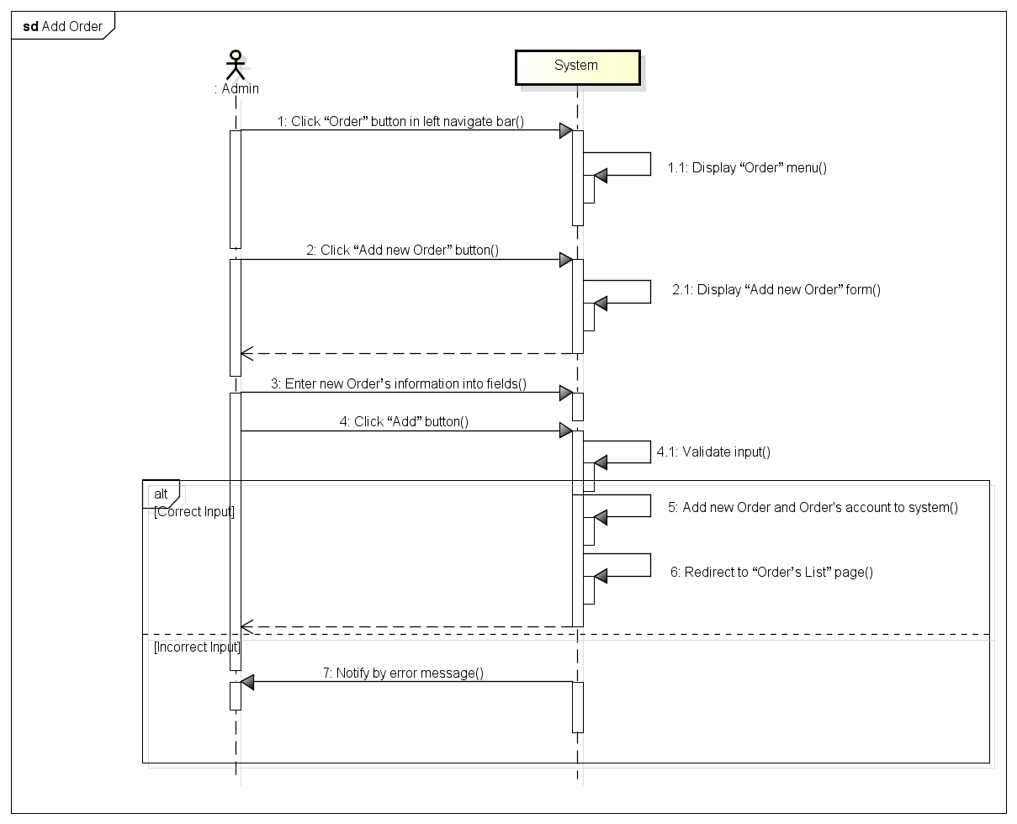

###### *UC- 123:* Export transaction

|  |  |  |  |  |
| --- | --- | --- | --- | --- |
| **Use Case ID:** | | UC-123 | | |
| **Use Case Name:** | | Export transaction | | |
| **Created By:** | | HoangNK | **Last Updated By:** | HoangNK |
| **Date Created:** | | 19/09/2015 | **Date Last updated:** | 19/09/2015 |
| **Actor:** | | Admin | | |
| **Description:** | | Admin wants to export transactions to pdf file | | |
| **Triggering Event:** | | Admin exports transactions to PDF file | | |
| **Preconditions:** | | Admin logged in to system | | |
| **Post conditions:** | | An PDF file is exported | | |
| **Priority:** | | Medium | | |
| **Frequency of Use:** | | Sometime | | |
| **Main flow** | | | | |
| Step | Actor | Action | | |
|  | Admin | Click “Print transaction” button in left navigate bar | | |
|  | System | Display “Print transaction” screen | | |
|  | Admin | Pick transaction which want to export then click “Export” button | | |
|  | System | Export these orders to PDF file | | |
| **Alternative Flows:** | | N/A | | |
| **Exceptions:** | | | | |
| EC1 | At step 3, if Admin doesn’t pick any order | | | |
| Step | Actor | Action | | |
| 3.1 | System | “Export” button isn’t active for click | | |
| **Includes:** | | N/A | | |
| **Special Requirements:** | | * Exported file must be in pdf format | | |
| **Notes and Issues:** | | N/A | | |

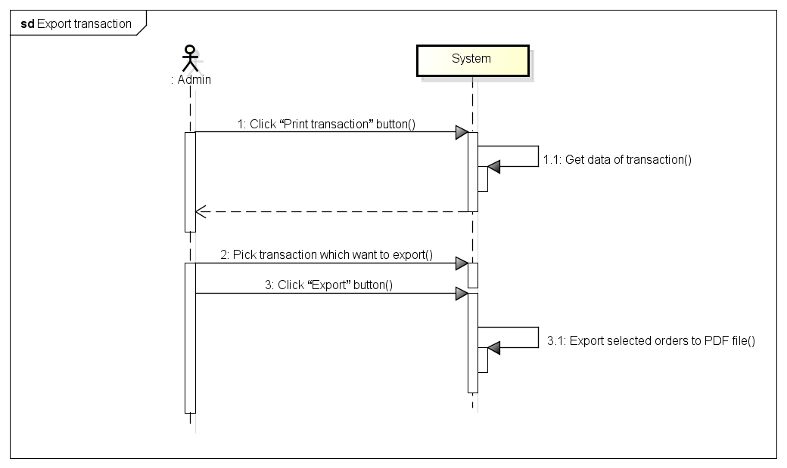

###### *UC- 124:* *Assign Task*

|  |  |  |  |  |
| --- | --- | --- | --- | --- |
| **Use Case ID:** | | UC-124 | | |
| **Use Case Name:** | | Assign Task | | |
| **Created By:** | | HoangNK | **Last Updated By:** | HoangNK |
| **Date Created:** | | 19/09/2015 | **Date Last updated:** | 19/09/2015 |
| **Actor:** | | Admin | | |
| **Description:** | | Admin divides orders to free Shipper | | |
| **Triggering Event:** | | Admin assigns task for Shipper | | |
| **Preconditions:** | | Admin logged in to system | | |
| **Post conditions:** | | Task is assigned for Shipper | | |
| **Priority:** | | High | | |
| **Frequency of Use:** | | Often | | |
| **Main flow** | | | | |
| Step | Actor | Action | | |
|  | Admin | Click “Shipper” button in left navigate bar | | |
|  | System | Display “Shipper” menu in left navigate bar | | |
|  | Admin | Click “Assign Task” button | | |
|  | System | Get data of Order and Shipper then display “Assign Task” screen | | |
|  | Admin | Pick a Shipper in Shipper’s list then pick Order for this Shipper in Order’s list then click “Assign” button | | |
|  | System | Hide picked orders from Order’s list and update Shipper’s information in database | | |
| **Alternative Flows:** | | **N/A** | | |
| **Exceptions:** | | | | |
| EC1 | At step 5, if Admin doesn’t pick any order | | | |
| Step | Actor | Action | | |
| 5.1 | System | Order isn’t active to pick and “Assign” button isn’t active to click | | |
| EC2 | At step 5, if Admin cancel a picked order | | | |
| Step | Actor | Action | | |
| 5.2 | System | Order is showed in order's list | | |
| **Includes:** | | N/A | | |
| **Special Requirements:** | | * Available Shippers are displayed in Shipper’s list * Available Orders are displayed in Order’s list | | |
| **Notes and Issues:** | | N/A | | |

*UC125 View dashboard*

|  |  |  |  |  |
| --- | --- | --- | --- | --- |
| **Use Case ID:** | | UC-125 | | |
| **Use Case Name:** | | View dashboard | | |
| **Created By:** | | HoangNK | **Last Updated By:** | HoangNK |
| **Date Created:** | | 19/09/2015 | **Date Last updated:** | 19/09/2015 |
| **Actor:** | | Admin | | |
| **Description:** | | Admin wants to view statistics | | |
| **Triggering Event:** | | Admin views dashboard | | |
| **Preconditions:** | | Admin logged in to system | | |
| **Post conditions:** | | Dashboard screen with statistics is displayed | | |
| **Priority:** | | Normal | | |
| **Frequency of Use:** | | Sometime | | |
| **Main flow** | | | | |
| Step | Actor | Action | | |
|  | Admin | Click “Dashboard” button in left navigate bar | | |
|  | System | Display “Dashboard” screen | | |
| **Alternative Flows:** | | N/A | | |
| **Exceptions:** | | N/A | | |
| **Includes:** | | N/A | | |
| **Special Requirements:** | | N/A | | |
| **Notes and Issues:** | | N/A | | |

## 1.2. Web application for Store

### 1.2.1. User Case Diagram

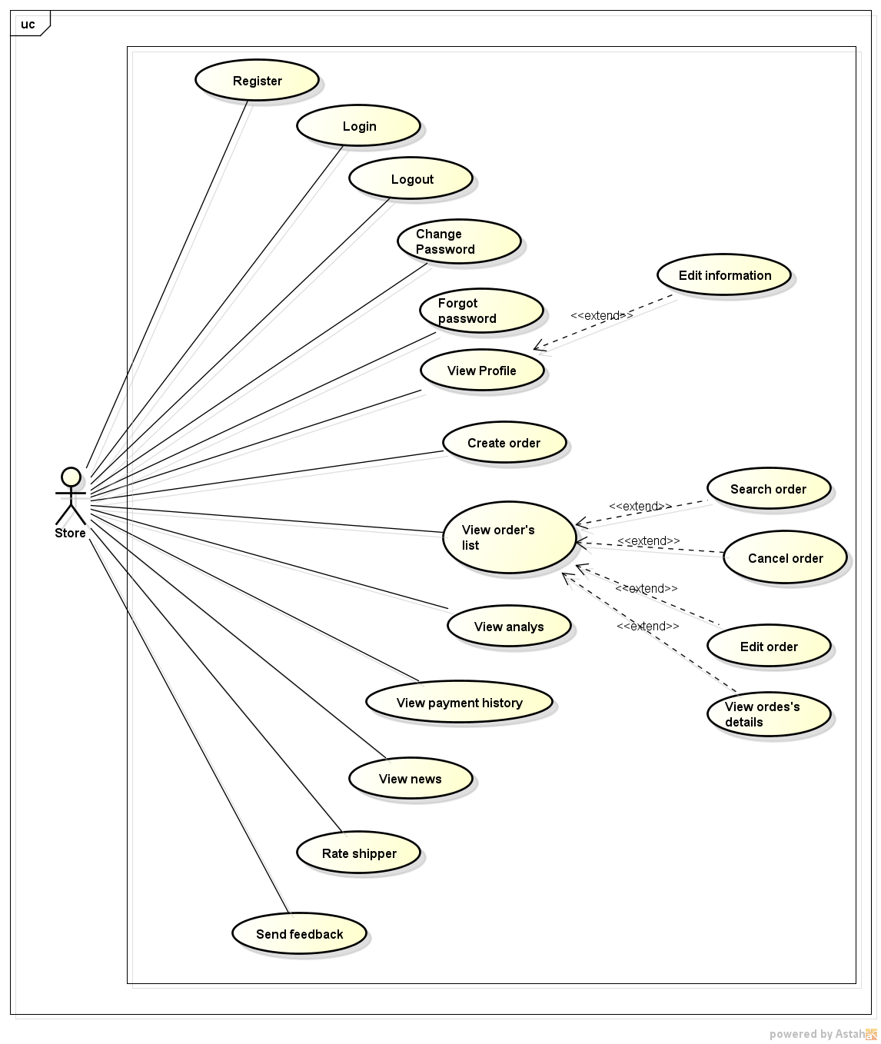

### 1.2.2. Function

###### *UC-201:* *Register*

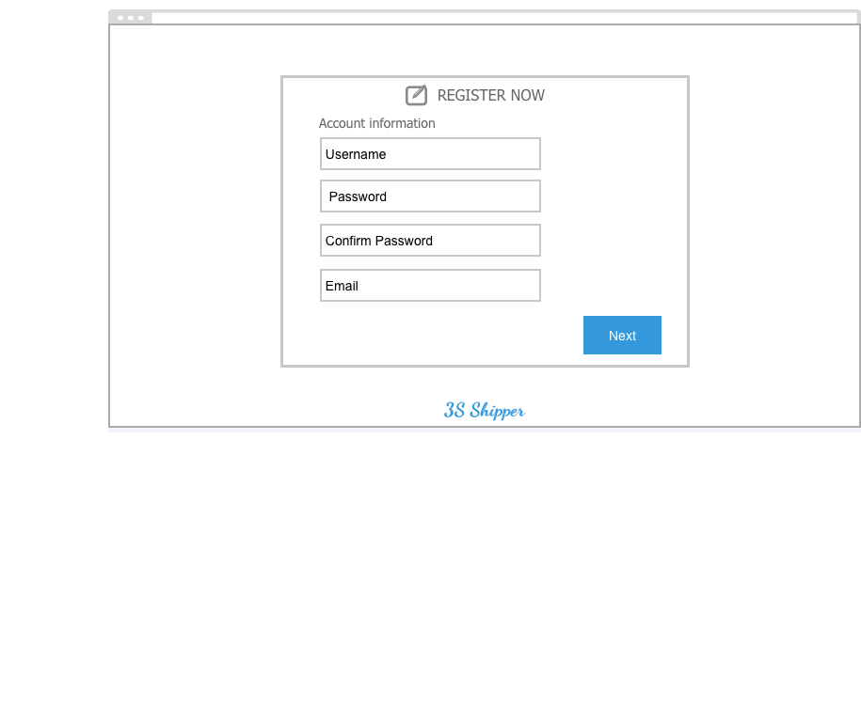

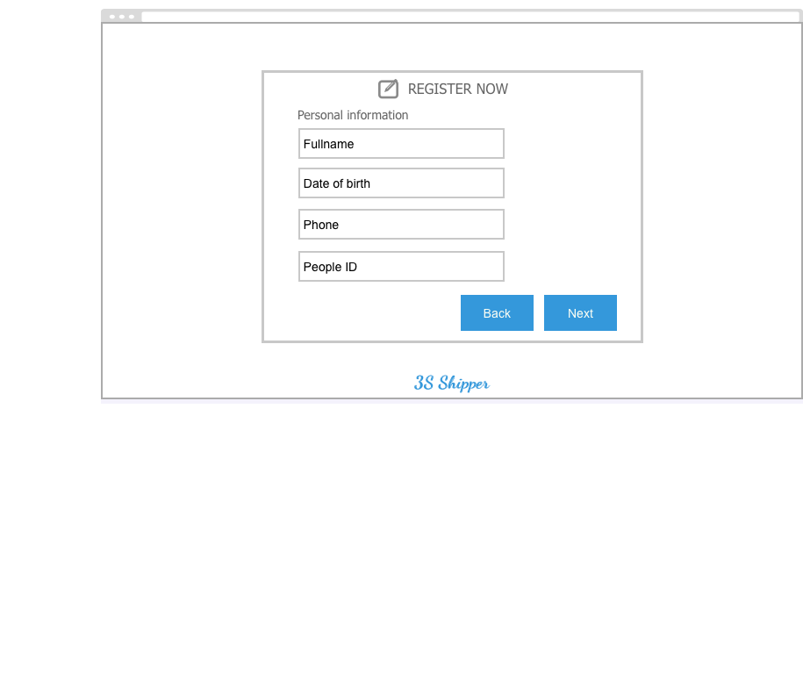

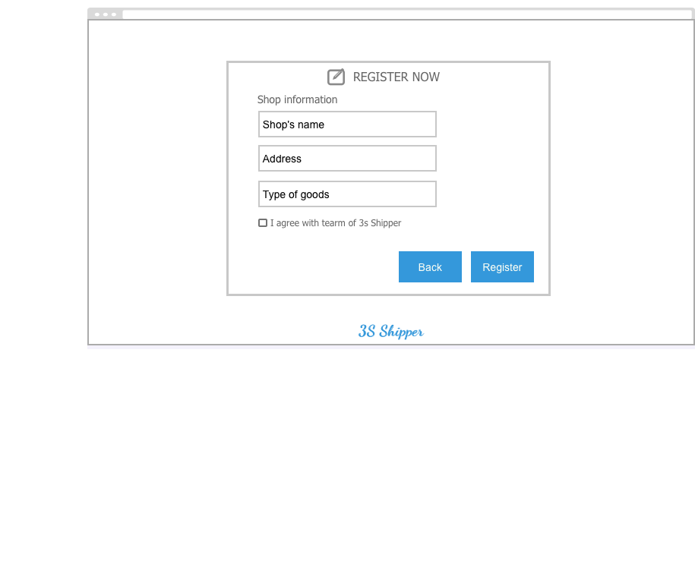

|  |  |  |  |  |
| --- | --- | --- | --- | --- |
| **Use Case ID:** | | UC-201 | | |
| **Use Case Name:** | | Register | | |
| **Created By:** | | KhanhKC | **Last Updated By:** | KhanhKC |
| **Date Created:** | | 19/09/2015 | **Date Last updated:** | 20/09/2015 |
| **Actor:** | | Guest | | |
| **Description:** | | Visitor can creates new account to use more function as a registered Store | | |
| **Triggering event:** | | Guest registers a new account. | | |
| **Preconditions:** | | Guest on 3S website | | |
| **Post conditions:** | | - Account’s information have been saved to database  - Confirm email have been send to Guest | | |
| **Priority:** | | Normal | | |
| **Frequency of Use:** | | Sometime | | |
| **Main flow** | | | | |
| Step | Actor | Action | | |
|  | Guest | Click “Register” | | |
|  | System | Displays “Register” screen includes:  - User name text box  - Password text box  - Full name  - Store name  - Store address  - Store’s goods  - Email text box  - Date of Birth date picker  - Phone number text box  - Register button  - Cancel button  - Terms hyperlink. | | |
|  | Guest | Enters data in fields | | |
|  | Guest | Clicks “Register” | | |
|  | System | Validate entered data. | | |
|  | System | Sends confirm email to Guest | | |
|  | System | Display “Confirm Registered” message. | | |
| **Alternative Flows:** | | N/A | | |
| **Exceptions:** | | | | |
| EC1 | At step 4, Store click “Cancel” button | | | |
| Step | Actor | Action | | |
| 4.1 | System | Displays “Confirm” popup | | |
| 4.2 | Store | Clicks “Yes” button | | |
| 4.3 | System | Displays “Homepage” for Guest | | |
| EC2 | At step 4.2, Store click on “No” button. | | | |
| Step | Actor | Action | | |
| 4.2.1 | System | Closes popup. | | |
| EC3 | At step 4, required fields are not entered | | | |
| Step | Actor | Action | | |
| 4.1 | System | Displays “Register” screen with error message “*is require” | | |
| EC4 | At step 5, entered data are wrong type of data | | | |
| Step | Actor | Action | | |
| 4.1 | System | Displays “Register” screen with error message. | | |
| **Includes:** | | N/A | | |
| **Special Requirements:** | | * Username must not yet exist in database. * Length of password must between 6 and 10. * Email must be under the standard format. | | |
| **Notes and Issues:** | | N/A | | |

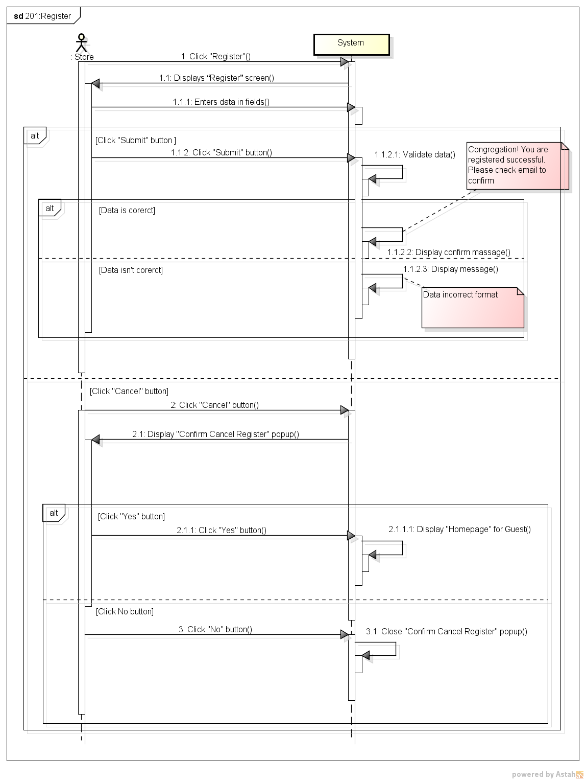***Sequence Diagram***

###### *UC-202:* *Login*

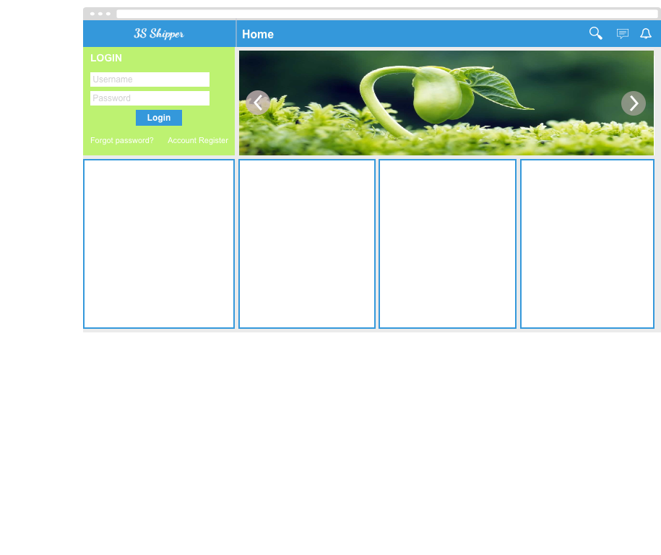

|  |  |  |  |  |
| --- | --- | --- | --- | --- |
| **Use Case ID:** | | UC-202 | | |
| **Use Case Name:** | | Login | | |
| **Created By:** | | KhanhKC | **Last Updated By:** | KhanhKC |
| **Date Created:** | | 19/09/2015 | **Date Last Updated:** | 20/09/2015 |
| **Actor:** | | Store | | |
| **Description:** | | Store logins to 3S system to use functions of system. | | |
| **Triggering event:** | | Store logins to system. | | |
| **Preconditions:** | | Store on the “Homepage” of 3S website  Store account must be exits | | |
| **Post conditions:** | | Logs Store into system  Redirects Store to “Homepage” screen (Refer to UC-218: View Homepage) and display as Store | | |
| **Priority:** | | High | | |
| **Frequency of Use:** | | Sometime | | |
| **Main flow** | | | | |
| Step | Actor | Action | | |
|  | Store | Enters User name and Password | | |
|  | Store | Clicks “Login” | | |
|  | System | Check “Username” and “Password” in database. | | |
|  | System | Logs Store into system | | |
|  | System | Redirects Store to “Homepage” screen and display as Store | | |
| **Alternative:** | | | | |
| **Exceptions:** | | | | |
| EC2 | At step 4 in the main flows, if Store click other hyperlinks | | | |
| Step | Actor | Action | | |
| 3.1 | System | Redirects Store to chosen hyperlink | | |
| EC3 | At step 4 in main flow, if Store entered wrong User name or Password | | | |
| Step | Actor | Action | | |
| 3.1 | System | Displays message “Username or Password is wrong” | | |
| **Includes:** | | N/A | | |
| **Special Requirements:** | | N/A | | |
| **Notes and Issues:** | | N/A | | |

***Sequence Diagram***

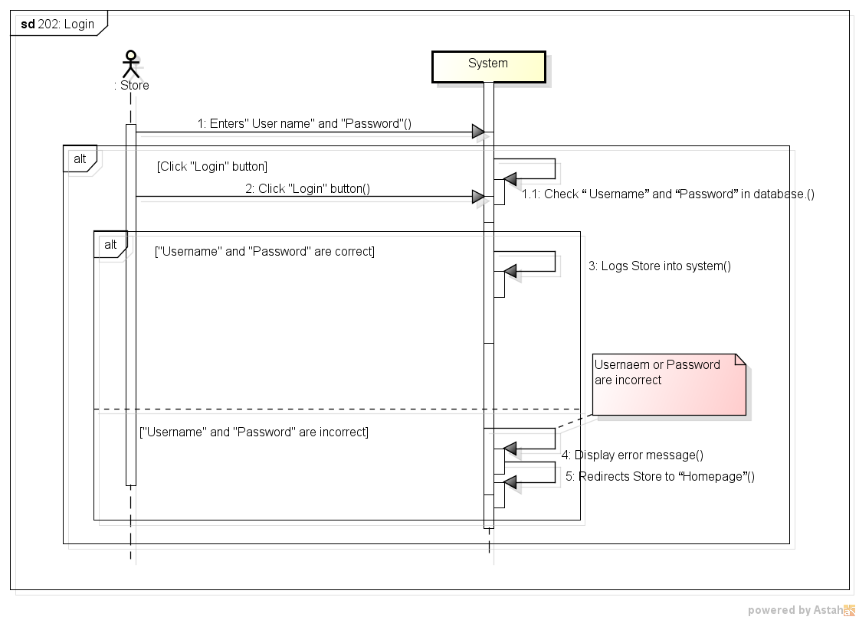

###### *UC-203:* *Logout*

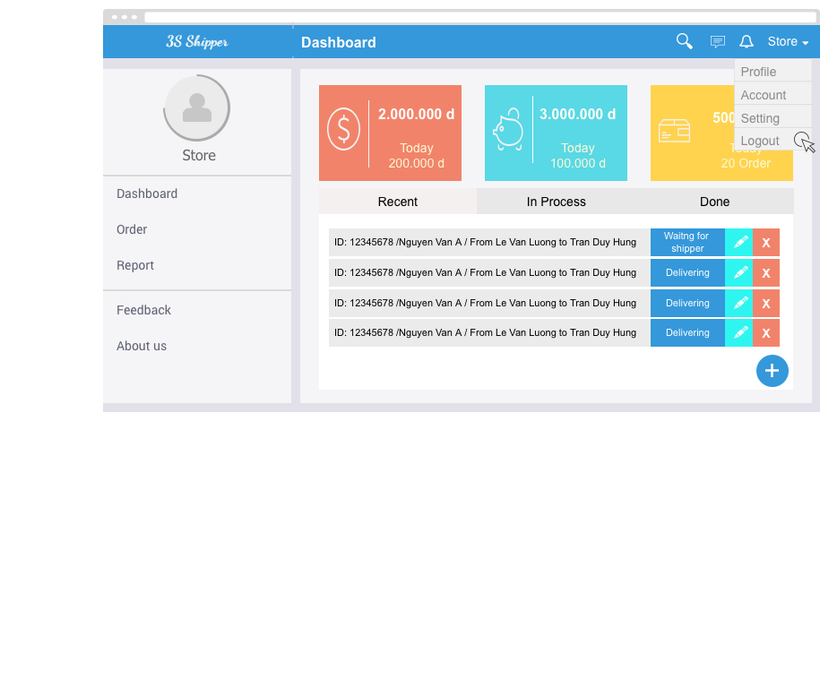

|  |  |  |  |  |
| --- | --- | --- | --- | --- |
| **Use Case ID:** | | UC-203 | | |
| **Use Case Name:** | | Logout | | |
| **Created By:** | | KhanhKC | **Last Updated By:** | KhanhKC |
| **Date Created:** | | 19/09/2015 | **Date Last updated:** | 20/09/2015 |
| **Actor:** | | Store | | |
| **Description:** | | When Store wants to logout their account | | |
| **Triggering event:** | | Store logout from system. | | |
| **Preconditions:** | | Store logged in to system | | |
| **Post conditions:** | | Log Store out from system.  Redirect Store to “Login” screen | | |
| **Priority:** | | High | | |
| **Frequency of Use:** | | Often | | |
| **Main flow** | | | | |
| Step | Actor | Action | | |
|  | Store | Click Logout | | |
|  | System | Logout Store from system | | |
|  | System | Display Homepage for Guest | | |
| **Alternative Flows:** | | | | |
| **Exceptions:** | | N/A | | |
| **Includes:** | | N/A | | |
| **Special Requirements:** | | N/A | | |
| **Notes and Issues:** | | N/A | | |

***Sequence Diagram***

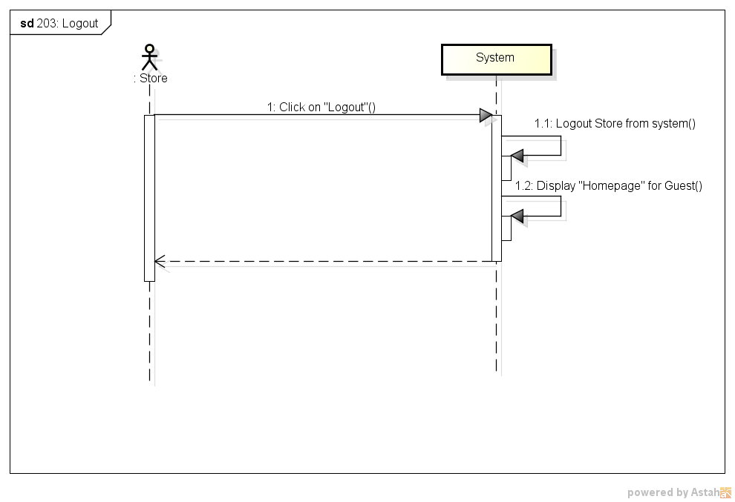

*UC-204:* *Change password*

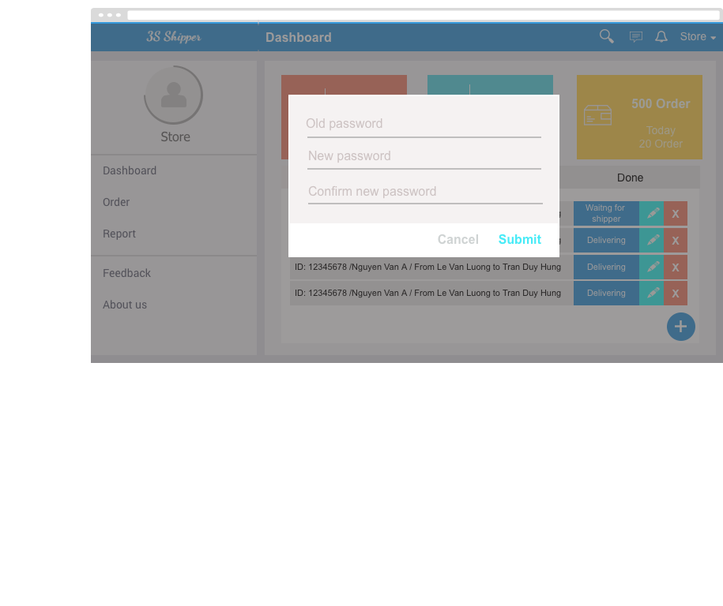

|  |  |  |  |  |
| --- | --- | --- | --- | --- |
| **Use Case ID:** | | UC-204 | | |
| **Use Case Name:** | | Change password | | |
| **Created By:** | | KhanhKC | **Last Updated By:** | KhanhKC |
| **Date Created:** | | 19/09/2015 | **Date Last updated:** | 20/09/2015 |
| **Actor:** | | Store | | |
| **Description:** | | Store want to change login password. | | |
| **Triggering event:** | | Store change password. | | |
| **Preconditions:** | | Store logged in to system | | |
| **Post conditions:** | | New password has been saved in database. | | |
| **Priority:** | | High | | |
| **Frequency of Use:** | | Sometime | | |
| **Main flow** | | | | |
| Step | Actor | Action | | |
|  | Store | Click “Change password” | | |
|  | System | Display “Change password” screen includes:  - Old password text box  - New password text box  - Confirm new password text box  - Submit button | | |
|  | Store | Enters data in fields | | |
|  | Store | Click “Submit” button | | |
|  | System | Validate data | | |
|  | System | Display “Change password” screen with message “ Change password successful” | | |
| **Alternative Flows:** | | N/A | | |
| **Exceptions:** | | | | |
| EC1 | At step 2, required fields are not entered | | | |
| Step | Actor | Action | | |
| 4.1 | System | Display “Change password” screen with error message “*is require” | | |
| EC2 | At step 2, “Old password” is incorrect | | | |
| Step | Actor | Action | | |
| 4.1 | System | Display “Change password” screen with error message: “Old password is incorrect” | | |
| EC3 | At step 2, confirm new password is not the same with new password | | | |
| Step | Actor | Action | | |
| 4.1 | System | Display “Change password” screen with error message.” Confirm new password is not the same with new password. Please enter again!” | | |
| **Includes:** | | N/A | | |
| **Special Requirements:** | | Length of “New password” must between 6 and 10. | | |
| **Notes and Issues:** | | N/A | | |

***Sequence Diagram***

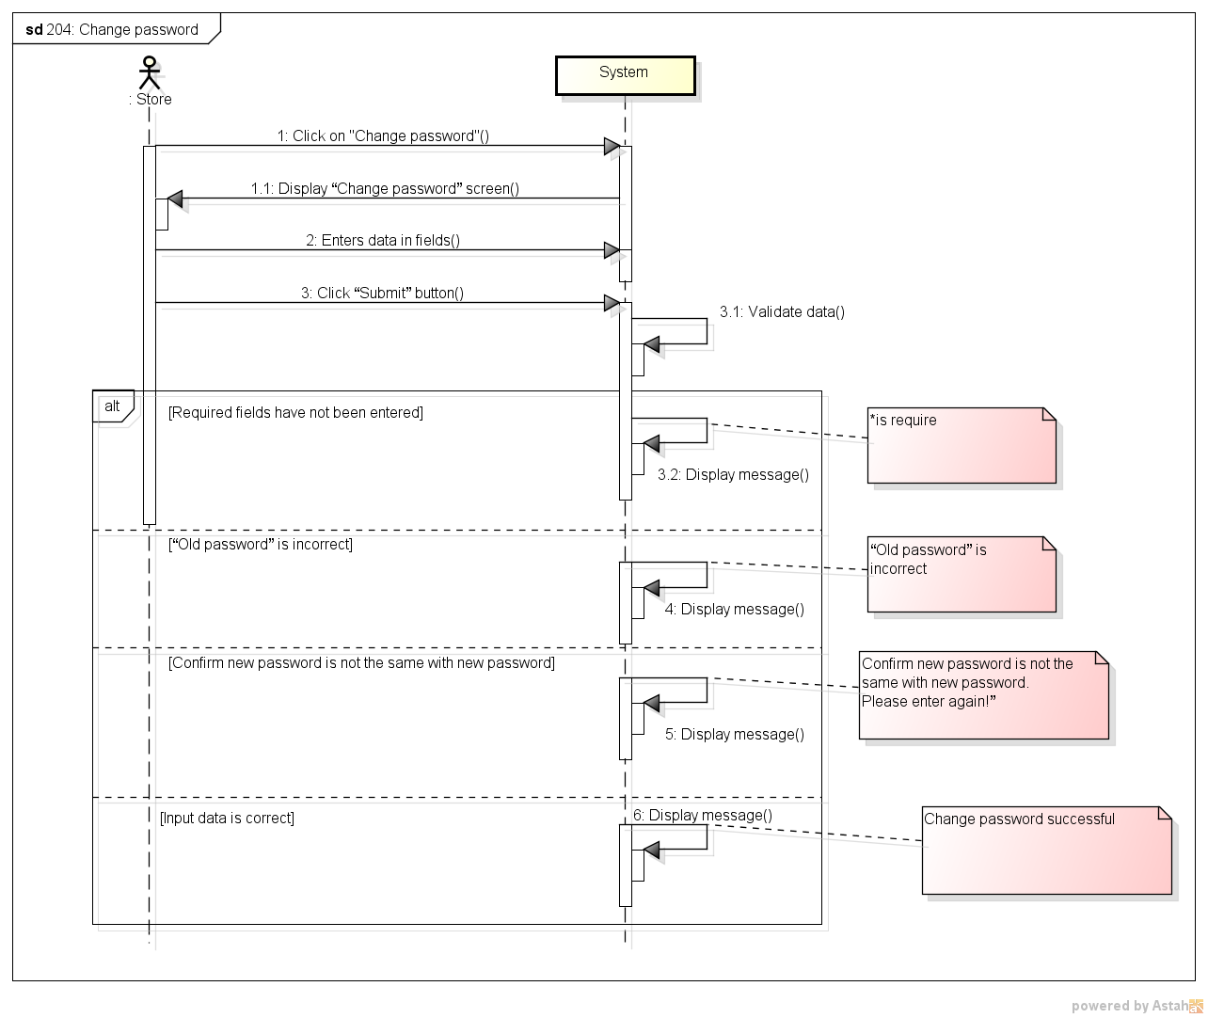

###### *UC-205:* *Forgot password*

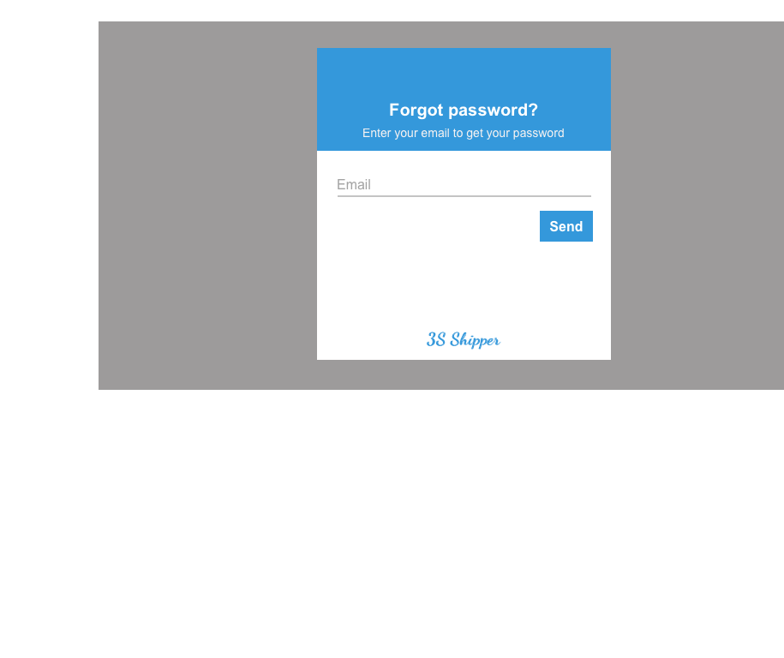

|  |  |  |  |  |
| --- | --- | --- | --- | --- |
| **Use Case ID:** | | UC-205 | | |
| **Use Case Name:** | | Forgot password | | |
| **Created By:** | | KhanhKC | **Last Updated By:** | KhanhKC |
| **Date Created:** | | 19/09/2015 | **Date Last updated:** | 20/09/2015 |
| **Actor:** | | Store | | |
| **Description:** | | This function help store receive their login password when they forgot. | | |
| **Triggering event:** | | Store request system to receive new password. | | |
| **Preconditions:** | | Store on the “Login” popup (Refer to UC-202: Login) | | |
| **Post conditions:** | | - A new password has been updated for Store  - An email has been send to registered email of Store include new password. | | |
| **Priority:** | | High | | |
| **Frequency of Use:** | | Sometime | | |
| **Main flow** | | | | |
| Step | Actor | Action | | |
|  | Store | Click “Forgot password” hyperlink on “Login” popup | | |
|  | System | Display “Forgot” popup includes:  - Email text box  - Submit button | | |
|  | Guest | Enters registered email. | | |
|  | Guest | Click “Submit” button | | |
|  | System | Update a new password for Store | | |
|  | System | Send confirm email with a new password to registered email of Store | | |
| **Alternative Flows:** | | N/A | | |
| **Exceptions:** | | | | |
| EC1 | At step 3, email are not a registered email | | | |
| Step | Actor | Actor | | |
| 4.1 | System | Displays error message:” Email is not exist” | | |
| **Includes:** | | N/A | | |
| **Special Requirements:** | | N/A | | |
| **Notes and Issues:** | | N/A | | |

***Sequence Diagram***

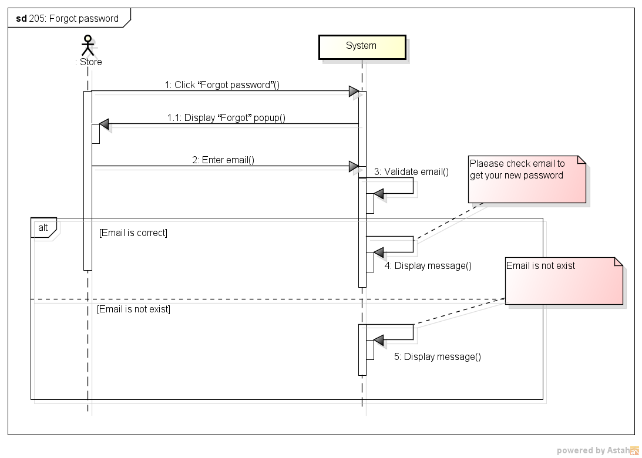

###### *UC-206:* *View profile*

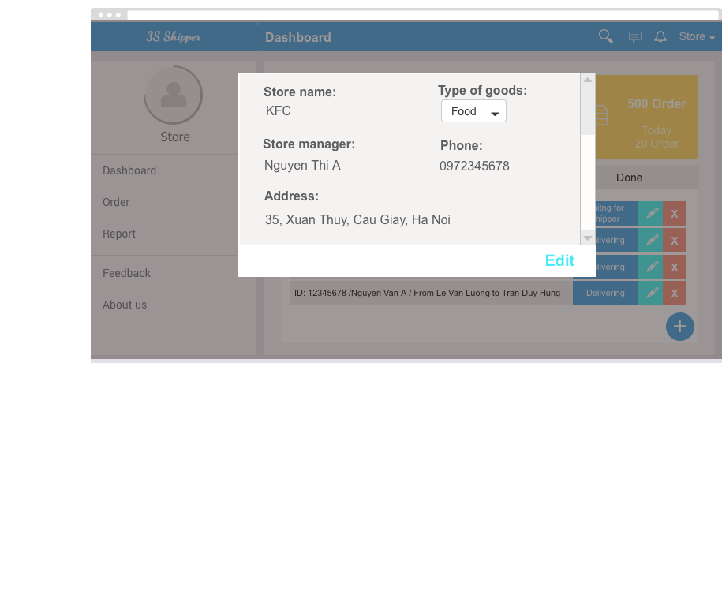

|  |  |  |  |  |
| --- | --- | --- | --- | --- |
| **Use Case ID:** | | UC-206 | | |
| **Use Case Name:** | | View profile | | |
| **Created By:** | | KhanhKC | **Last Updated By:** | KhanhKC |
| **Date Created:** | | 19/09/2015 | **Date Last updated:** | 20/09/2015 |
| **Actor:** | | Store | | |
| **Description:** | | Help Store view their own personal information. | | |
| **Triggering event:** | | Store view profile. | | |
| **Preconditions:** | | Store logged into system. | | |
| **Post conditions:** | | “Profile” screen are displayed. | | |
| **Priority:** | | Normal | | |
| **Frequency of Use:** | | Sometime | | |
| **Main flow** | | | | |
| Step | Actor | Action | | |
|  | Store | Click on “Store name” at top-right of 3S website. | | |
|  | System | Display “Profile” screen includes details information of Store | | |
| **Alternative Flows:** | | N/A | | |
| **Exceptions:** | | N/A | | |
| **Includes:** | | N/A | | |
| **Special Requirements:** | | N/A | | |
| **Notes and Issues:** | | N/A | | |

***Sequence Diagram***

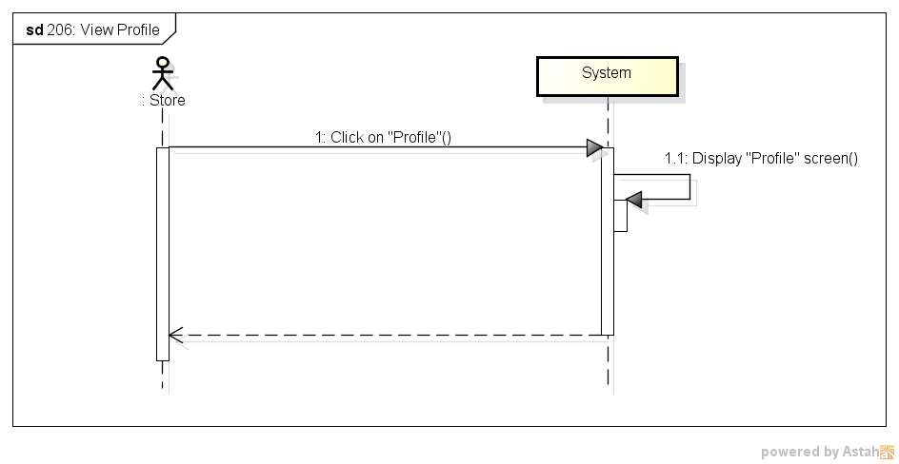

###### *UC-207:* *Edit profile*

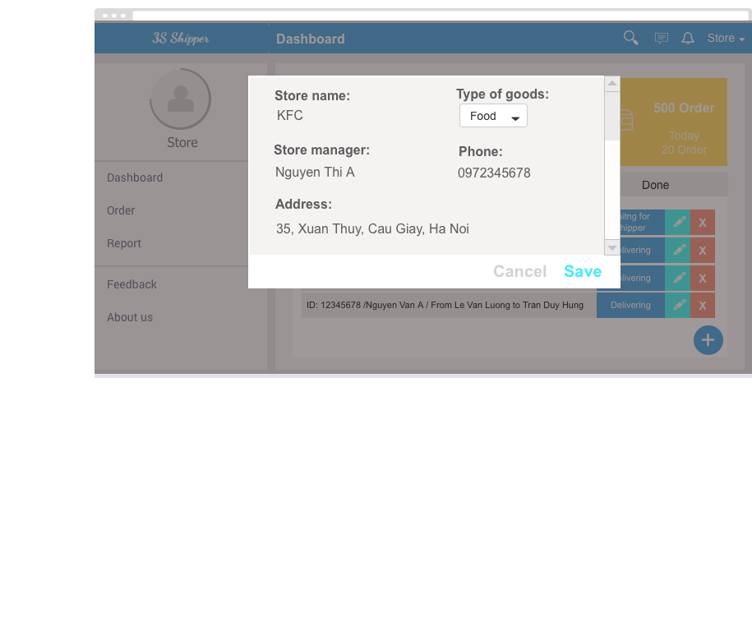

|  |  |  |  |  |
| --- | --- | --- | --- | --- |
| **Use Case ID:** | | UC-207 | | |
| **Use Case Name:** | | Edit profile | | |
| **Created By:** | | KhanhKC | **Last Updated By:** | KhanhKC |
| **Date Created:** | | 19/09/2015 | **Date Last updated:** | 20/09/2015 |
| **Actor:** | | Store | | |
| **Description:** | | Help stores edit their own profile. | | |
| **Triggering event:** | | Store edit profile. | | |
| **Preconditions:** | | Store are on “Profile” screen | | |
| **Post conditions:** | | New profile have been display on “Profile screen” and saved in database. | | |
| **Priority:** | | Normal | | |
| **Frequency of Use:** | | Sometime | | |
| **Main flow** | | | | |
| Step | Actor | Action | | |
|  | Store | Click “Edit profile” button on “Profile” screen | | |
|  | System | Enable fields on profile screen. | | |
|  | Store | Enters data in fields | | |
|  | Store | Click “Submit” button | | |
|  | System | Validate entered data. | | |
|  | System | Update data to database | | |
|  | System | Display “View Profile” screen. (Refer to UC-206: View Profile” | | |
| **Alternative Flows:** | | N/A | | |
| **Exceptions:** | | | | |
| EC1 | At step 3, require fields are empty | | | |
| Step | Actor | Action | | |
| 4.1 | System | Display “Edit profile” screen with error message: “* is require” | | |
| EC2 | At step 4, Store click “Cancel” button | | | |
| Step | Actor | Action | | |
| 4.1 | System | Display “View profile” screen (Refer to UC-206: View Profile” | | |
| **Includes:** | | N/A | | |
| **Special Requirements:** | | N/A | | |
| **Notes and Issues:** | | N/A | | |

***Sequence Diagram***

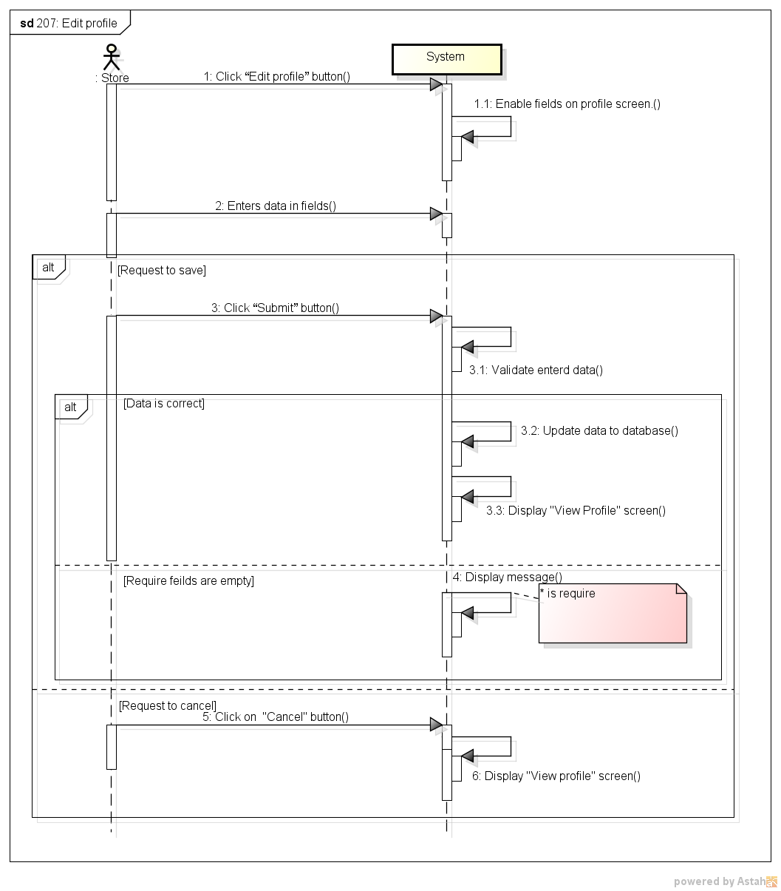

###### *UC-208:* *Create order*

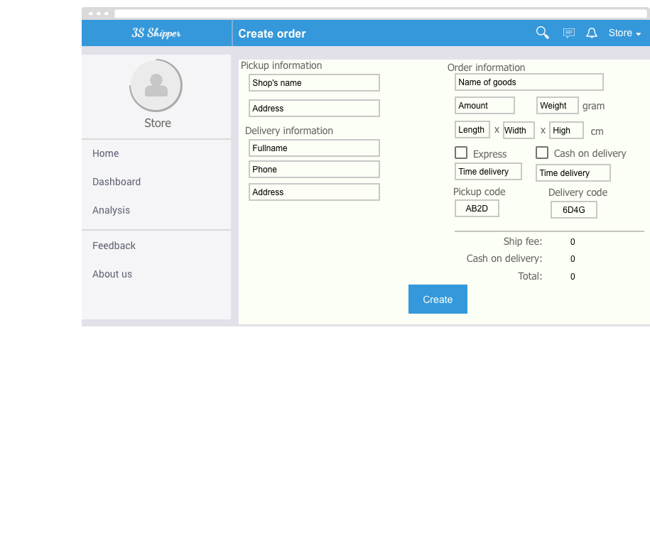

|  |  |  |  |  |
| --- | --- | --- | --- | --- |
| **Use Case ID:** | | UC-208 | | |
| **Use Case Name:** | | Create order | | |
| **Created By:** | | KhanhKC | **Last Updated By:** | KhanhKC |
| **Date Created:** | | 19/09/2015 | **Date Last updated:** | 20/09/2015 |
| **Actor:** | | Store | | |
| **Description:** | | Store create order to request delivery service from system | | |
| **Triggering event:** | | Store create new order. | | |
| **Preconditions:** | | Store are logged into system. | | |
| **Post conditions:** | | Order information have been send to system and saved to database. | | |
| **Priority:** | | High | | |
| **Frequency of Use:** | | Always | | |
| **Main flow** | | | | |
| Step | Actor | Action | | |
|  | Store | Click “Create order” button | | |
|  | System | Display “Create order” screen includes:  - “From” text box  - “Pick up locations” text box  - “To” text box  - “Delivery address” text box  - “Phone” text box  - “Weight” text box  - “Size” text box  - “Vehicle” drop down list  - “Express” checkbox  - “Time delivery” text box  - “Cash on delivery” check box  - “ Amount of money” text box  - “Submit” button  - “Cancel” button | | |
|  | Store | Enters data in fields | | |
|  | Store | Click “Submit” button | | |
|  | System | Display “Order details” screen (Refer to UC-213: Order’s details) | | |
| **Alternative Flows:** | | | | |
| AT1 | At step 3, Store check on “Express” check box. | | | |
| Step | Actor | Action | | |
| 3.1 | System | Disable “Time delivery” text box | | |
| **Exceptions:** | | | | |
| EC1 | At step 4, required fields are empty | | | |
| Step | Actor | Action | | |
| 4.1 | System | Display Register screen with error message “*is require” | | |
| EC3 | At step 4, Store click “Cancel” button | | | |
| Step | Actor | Action | | |
| 4.1 | System | Redirects Store to “Order’s list screen | | |
| **Includes:** | | N/A | | |
| **Special Requirements:** | | N/A | | |
| **Notes and Issues:** | | N/A | | |

***Sequence Diagram***

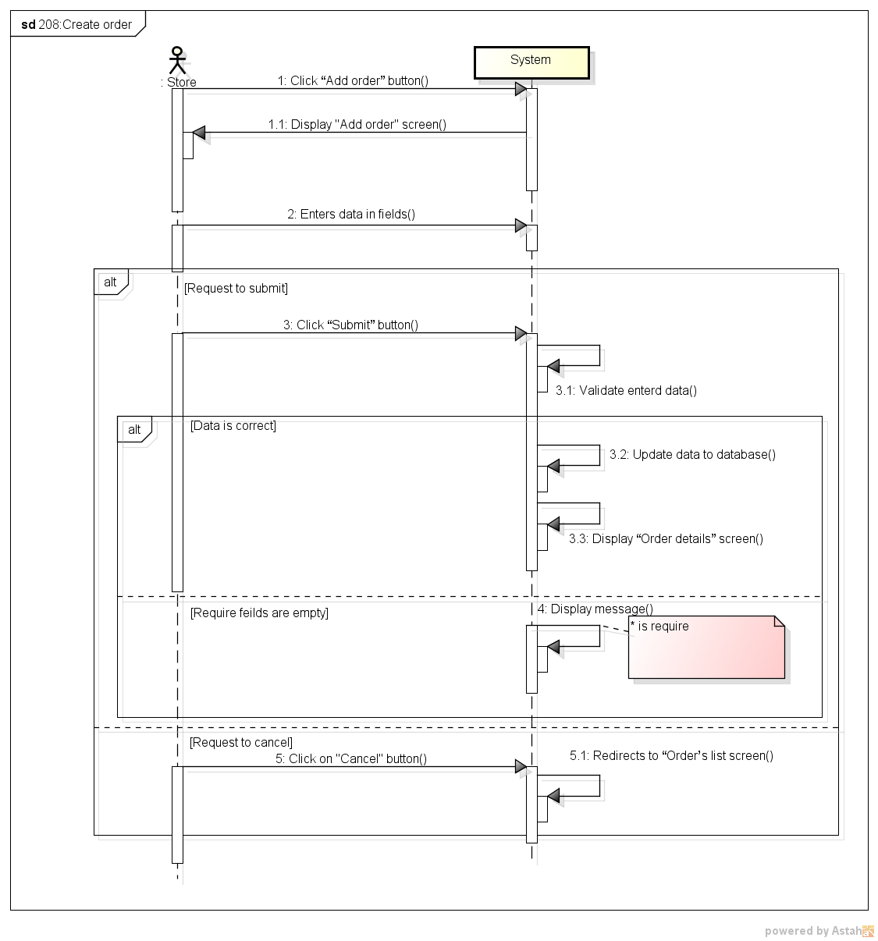

###### *UC-209:* *View order’s list*

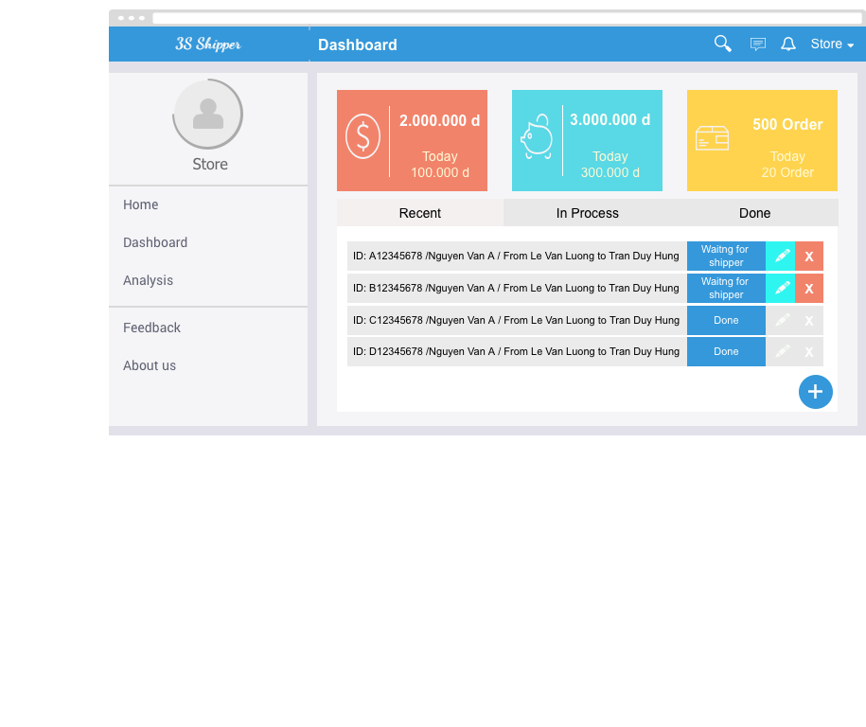

|  |  |  |  |  |
| --- | --- | --- | --- | --- |
| **Use Case ID:** | | UC-209 | | |
| **Use Case Name:** | | View order’s list | | |
| **Created By:** | | KhanhKC | **Last Updated By:** | KhanhKC |
| **Date Created:** | | 19/09/2015 | **Date Last updated:** | 20/09/2015 |
| **Actor:** | | Store | | |
| **Description:** | | Display list of all order created by Store. | | |
| **Triggering event:** | | Store view list of order. | | |
| **Preconditions:** | | Store logged into system. | | |
| **Post conditions:** | | “Order’s list” screen are displayed. | | |
| **Priority:** | | High | | |
| **Frequency of Use:** | | Always | | |
| **Main flow** | | | | |
| Step | Actor | Action | | |
|  | Store | Click on “Order’s list” menu | | |
|  | System | Display “Order’s list” screen | | |
| **Alternative Flows:** | | N/A | | |
| **Exceptions:** | | N/A | | |
| **Includes:** | | N/A | | |
| **Special Requirements:** | | N/A | | |
| **Notes and Issues:** | | N/A | | |

***Sequence Diagram***

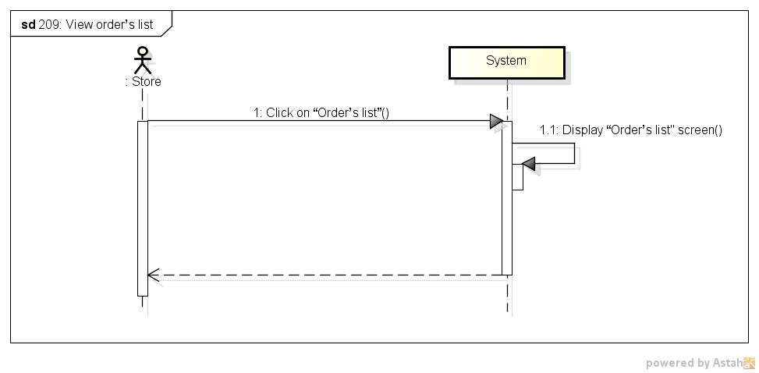

###### *UC-210:* *Search orders*

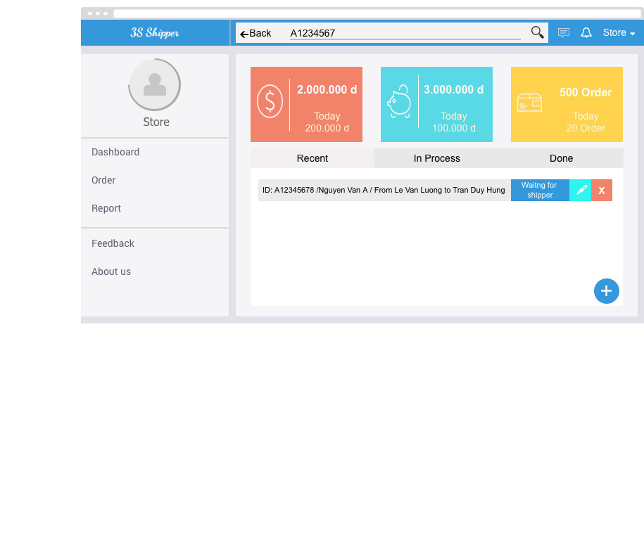

|  |  |  |  |  |
| --- | --- | --- | --- | --- |
| **Use Case ID:** | | UC-210 | | |
| **Use Case Name:** | | Search orders | | |
| **Created By:** | | KhanhKC | **Last Updated By:** | KhanhKC |
| **Date Created:** | | 19/09/2015 | **Date Last updated:** | 20/09/2015 |
| **Actor:** | | Store | | |
| **Description:** | | Display orders by code. | | |
| **Triggering event:** | | Search order | | |
| **Preconditions:** | | Store on “Order’s list” screen. (Refer to UC-209: View order’s list) | | |
| **Post conditions:** | | Searched result are displayed on screen. | | |
| **Priority:** | | High | | |
| **Frequency of Use:** | | Often | | |
| **Main flow** | | | | |
| Step | Actor | Action | | |
|  | Store | Click on “Search” button | | |
|  | Store | Input code | | |
|  | Store | Click on “Search” button | | |
|  | System | Display searched result on screen. | | |
| **Alternative Flows:** | | N/A | | |
| **Exceptions:** | | N/A | | |
| **Includes:** | | N/A | | |
| **Special Requirements:** | | N/A | | |
| **Notes and Issues:** | | N/A | | |

***Sequence Diagram***

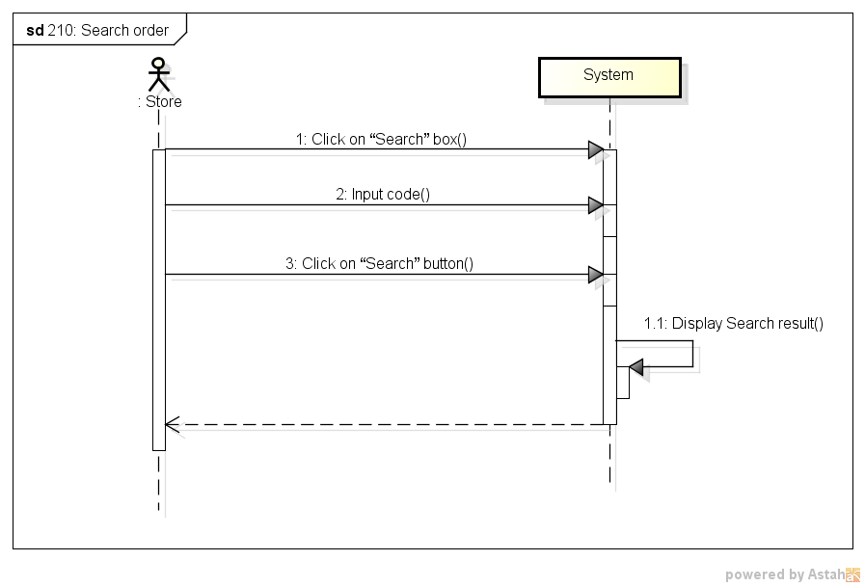

###### *UC-211:* *Cancel order*

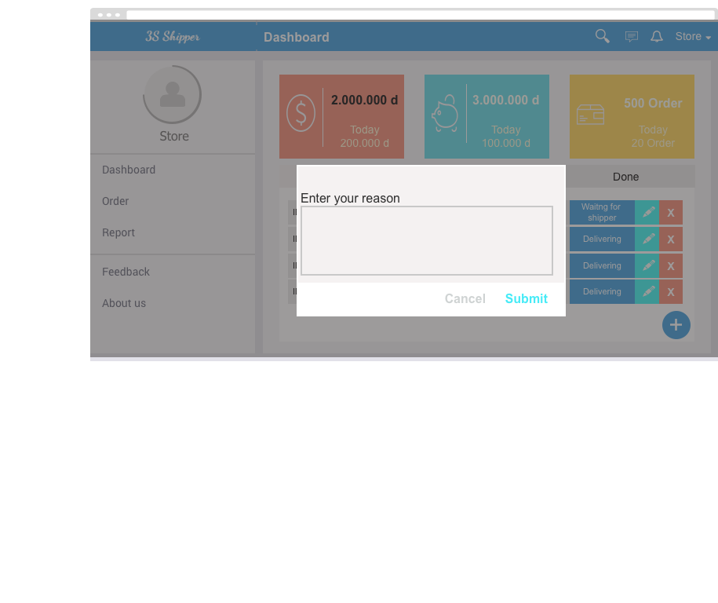

|  |  |  |  |  |
| --- | --- | --- | --- | --- |
| **Use Case ID:** | | UC-211 | | |
| **Use Case Name:** | | Cancel order | | |
| **Created By:** | | KhanhKC | **Last Updated By:** | KhanhKC |
| **Date Created:** | | 19/09/2015 | **Date Last updated:** | 20/09/2015 |
| **Actor:** | | Store | | |
| **Description:** | | Help Stores cancel uncompleted orders. | | |
| **Triggering event:** | |  | | |
| **Preconditions:** | | Store are on “Order’s list” screen (Refer to UC-209: View order’s list) | | |
| **Post conditions:** | | - Order status has been changed to “Cancel”  - Order information has been updated to database. | | |
| **Priority:** | | Normal | | |
| **Frequency of Use:** | | Sometime | | |
| **Main flow** | | | | |
| Step | Actor | Action | | |
|  | Store | Click “X” button on the row contain order brief information. | | |
|  | System | Display “Confirm Cancel” popup | | |
|  | Store | Enter cancel reason | | |
|  | Store | Click “Submit” button | | |
|  | System | Change status of order to “Cancel” | | |
| **Alternative Flows:** | | N/A | | |
| **Exceptions:** | | | | |
| EC1 | At step 4, Store click “Cancel” button | | | |
| Step | Actor | Action | | |
| 3.1 | System | Close popup | | |
| EC1 | At step 3, Store enter nothing. | | | |
| Step | Actor | Action | | |
| 3.1 | System | Display error message on “Confirm Cancel” popup: “Please enter your reason” | | |
| **Includes:** | | N/A | | |
| **Special Requirements:** | | N/A | | |
| **Notes and Issues:** | | N/A | | |

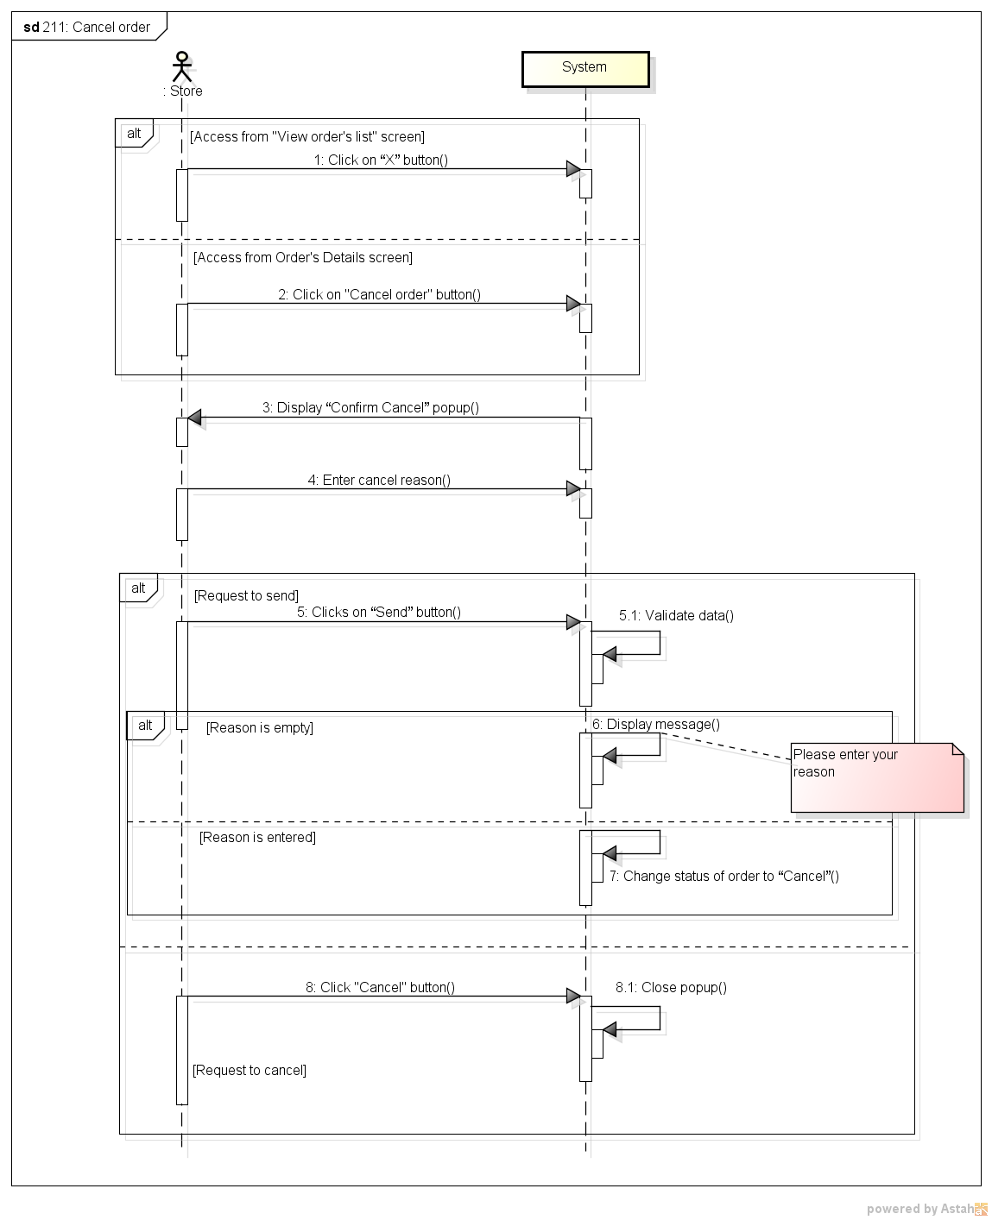

###### *UC-212:* *Edit Order*

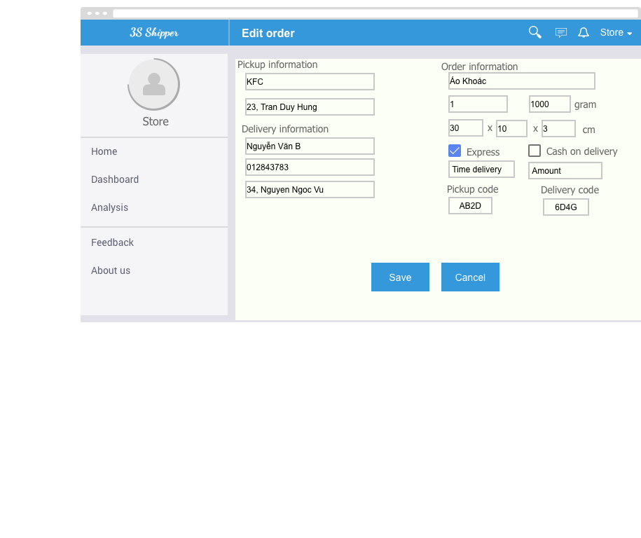

|  |  |  |  |  |
| --- | --- | --- | --- | --- |
| **Use Case ID:** | | UC-212 | | |
| **Use Case Name:** | | Edit Order | | |
| **Created By:** | | KhanhKC | **Last Updated By:** | KhanhKC |
| **Date Created:** | | 19/09/2015 | **Date Last updated:** | 20/09/2015 |
| **Actor:** | | Store | | |
| **Description:** | | Store can edits information of orders. | | |
| **Triggering event:** | | Store edits order | | |
| **Preconditions:** | | Store are on “Order’s list” screen or Store are on “Order details” screen. (Refer to UC-209: View order’s list) | | |
| **Post conditions:** | | New Order information have been display on details screen and updated in database. | | |
| **Priority:** | | High | | |
| **Frequency of Use:** | | Often | | |
| **Main flow** | | | | |
| Step | Actor | Action | | |
|  | Store | Click “Edit” button on the row contain order information. | | |
|  | System | Display “Order details” screen:  - “Start address” text box  - “Finish address” text box  - “Weight” text box  - “Size” text box  - “Vehicle” drop down list  - “Express” checkbox  - “Time delivery” text box  - “Submit” button | | |
|  | Store | Enters data in fields | | |
|  | Store | Click “Submit” button | | |
|  | System | Display “Order details” with updated information. | | |
| **Alternative Flows:** | | | | |
| AT1 | At step 1, Store click on “Edit” button on “Order details” screen. | | | |
| Step | Actor | Action | | |
| 1.1 | System | Change fields on “Order details” to editable. | | |
| 1.2 | Go to “Step 2” | | | |
| **Exceptions:** | | | | |
| EC1 | At step 3, require fields are empty | | | |
| Step | Actor | Action | | |
| 4.1 | System | Display “Edit Order” screen with error message: “* is require” | | |
| EC2 | At step 4, Store click “Cancel” button | | | |
| Step | Actor | Action | | |
| 4.1 | System | Display “View profile” screen (Refer to UC-206: View Profile” | | |
| **Includes:** | | N/A | | |
| **Special Requirements:** | | N/A | | |
| **Notes and Issues:** | | N/A | | |

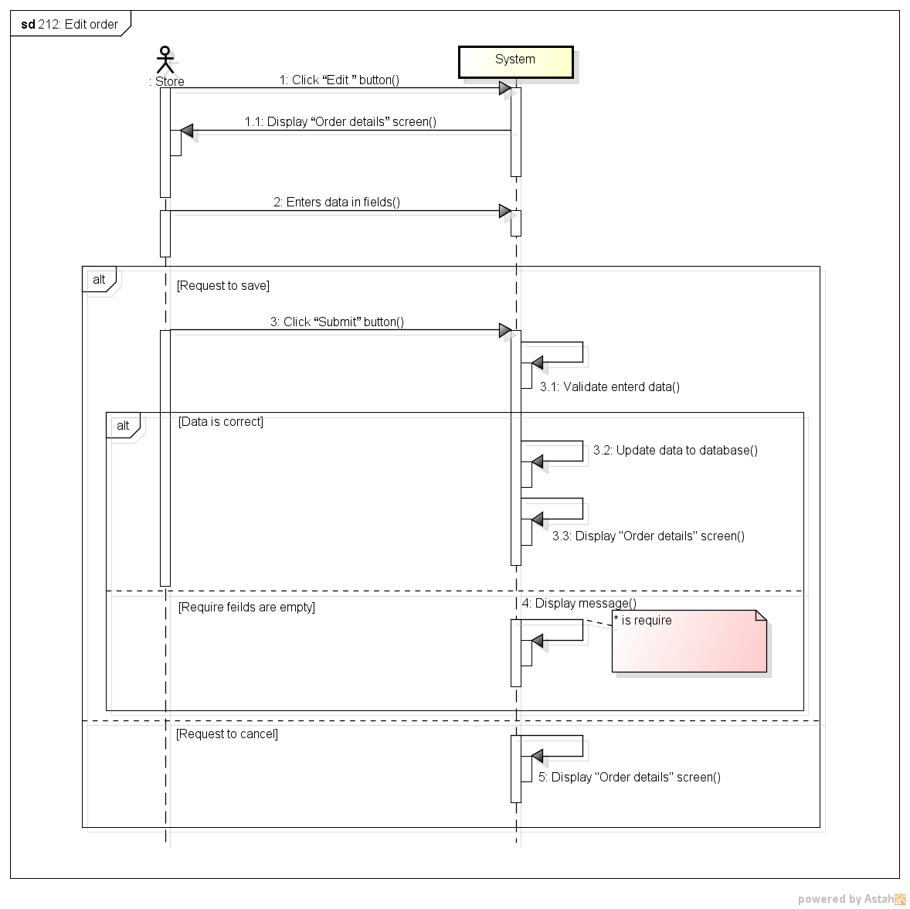

###### *UC- 213:* *Order’s details*

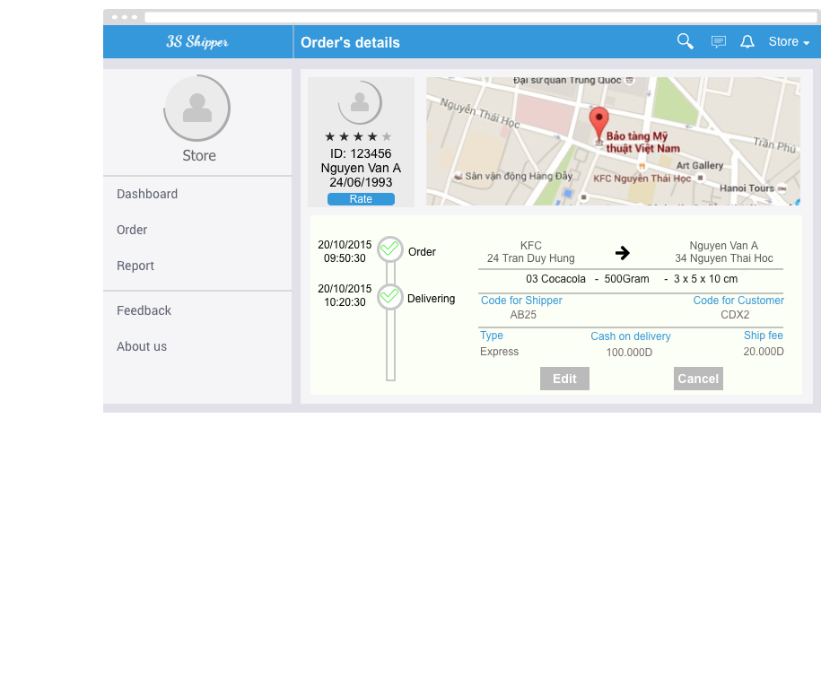

|  |  |  |  |  |
| --- | --- | --- | --- | --- |
| **Use Case ID:** | | UC-213 | | |
| **Use Case Name:** | | Order’ Details | | |
| **Created By:** | | KhanhKC | **Last Updated By:** | KhanhKC |
| **Date Created:** | | 19/09/2015 | **Date Last updated:** | 20/09/2015 |
| **Actor:** | | Store | | |
| **Description:** | | Display details information of orders. | | |
| **Triggering event:** | | Store view order details | | |
| **Preconditions:** | | Store on “Order’s list” screen. | | |
| **Post conditions:** | | “Order’s details” screen are displayed. | | |
| **Priority:** | | High | | |
| **Frequency of Use:** | | Always | | |
| **Main flow** | | | | |
| Step | Actor | Action | | |
|  | Store | Click on row contain order brief information | | |
|  | System | Display “Order’s details” screen that includes details information of Order. | | |
| **Alternative Flows:** | | N/A | | |
| **Exceptions:** | | N/A | | |
| **Includes:** | | N/A | | |
| **Special Requirements:** | | N/A | | |
| **Notes and Issues:** | | N/A | | |

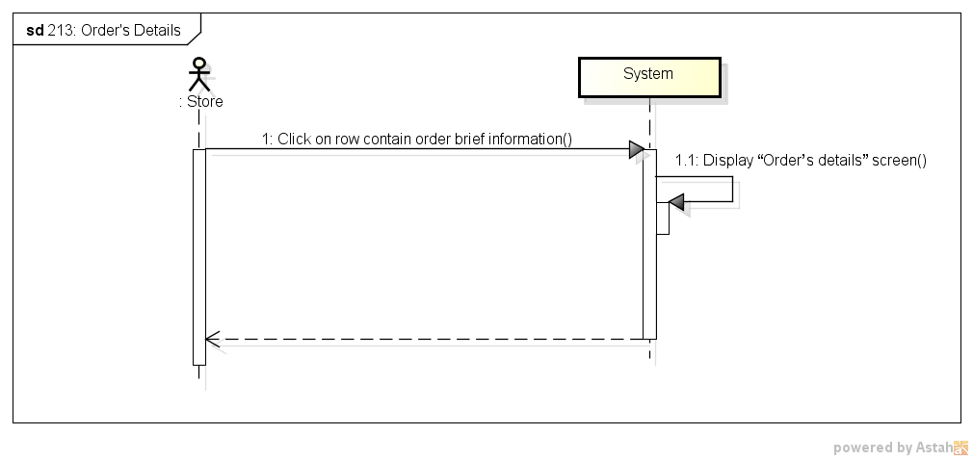

###### *UC-216:* *Rate shipper*

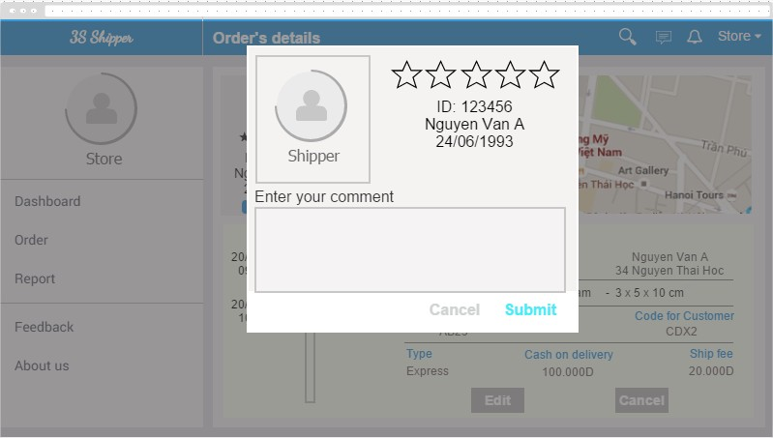

|  |  |  |  |  |
| --- | --- | --- | --- | --- |
| **Use Case ID:** | | UC-216 | | |
| **Use Case Name:** | | Rate shipper | | |
| **Created By:** | | HuyTDH | **Last Updated By:** | KhanHKC |
| **Date Created:** | | 19/09/2015 | **Date Last updated:** | 20/09/2015 |
| **Actor:** | | Store | | |
| **Description:** | | Store rates service quality of shipper for each order | | |
| **Triggering event:** | | Store rates shipper. | | |
| **Preconditions:** | | Store logged in, there’s a shipper bears responsibility for shipping store’s order | | |
| **Post conditions:** | | Shipper rating send to system | | |
| **Priority:** | | Normal | | |
| **Frequency of Use:** | | Often | | |
| **Main flow** | | | | |
| Step | Actor | Action | | |
|  | Store | Goes to “Order List” | | |
|  | Store | Click on “Rate” button | | |
|  | System | Displays “Shipper Rating” pop-up | | |
|  | Store | Selects rate score (1-5 stars) | | |
|  | Store | Enters some content | | |
|  | Store | Clicks on “Send” button | | |
|  | System | Display message “Thanks for your rating!” | | |
| **Alternative Flows:** | | | | |
| **Exceptions:** | | | | |
| EC1 | At step 9, Store click “Cancel” button | | | |
| Step | Actor | Action | | |
| 4.1 | Store | Store Click “Cancel” button | | |
| 4.2 | System | Close popup. | | |
| **Includes:** | | N/A | | |
| **Special Requirements:** | | N/A | | |
| **Notes and Issues:** | | N/A | | |

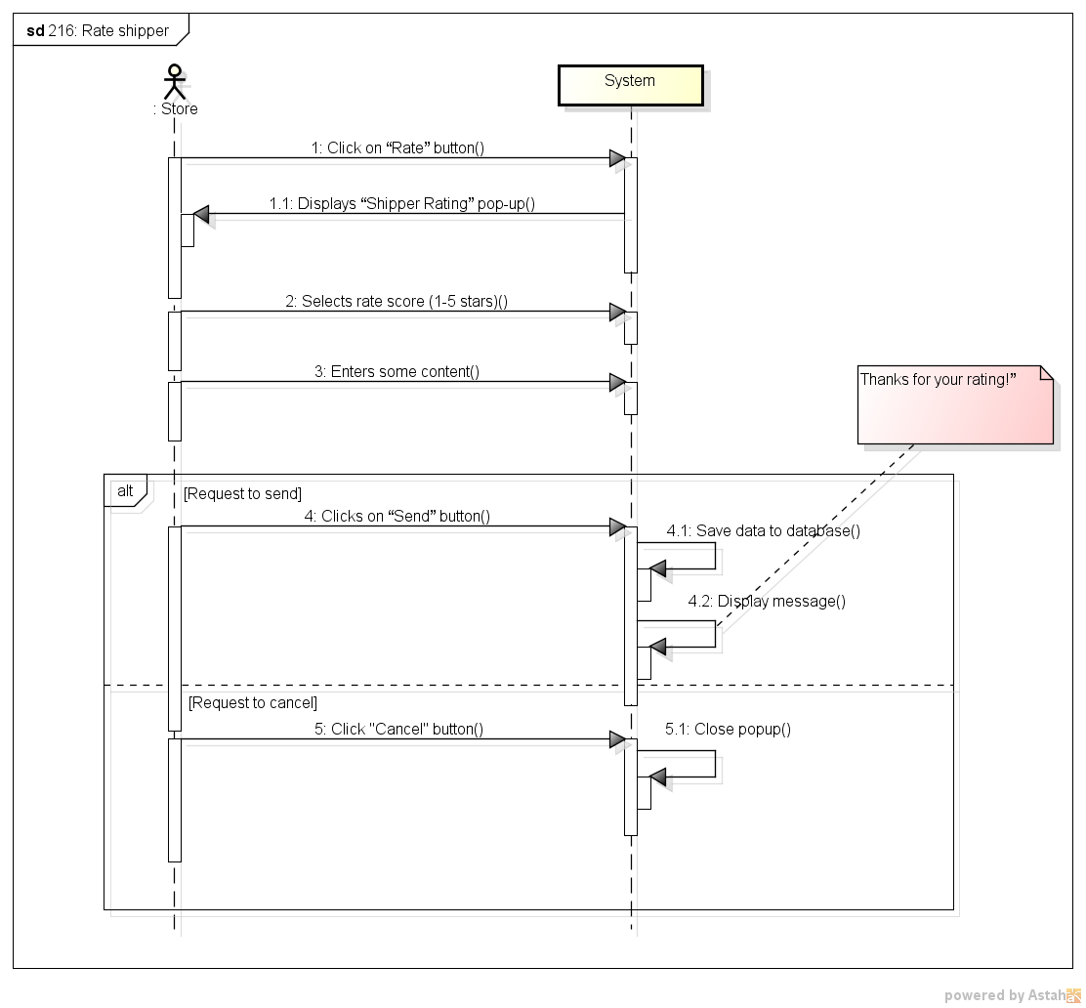

###### *UC-217:* *Send feedback*

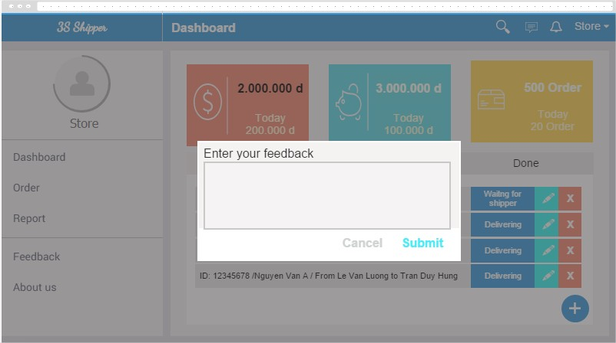

|  |  |  |  |  |
| --- | --- | --- | --- | --- |
| **Use Case ID:** | | UC-217 | | |
| **Use Case Name:** | | Send feedback | | |
| **Created By:** | | HuyTDH | **Last Updated By:** | KhanhKC |
| **Date Created:** | | 19/09/2015 | **Date Last updated:** | 20/09/2015 |
| **Actor:** | | Store | | |
| **Description:** | | Store send feedback about service to system | | |
| **Triggering event:** | | Store send feedback about service to system | | |
| **Preconditions:** | | Store logged in  Internet connection is on | | |
| **Post conditions:** | | Feedback will be sent to system | | |
| **Priority:** | | Normal | | |
| **Frequency of Use:** | | Sometimes | | |
| **Main flow** | | | | |
| Step | Actor | Action | | |
|  | Store | Click on “Send feedback” on navigation bar | | |
|  | System | Displays “Send feedback” pop-up | | |
|  | Store | Enters some content | | |
|  | Store | Clicks on “Send” | | |
|  | System | Validate content | | |
|  | System | Shows message “Thanks for your feedback!” | | |
| **Alternative Flows:** | | N/A | | |
| **Exceptions:** | | | | |
| EC1 | Store doesn’t enter content | | | |
| Step | Actor | Action | | |
| 4.1 | Store | Store clicks “Send” | | |
| 4.2 | System | System shows message “Please enter content of feedback!” | | |
| **Includes:** | | N/A | | |
| **Special Requirements:** | | N/A | | |
| **Notes and Issues:** | | N/A | | |

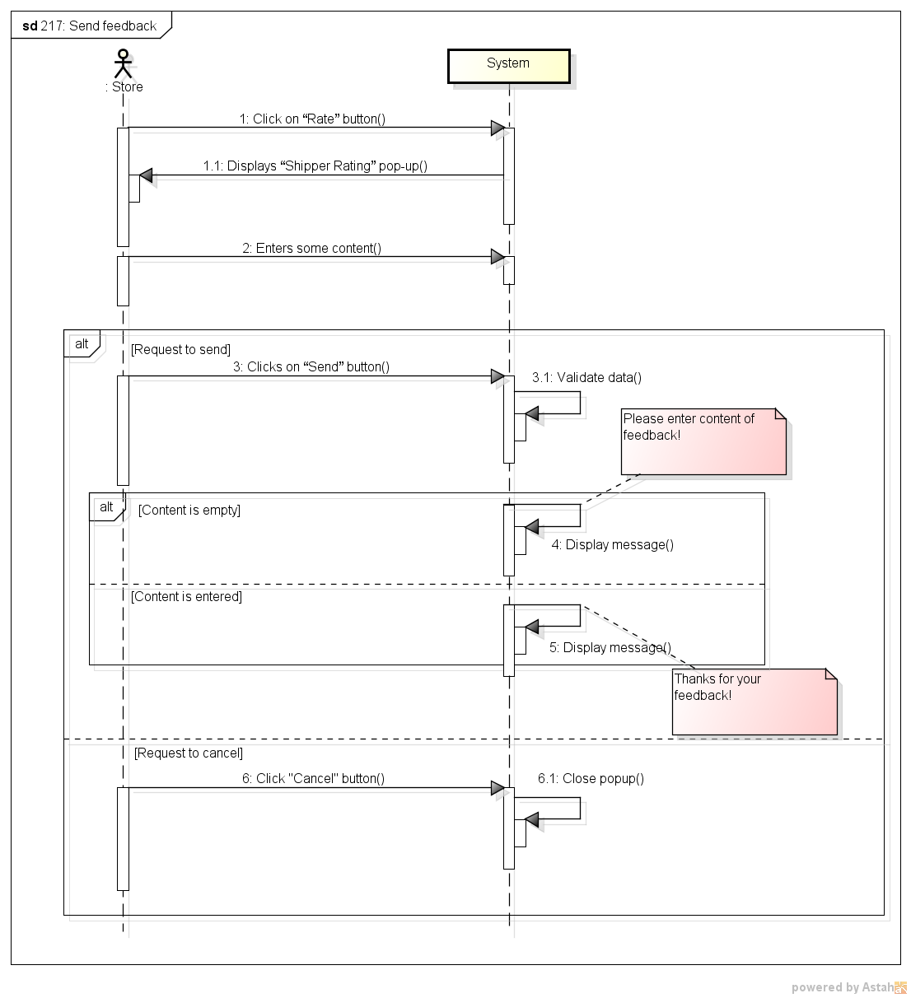

###### *UC-218:* *View Homepage*



|  |  |  |  |  |
| --- | --- | --- | --- | --- |
| **Use Case ID:** | | UC-218 | | |
| **Use Case Name:** | | View Homepage | | |
| **Created By:** | | KhanhKC | **Last Updated By:** | KhanhKC |
| **Date Created:** | | 20/09/2015 | **Date Last updated:** | 20/09/2015 |
| **Actor:** | | Store, Guest | | |
| **Description:** | | Homepage show information about 3S service. | | |
| **Triggering event:** | | Store or Guest access to 3S website. | | |
| **Preconditions:** | | Store or Guest access to 3S website. | | |
| **Post conditions:** | | “Homepage” screen has been displayed. | | |
| **Priority:** | | High | | |
| **Frequency of Use:** | | Always | | |
| **Main flow** | | | | |
| Step | Actor | Action | | |
|  | Store, Guest | Access to 3S website. | | |
|  | System | Displays “Homepage” screen. | | |
| **Alternative Flows:** | | N/A | | |
| **Exceptions:** | | N/A | | |
| **Includes:** | | N/A | | |
| **Special Requirements:** | | N/A | | |
| **Notes and Issues:** | | N/A | | |

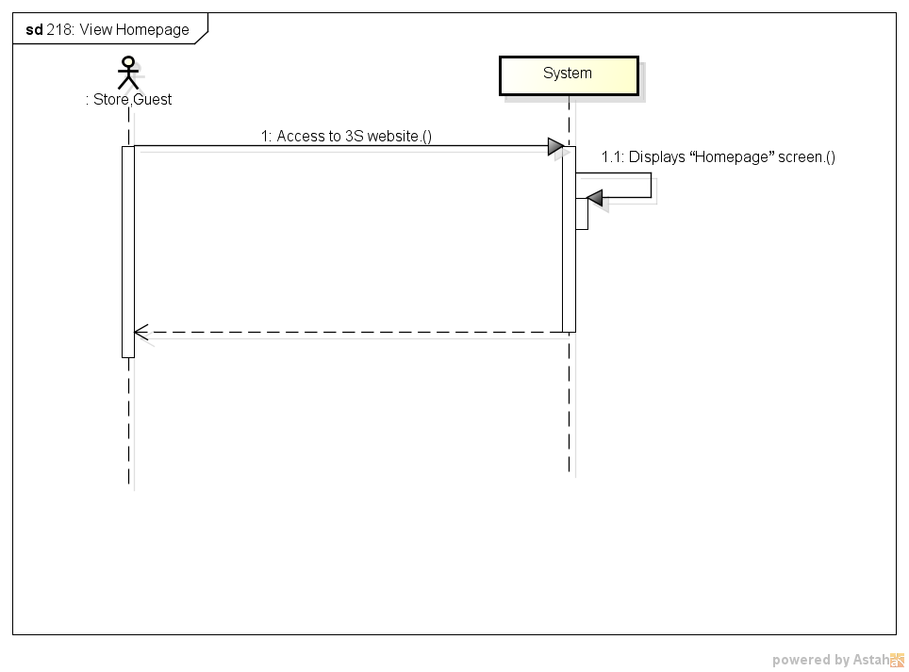

## 1.3. Mobile application for Shipper

### 1.3.1. User Case Diagram

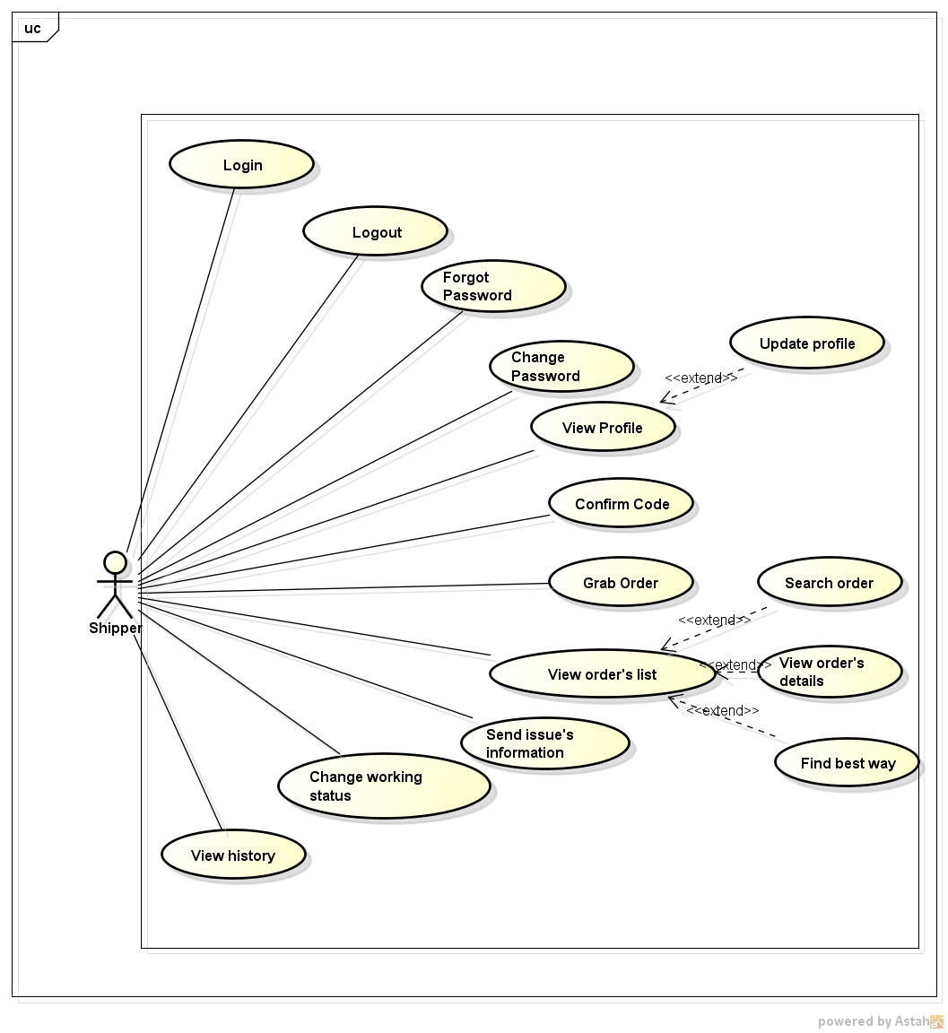

### 1.3.2. Function

###### *UC-301:* *Login*

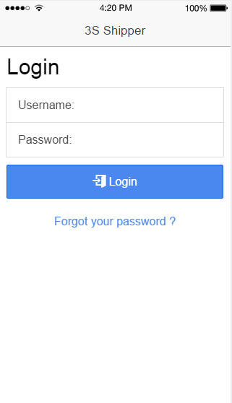

|  |  |  |  |  |
| --- | --- | --- | --- | --- |
| Use Case ID: | | UC-301 | | |
| Use Case Name: | | Login | | |
| Created By: | | QuyenNV | Last Updated By: | QuyenNV |
| Date Created: | | 19/09/2015 | Date Last Updated: | 24/09/2015 |
| Actor: | | Shipper | | |
| Description: | | Shipper provides his or her access credentials in order to use system. | | |
| Triggering event | | Shipper login to system. | | |
| Preconditions: | | Internet connection is established. | | |
| Post - conditions: | | The shipper’s session is stored. | | |
| Priority: | | High | | |
| Frequency of Use: | | Sometime | | |
| **Main flow** | | | | |
| Step | Actor | Action | | |
| 1 | Shipper | Tabs on application | | |
| 2 | System | Request the shipper input the following fields are available:  + username  + password | | |
| 3 | Shipper | Enter information (username and password). Shipper clicks on Log In. | | |
| 4 | System | Validate UserName and Password | | |
| 5 | System | Login successful into application. System grant access to system and redirect to Order’s list screen | | |
| **Alternative Flows:** | | N/A | | |
| **Exceptions:** | | | | |
| EC1 | At step 4, if account’s information is invalid | | | |
| Step | Actor | Action | | |
| 4.1 | System | Display an error message on [Login] screen | | |
| **Includes:** | | N/A | | |
| **Special Requirements:** | | N/A | | |
| **Notes and Issues:** | | N/A | | |

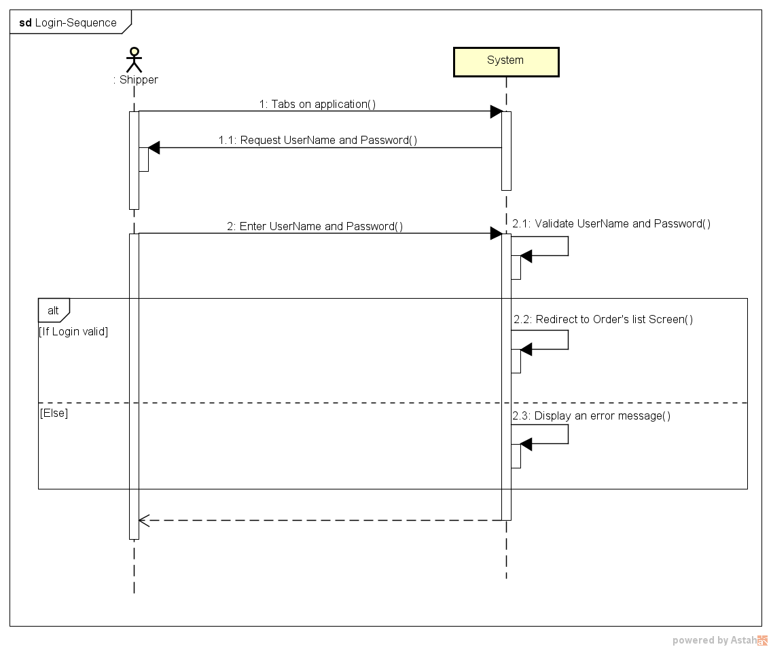**Sequence Diagram**

###### *UC-302:* *Logout*

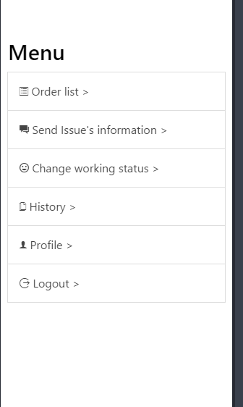

|  |  |  |  |  |
| --- | --- | --- | --- | --- |
| Use Case ID: | | UC-302 | | |
| Use Case Name: | | Logout | | |
| Created By: | | QuyenNV | Last Updated By: | QuyenNV |
| Date Created: | | 19/09/2015 | Date Last Updated: | 24/09/2015 |
| Actor: | | Shipper | | |
| Description: | | When shipper finish their work they will logout of the system. | | |
| Triggering event | | Shipper logout of the system. | | |
| Preconditions: | | * To be logged in the system * To have Internet connection through device | | |
| Post - conditions: | | * The connection to the server is terminated. | | |
| Priority: | | High | | |
| Frequency of Use: | | Sometime | | |
| **Main flow** | | | | |
| Step | Actor | Action | | |
|  | Shipper | Click “log out” button. | | |
|  | System | Terminates the connection. Local storage destroy login state. | | |
|  | System | Redirect to “Login” screen of application | | |
| **Alternative Flows:** | | N/A | | |
| **Exceptions:** | | N/A | | |
| **Includes:** | | N/A | | |
| **Special Requirements:** | | N/A | | |
| **Notes and Issues:** | | N/A | | |

* 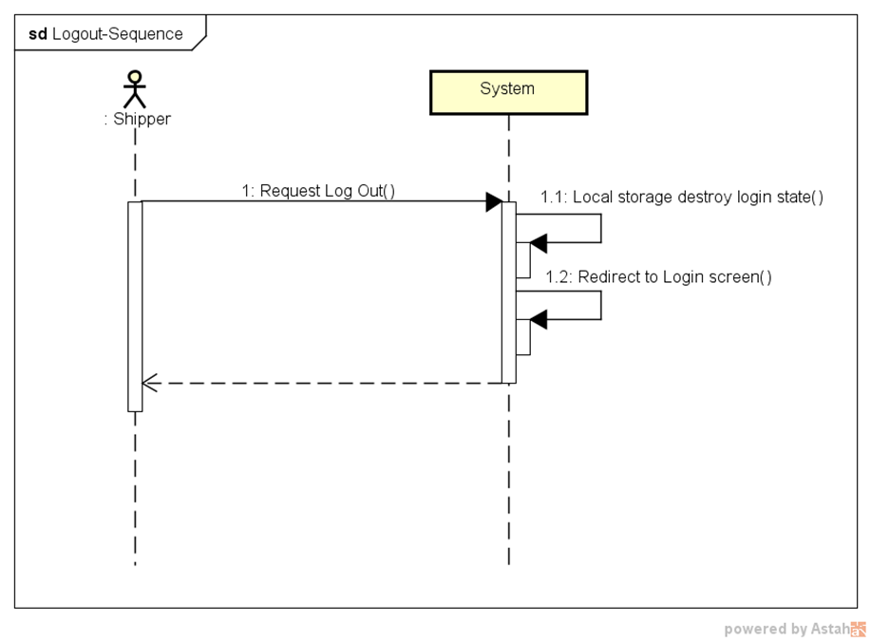**Sequence Diagram:**

###### *UC-303:* *Forgot password*

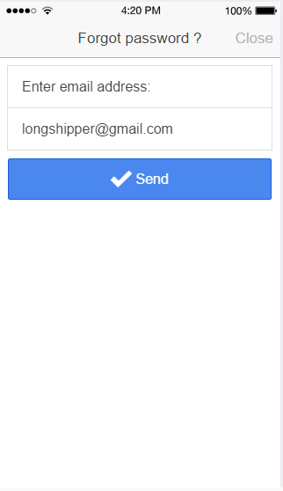

|  |  |  |  |  |
| --- | --- | --- | --- | --- |
| Use Case ID: | | UC-303 | | |
| Use Case Name: | | Forgot password | | |
| Created By: | | QuyenNV | Last Updated By: | QuyenNV |
| Date Created: | | 19/09/2015 | Date Last Updated: | 24/09/2015 |
| Actor: | | Shipper | | |
| Description: | | * When shipper forgot their password. Shipper wants reset their password. | | |
| Triggering event | | * Shipper forgot their password. | | |
| Preconditions: | | * To have internet connection through device. * Shipper haven’t logged in to the system yet. * On “Login” screen | | |
| Post - conditions: | | * New password is sent to email of shipper | | |
| Priority: | | High | | |
| Frequency of Use: | | Sometime | | |
| **Main flow** | | | | |
| Step | Actor | Action | | |
|  | Shipper | Click “Forgot password” | | |
|  | System | A new page ‘Forgot password’ appears. | | |
|  | Shipper | Enter email address used for registration. Shipper clicks the [Send] button. | | |
|  | System | Validate Email Address. | | |
|  | System | Send new password into email of shipper | | |
|  | System | The page is refreshed. The message is displayed: “New passwords has been sent to your email” | | |
| **Alternative Flows:** | | N/A | | |
| **Exceptions:** | | | | |
| EC1 | At step 4, if email is invalid | | | |
| Step | Actor | Action | | |
| 4.1 | System | Notify in screen with error message | | |
| **Includes:** | | N/A | | |
| **Special Requirements:** | | **Email Address:** A string from 1 to 244 characters in length, can contain any kind of characters, followed by “@gmail.com”. (Ex: longshipper@gmail.com). Cannot be null. | | |
| **Notes and Issues:** | | N/A | | |

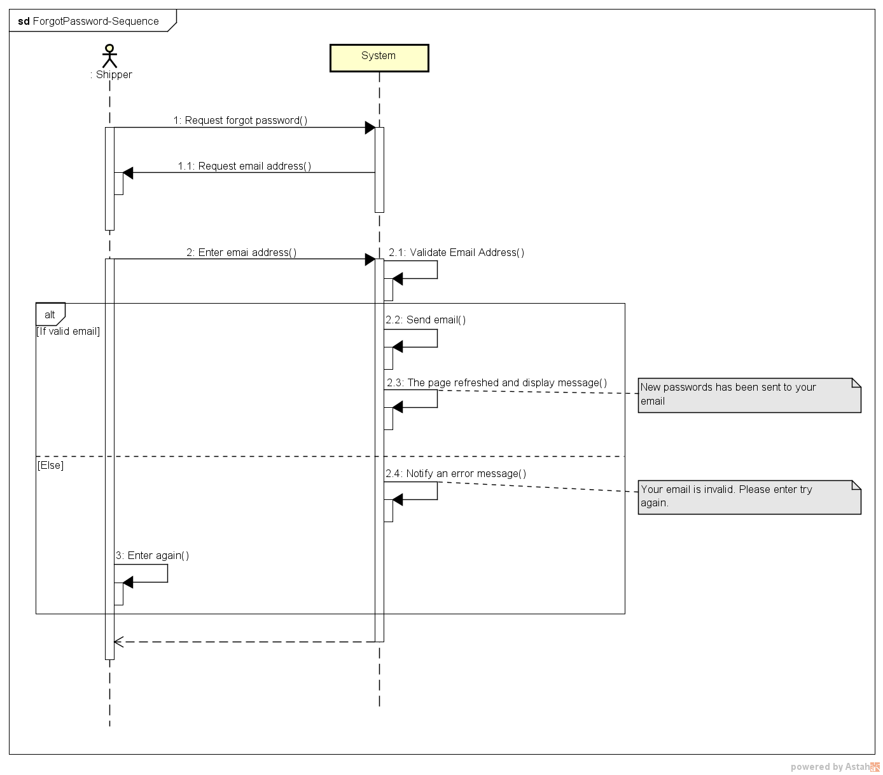**Sequence Diagram**

###### *UC-304:* *Change password*

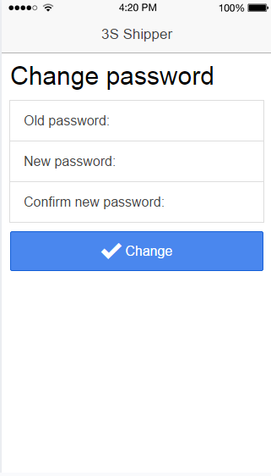

|  |  |  |  |  |
| --- | --- | --- | --- | --- |
| Use Case ID: | | UC-304 | | |
| Use Case Name: | | Change password | | |
| Created By: | | QuyenNV | Last Updated By: | QuyenNV |
| Date Created: | | 19/09/2015 | Date Last Updated: | 25/09/2015 |
| Actor: | | Shipper | | |
| Description: | | Shipper wants change their password. | | |
| Triggering event | | Shipper changes password. | | |
| Preconditions: | | * To have internet connection through device * To be logged in the system * Switch to “Profile” screen | | |
| Post - conditions: | | * New password stored in database. Shipper changes password is successfully | | |
| Priority: | | High | | |
| Frequency of Use: | | Sometime | | |
| **Main flow** | | | | |
| Step | Actor | Action | | |
|  | Shipper | Click “Change Password” button | | |
|  | System | “Change Password” screen shows up. | | |
|  | Shipper | Enter required information (Old Password, new password, re-enter password) and click “Update Password” button. | | |
|  | System | Validate input | | |
|  | System | Update new password of this account to database and redirect to the “Profile” screen. | | |
| **Alternative Flows:** | | N/A | | |
| **Exceptions:** | | | | |
| EC1 | At step 4, if any field is incorrect format or blank | | | |
| Step | Actor | Action | | |
| 4.1 | System | Notify in screen with error message | | |
| EC2 | At step 4, if shipper provides new password doesn’t match the re-enter password | | | |
| Step | Actor | Action | | |
| 4.1 | System | Notify in screen with error message | | |
| **Includes:** | | N/A | | |
| **Special Requirements:** | | **Old Password:** Cannot be null.  **New Password:** Minimum of password is 7 character and needs at least one number.  **Re-Enter Password**: Cannot be null. | | |
| **Notes and Issues:** | | N/A | | |

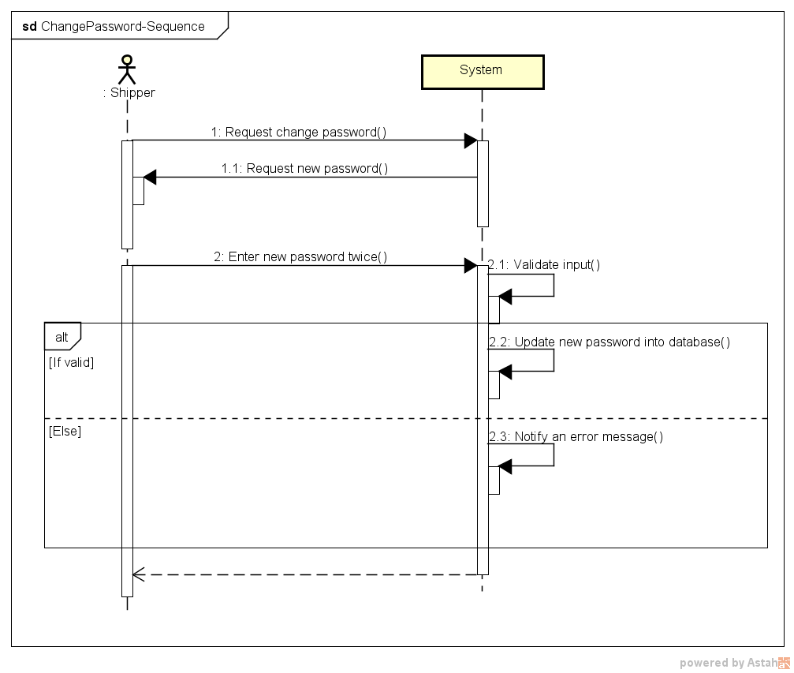Sequence Diagram:

###### *UC-305:* *View Profile*

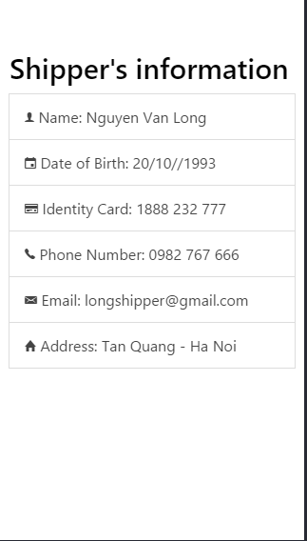

|  |  |  |  |  |
| --- | --- | --- | --- | --- |
| **Use Case ID:** | | UC-005 | | |
| **Use Case Name:** | | View Profile | | |
| **Created By:** | | QuyenNV | **Last Updated By:** | QuyenNV |
| **Date Created:** | | 19/09/2015 | **Date Last updated:** | 25/09/2015 |
| **Actor:** | | Shipper | | |
| **Description:** | | Shipper can view his/her information. | | |
| **Triggering event** | | Shipper wants view Profile | | |
| **Preconditions:** | | * To have internet connection through device * To be logged in the system | | |
| **Post conditions:** | | The information of current logged in will appear in the [Profile] screen. | | |
| **Priority:** | | High | | |
| **Frequency of Use:** | | Sometime | | |
| **Main flow** | | | | |
| Step | Actor | Action | | |
| 1 | Shipper | Click “Profile” button in left navigate bar | | |
| 2 | System | Load information of shipper and Display “Profile” screen | | |
| **Alternative Flows:** | | **N/A** | | |
| **Exceptions:** | | | | |
| **Includes:** | | N/A | | |
| **Special Requirements:** | | N/A | | |
| **Notes and Issues:** | | N/A | | |

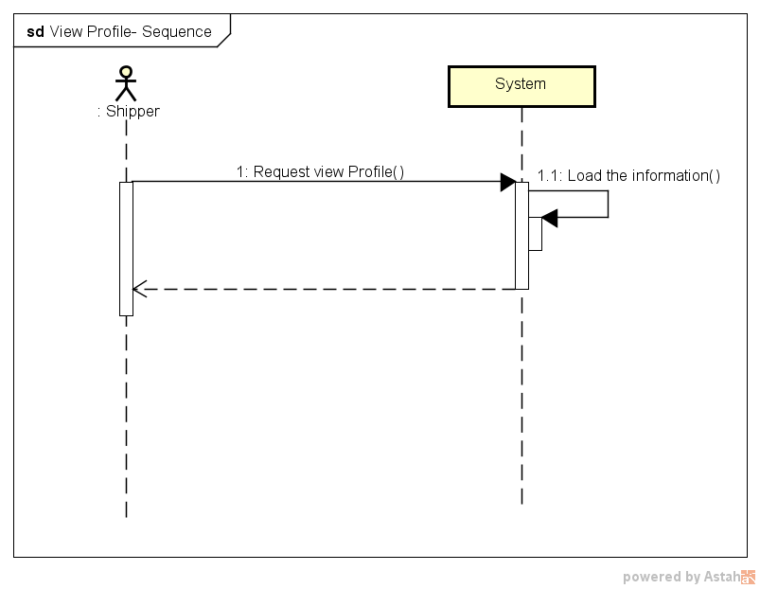**Sequence Diagram:**

###### *UC-306:* *Update Profile*

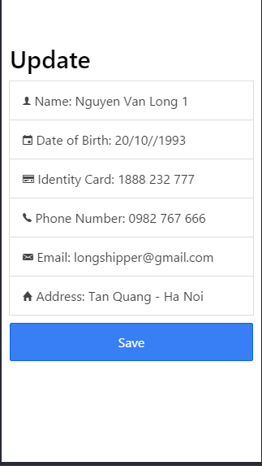

|  |  |  |  |  |
| --- | --- | --- | --- | --- |
| **Use Case ID:** | | UC-006 | | |
| **Use Case Name:** | | Update Profile | | |
| **Created By:** | | QuyenNV | **Last Updated By:** | QuyenNV |
| **Date Created:** | | 19/09/2015 | **Date Last updated:** | 25/09/2015 |
| **Actor:** | | Shipper | | |
| **Description:** | | Shipper can modify their related information (Email, Date of Birth, Phone Number, Identity Card, Address) | | |
| **Triggering event** | | Shipper wants to update their profile | | |
| **Preconditions:** | | * To have internet connection through device * To be logged in the system * Switch to [Profile] screen. | | |
| **Post conditions:** | | Update new information in database. Update Profile is successfully. | | |
| **Priority:** | | Low | | |
| **Frequency of Use:** | | Sometime | | |
| **Main flow** | | | | |
| Step | Actor | Action | | |
| 1 | Shipper | Click [Edit Profile] button | | |
| 2 | System | Display [Edit profile] screen | | |
| 3 | Shipper | Enter required information (Name, Email, Phone Number, Identity Card, Date of Birth, Address) | | |
| 5 | System | Validate input | | |
| 6 | System | Store new information of Shipper into database | | |
| 7 | System | Display an success message to shipper | | |
| **Alternative Flows:** | | **N/A** | | |
| **Exceptions:** | | | | |
| EC1 | At step 5 | If any required field is not entered | | |
| Step | Actor | Action | | |
| 5.1 | System | Notify an error message “*is require” | | |
| **Includes:** | | N/A | | |
| **Special Requirements:** | | N/A | | |
| **Notes and Issues:** | | N/A | | |

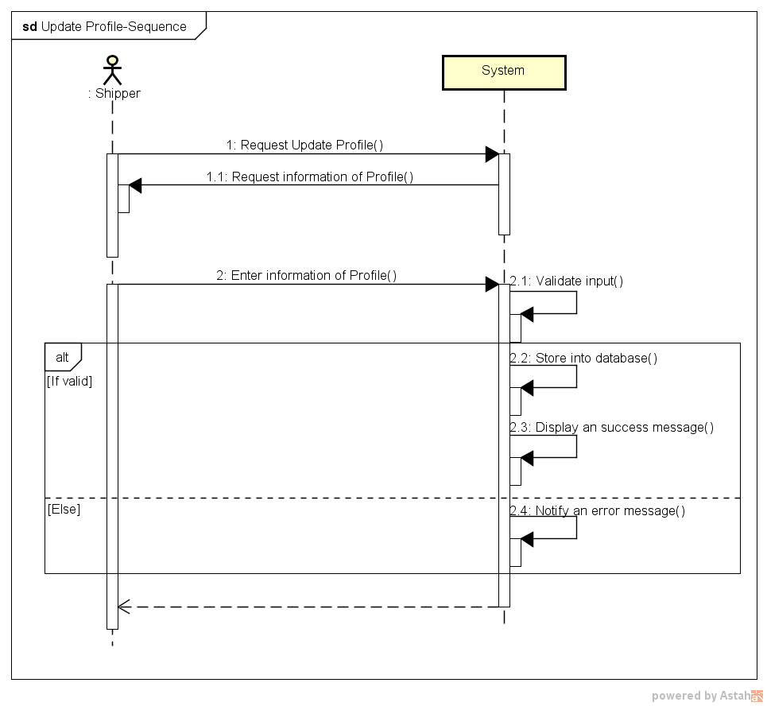Sequence Diagram:

###### *UC-307:* *Confirm Code*

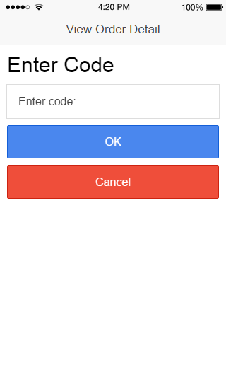

|  |  |  |  |  |
| --- | --- | --- | --- | --- |
| **Use Case ID:** | | UC-007 | | |
| **Use Case Name:** | | Confirm Code | | |
| **Created By:** | | QuyenNV | **Last Updated By:** | QuyenNV |
| **Date Created:** | | 19/09/2015 | **Date Last updated:** | 25/09/2015 |
| **Actor:** | | Shipper | | |
| **Description:** | | Shipper entered code to confirm with customer. If code is wrong, shipper don’t pick up order from customer. Code is automatically generated by system. | | |
| **Triggering event** | | Shipper confirm code which automatically generated by system. | | |
| **Preconditions:** | | * To have internet connection through device * To be logged in the system * Switch to [View Order’s Details] screen. | | |
| **Post conditions:** | | Order’s Code is confirmed | | |
| **Priority:** | | High | | |
| **Frequency of Use:** | | Always | | |
| **Main flow** | | | | |
| Step | Actor | Action | | |
| 1. | Shipper | Click [Enter Code] button | | |
| 2. | System | Display [Enter Code] screen | | |
| 3. | Shipper | Enter code which be provided by customer and click “Enter” button. | | |
| 4. | System | Queries the Order database | | |
| 5. | System | Display an success message on [View Order’s Details] screen | | |
| **Alternative Flows:** | | **N/A** | | |
| **Exceptions:** | | | | |
| EC1 | At step 2, if Shipper doesn’t enter confirm code. | | | |
| Step | Actor | Action | | |
| 2.1 | Shipper | Taps on “Cancel” button | | |
| 2.2 | System | Display “View Order’s Detail” screen | | |
| EC2 | At step 4, if code in Order database does not exist or Order cannot establish a connection to the database due to some reasons (ex: network failure). | | | |
| Step | Actor | Action | | |
| 4.1 | System | An error message will show up on screen to tell the shipper about the problem | | |
| **Includes:** | | N/A | | |
| **Special Requirements:** | | N/A | | |
| **Notes and Issues:** | | N/A | | |

**Sequence Diagram:**

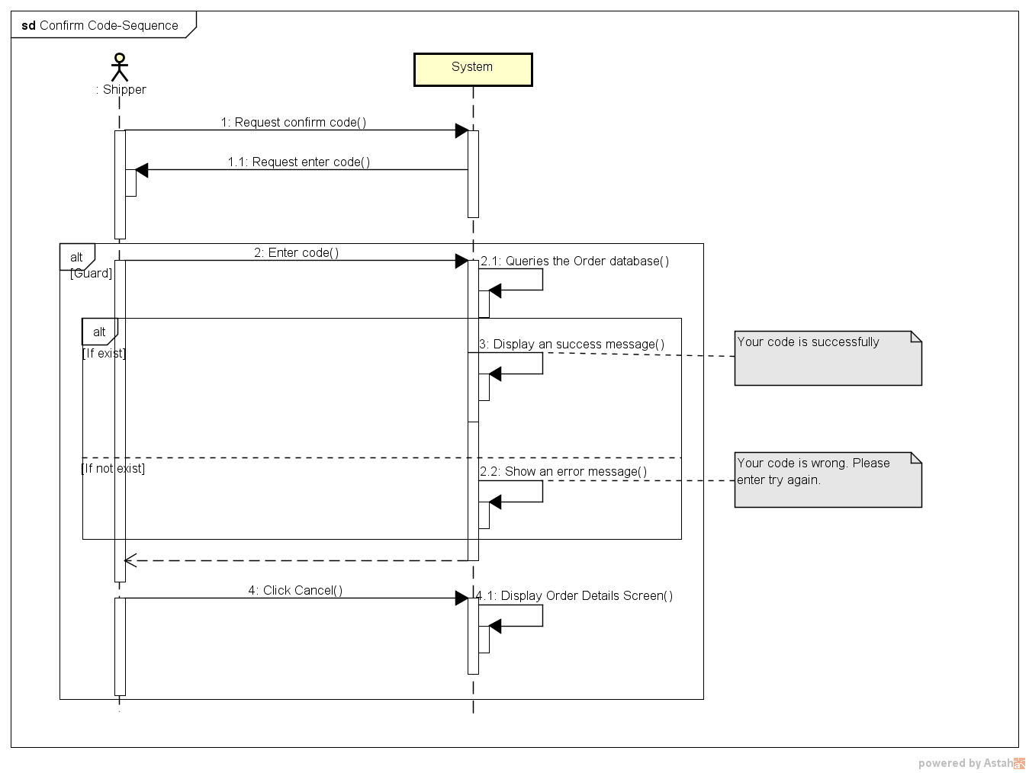

###### *UC-308:* *Grab order*

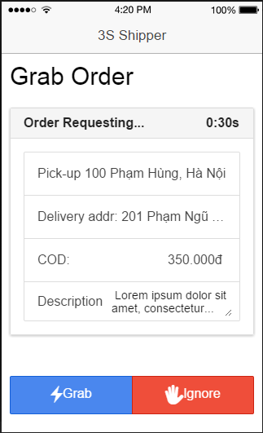

|  |  |  |  |  |  |  |
| --- | --- | --- | --- | --- | --- | --- |
| **Use Case ID:** | | | 3SP_308 | | | |
| **Use Case Name:** | | | Grab order | | | |
| **Created By:** | | | HuyTDH | | **Last Updated By:** | HuyTDH |
| **Date Created:** | | | 19/09/2015 | | **Date Last updated:** | 19/09/2015 |
| **Actor:** | | | Shipper | | | |
| **Description:** | | | When sever concurrently send shipping order to 5 shippers, the shipper who grabs order at the earliest time will take that order | | | |
| **Triggering Event:** | | | Server sends shipping request to shipper | | | |
| **Pre-conditions:** | | | Shipper logged in, internet connection is on, system is requesting to ship order | | | |
| **Post-conditions:** | | | The order is added to shipper working list, shipper’s status change to “Busy” | | | |
| **Priority:** | | | High | | | |
| **Frequency of Use:** | | | Often | | | |
| **Main flow** | | | | | | |
| Step | Actor | | Action | | | |
|  | System | | send shipping request to shipper’s app | | | |
|  | Shipper | | tabs on button “Grab” to take the order | | | |
|  | System | | validates whether the shipping request is taken or not | | | |
|  | System | | adds order to shipper’s working | | | |
|  | System | | changes shipper’s status to “Busy” | | | |
|  | System | | disable this request to other shippers | | | |
| **Alternative :** | | | | | | |
| N/A | | | | | | |
| **Exceptions:** | | | | | | |
| EC1 | | Shipper ignores request at step 2 | | | | |
| Step | | Actor | | Action | | |
| 2.1 | | Shipper | | Shipper tabs on button “Ignore” | | |
| 2.2 | | System | | System show confirm box | | |
|  | | Shipper | | Shipper confirms to ignore | | |
|  | | System | | System show warning “You have ignored x order(s) today!” | | |
| EC2 | | Shipper tabs on button “Grab” later than another shipper at step 2 | | | | |
| Step | | Actor | | Action | | |
| 2.1 | | Shipper | | Shipper tabs on “Grab” | | |
| 2.2 | | System | | System show message “The order has taken by another shipper!” | | |
| **Exceptions:** | | | N/A | | | |
| **Includes:** | | | N/A | | | |
| **Special Requirements:** | | | Shipper who receives shipping request is in top 5 nearest available ones to the store of that order. | | | |
| **Notes and Issues:** | | | N/A | | | |

**Sequence Diagram**

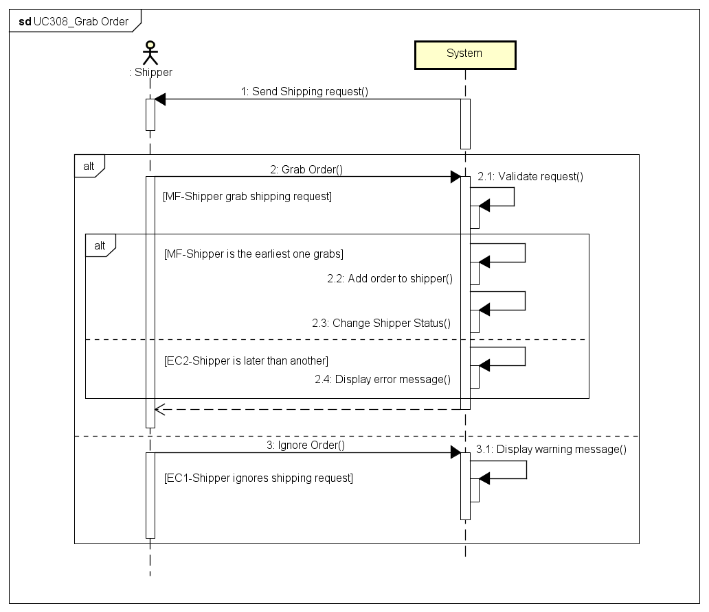

###### *UC309: View Orders List*

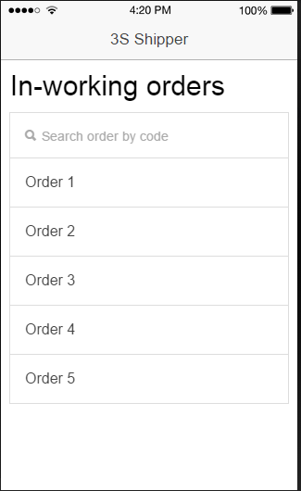

|  |  |  |  |  |
| --- | --- | --- | --- | --- |
| **Use Case ID:** | | 3SP_309 | | |
| **Use Case Name:** | | View orders list | | |
| **Created By:** | | HuyTDH | **Last Updated By:** | HuyTDH |
| **Date Created:** | | 19/09/2015 | **Date Last updated:** | 25/09/2015 |
| **Actor:** | | Shipper | | |
| **Description:** | | Shipper see the list of his in-working orders | | |
| **Triggering Event:** | | Shipper involves see orders list request | | |
| **Preconditions:** | | Shipper logged in | | |
| **Post conditions:** | | List in-working orders of this shipper is showed | | |
| **Priority:** | | High | | |
| **Frequency of Use:** | | Always | | |
| **Main flow** | | | | |
| Step | Actor | Action | | |
|  | Shipper | expands menu bar and tabs on “In-working orders” | | |
|  | System | load all data about in-working orders of that shipper | | |
|  | System | shows list in-working orders as a table, includes content:   * Order code * Pick-up point * Delivery point * Current Status | | |
| **Alternative Flows:** | | | | |
| **Exceptions:** | | | | |
| **Includes:** | | N/A | | |
| **Special Requirements:** | | N/A | | |
| **Notes and Issues:** | | N/A | | |

**Sequence Diagram**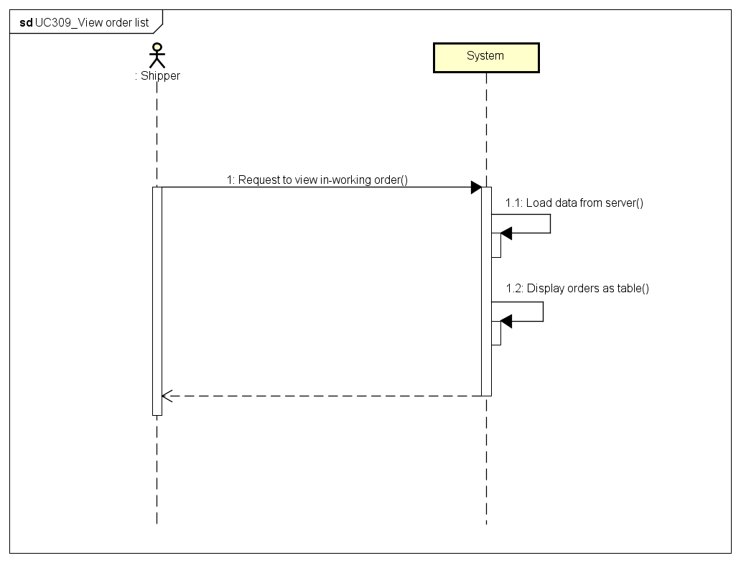

###### *UC310: Search Order*

|  |  |  |  |  |
| --- | --- | --- | --- | --- |
| **Use Case ID:** | | 3SP_310 | | |
| **Use Case Name:** | | Search order | | |
| **Created By:** | | HuyTDH | **Last Updated By:** | HuyTDH |
| **Date Created:** | | 19/09/2015 | **Date Last updated:** | 25/09/2015 |
| **Actor:** | | Shipper | | |
| **Description:** | | Shipper searches order(s) by order code | | |
| **Triggering Event:** | | Shipper involves find a specific order(s) by code | | |
| **Preconditions:** | | Shipper on View Orders List: 3SP_309 (See above) | | |
| **Post conditions:** | | Orders that match search condition will be displayed | | |
| **Priority:** | | Normal | | |
| **Frequency of Use:** | | Sometimes | | |
| **Main flow** | | | | |
| Step | Actor | Action | | |
|  | Shipper | goes to “View orders list” screen (refer to UC309 View order list) | | |
|  | Shipper | types order’s code to search box | | |
|  | System | filters orders data from current list | | |
|  | System | displays all in-working orders that match with search key | | |
| **Alternative Flows:** | | | | |
| **Exceptions:** | | | | |
| **Includes:** | | N/A | | |
| **Special Requirements:** | | Order code has format **3Sxxxxxx** but shipper no need to enter **3S** prefix of code Case insensitive search | | |
| **Notes and Issues:** | | Code format will be defined in the later phrase | | |

**Sequence Diagram**

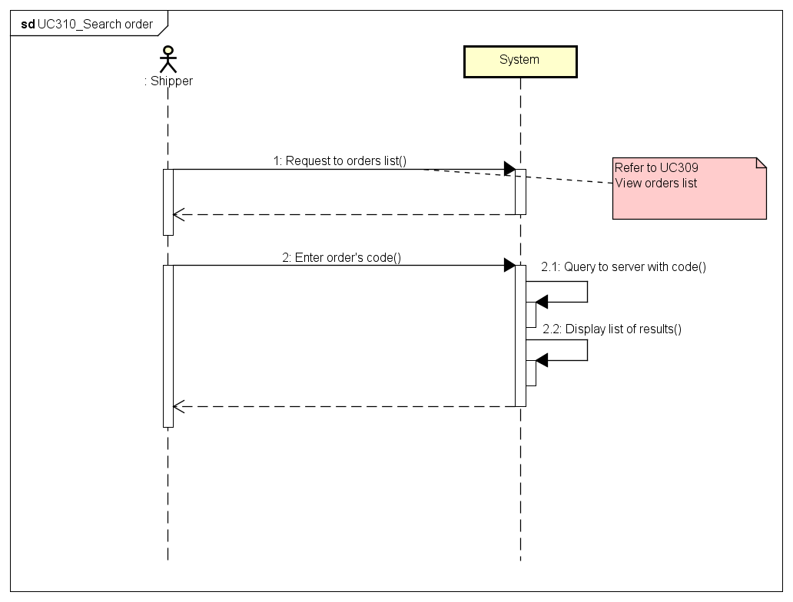

###### *UC311: View Order’s Detail*

**Mockup Design**

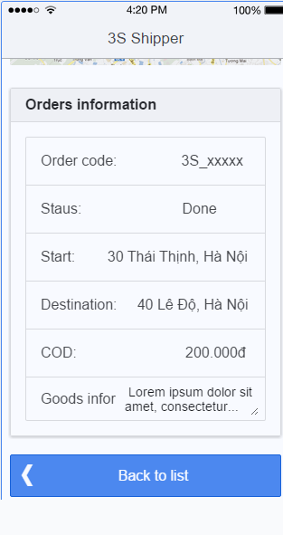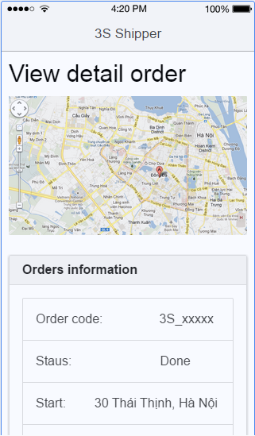

|  |  |  |  |  |
| --- | --- | --- | --- | --- |
| **Use Case ID:** | | 3SP_311 | | |
| **Use Case Name:** | | View order’s detail | | |
| **Created By:** | | HuyTDH | **Last Updated By:** | HuyTDH |
| **Date Created:** | | 19/09/2015 | **Date Last updated:** | 25/09/2015 |
| **Actor:** | | Shipper | | |
| **Description:** | | Shipper view detail of an order | | |
| **Triggering Event:** | | Shipper involves see order’s detail information request | | |
| **Preconditions:** | | Shipper is on list orders screen or working history screen | | |
| **Post conditions:** | | Detail information of that order is displayed | | |
| **Priority:** | | High | | |
| **Frequency of Use:** | | Always | | |
| **Main flow** | | | | |
| Step | Actor | Action | | |
|  | Shipper | Shipper enters “**In-Working Orders**” screen (Refer to UC309 above) | | |
|  | Shipper | Shipper tabs on “**View detail**” of that order from the list | | |
|  | System | System loads detail info of that order from server | | |
|  | System | System displays the detail information of order, includes:   * Order code * Order status * Pick-up address * Delivery address * Products information * COD (cast on delivery amount) | | |
| **Alternative Flows::** | | | | |
| AT1 | Shipper views detail from history: | | | |
| Step | Actor | Action | | |
| 1.1 | Shipper | Shipper enters “History” screen | | |
| 1.2 | Shipper | Shipper tabs on “View detail” of that order from the list | | |
| 1.3 | System | System displays the detail | | |
| **Exceptions:** | | N/A | | |
| **Includes:** | | N/A | | |
| **Special Requirements:** | | N/A | | |
| **Notes and Issues:** | | N/A | | |

**Sequence Diagram**

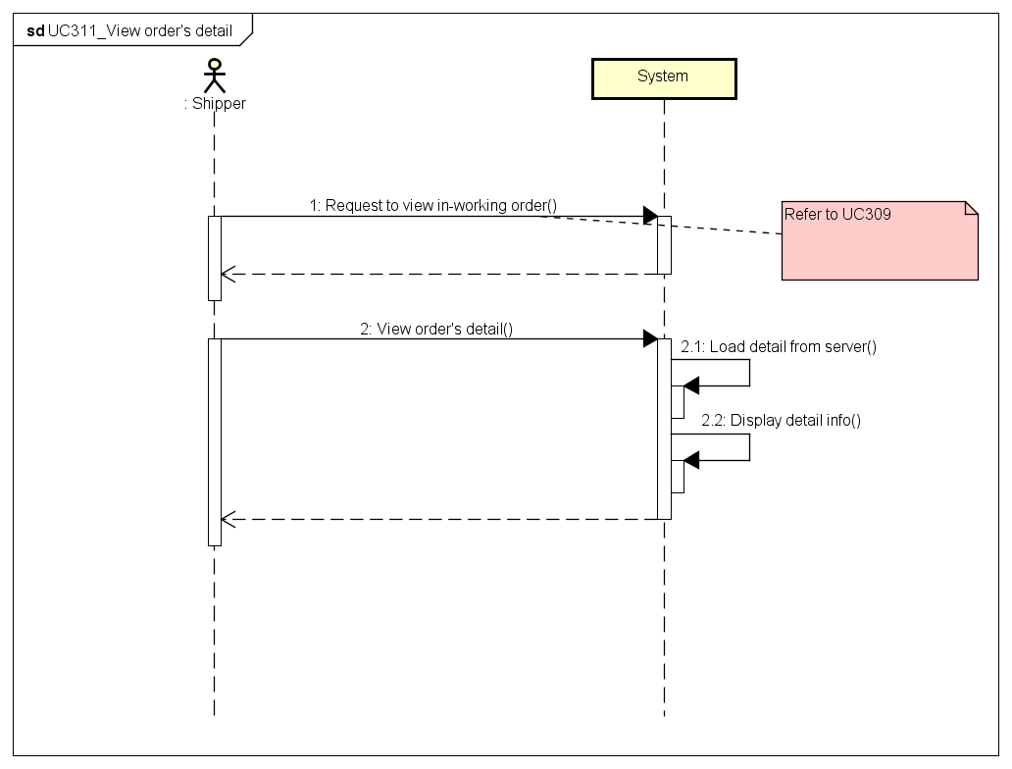

###### *UC312: Find Best Way*

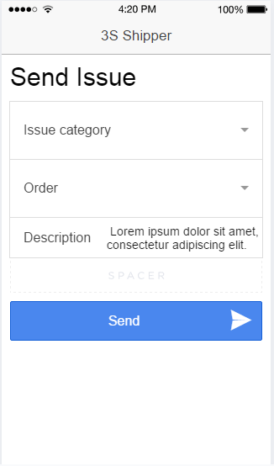

|  |  |  |  |  |
| --- | --- | --- | --- | --- |
| **Use Case ID:** | | 3SP_312 | | |
| **Use Case Name:** | | Find best way | | |
| **Created By:** | | HuyTDH | **Last Updated By:** | HuyTDH |
| **Date Created:** | | 19/09/2015 | **Date Last updated:** | 25/09/2015 |
| **Actor:** | | Shipper | | |
| **Description:** | | Shipper use system to find out the shortest way to go to destinations. | | |
| **Triggering event:** | | Shipper involves find best way request for his in-working orders. | | |
| **Preconditions:** | | Shipper logged in  Internet connection is on  GPS is on | | |
| **Post conditions:** | | The shortest way that go through all selected destinations will be displayed on map. | | |
| **Priority:** | | High | | |
| **Frequency of Use:** | | Always | | |
| **Main flow** | | | | |
| Step | Actor | Action | | |
|  | Shipper | Shipper selects “Find best way” from menu | | |
|  | System | System shows “Find best way” screen, includes:   * Google map * Destinations select box * “Find” button | | |
|  | Shipper | Shipper chooses one or all destinations | | |
|  | Shipper | Shipper tabs on “Find” | | |
|  | System | System call Google API to get the best way | | |
|  | System | System displays the shortest way to destinations on the map | | |
| **Alternative Flows:** | | N/A | | |
| **Exceptions:** | | | | |
| EC1 | At step 1 if GPS is off | | | |
| Step | Actor | Action | | |
| 1.1 | System | System displays message “Please turn on GPS and retry” | | |
| 1.2 | Shipper | Shipper turn on GPS | | |
| 1.3 | | Go to step 2 of main flow | | |
| **Includes:** | | N/A | | |
| **Special Requirements:** | | Shipper can choose <= 7 destinations | | |
| **Notes and Issues:** | | N/A | | |

**Sequence Diagram**

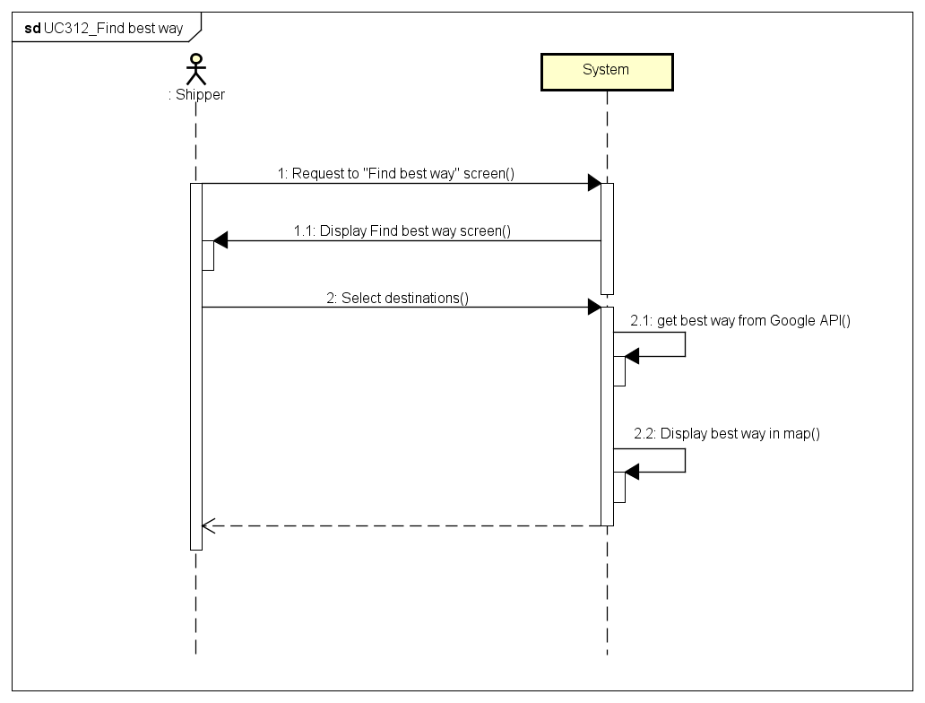

###### *UC313 Send Issue’s Information*



|  |  |  |  |  |
| --- | --- | --- | --- | --- |
| **Use Case ID:** | | 3SP_313 | | |
| **Use Case Name:** | | Send issue’s information | | |
| **Created By:** | | HuyTDH | **Last Updated By:** | HuyTDH |
| **Date Created:** | | 19/09/2015 | **Date Last updated:** | 19/09/2015 |
| **Actor:** | | Shipper | | |
| **Description:** | | Shipper sends issues to Admin to solve | | |
| **Triggering Event:** | | Shipper got issues need to send to Admin | | |
| **Preconditions:** | | Shipper logged in | | |
| **Post conditions:** | | Issue has been sent to Admin  Notification about issue has been display in admin’s screen | | |
| **Priority:** | | High | | |
| **Frequency of Use:** | | Sometimes | | |
| **Main flow** | | | | |
| Step | Actor | Action | | |
|  | Shipper | Shipper chooses “Send Issue” from Menu | | |
|  | System | System displays “Send Issue Box” | | |
|  | Shipper | Shipper types “Description”, chooses “Issue Category”, and could select one or all of his in-working orders. | | |
|  | Shipper | Shipper tabs on “Send” | | |
|  | System | System shows message “Issue has sent to system. Wait for Admin to solve” | | |
|  | System | System sent notification to admin about issue | | |
| **Alternative Flows:** | | N/A | | |
| **Exceptions:** | | N/A | | |
| **Includes:** | | N/A | | |
| **Special Requirements:** | | N/A | | |
| **Notes and Issues:** | | Issue description should have 30 - 250 characters | | |

**Sequence Diagram**

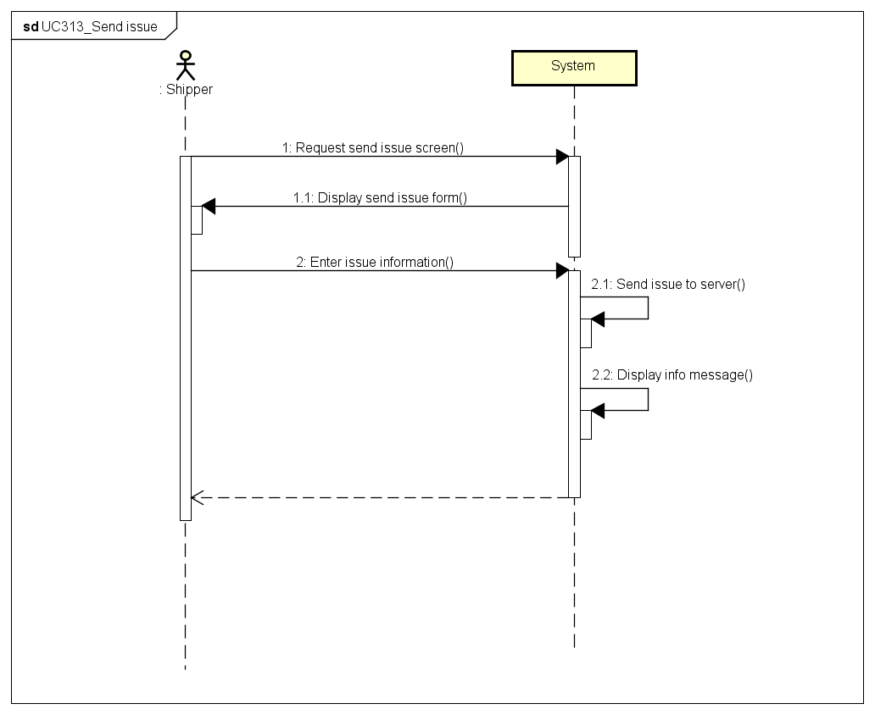

###### *UC314 Change Working Status*

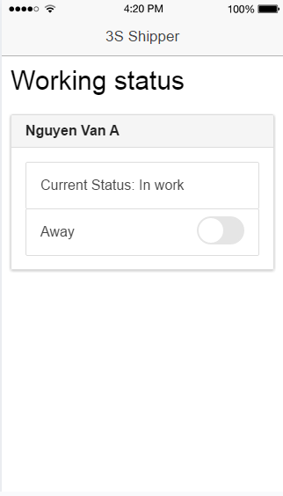

|  |  |  |  |  |
| --- | --- | --- | --- | --- |
| **Use Case ID:** | | 3SP_314 | | |
| **Use Case Name:** | | Change working status | | |
| **Created By:** | | HuyTDH | **Last Updated By:** | HuyTDH |
| **Date Created:** | | 19/09/2015 | **Date Last updated:** | 20/09/2015 |
| **Actor:** | | Shipper | | |
| **Description:** | | Shipper changes his working status “On working” / “Away”. And the system will decides to send shipping request to him or not. | | |
| **Triggering Event:** | | Shipper switches his status between ready to work or not ready. | | |
| **Preconditions:** | | Shipper logged in  Shipper current status is not “Busy” | | |
| **Post conditions:** | | Working status changed to “On working” / ”Away” | | |
| **Priority:** | | Normal | | |
| **Frequency of Use:** | | Sometimes | | |
| **Main flow** | | | | |
| Step | Actor | Action | | |
|  | Shipper | Shipper expands menu bar and tabs on “Change status” | | |
|  | System | System displays current status “On working” or ”Away” | | |
|  | Shipper | Shipper switches status button | | |
|  | System | System shows confirm message “Confirm change your status to [ABC]” ([ABC] is “On working” or ”Away”) | | |
|  | Shipper | Shipper tabs on “Confirm” | | |
|  | System | System changes the status | | |
| **Alternative Flows:** | | N/A | | |
| **Exceptions:** | | | | |
| EC1 | Shipper is on the way to ship some orders | | | |
| Step | Actor | Action | | |
| 1 | System | System displays current status “Busy” | | |
| 2 | Shipper | Shipper tabs on “Change” | | |
|  | System | System shows message “You can’t change status while shipping. Complete all in-working orders or contact to Admin” | | |
| **Includes:** | | N/A | | |
| **Special Requirements:** | | N/A | | |
| **Notes and Issues:** | | Change status should have time | | |

**Sequence Diagram**

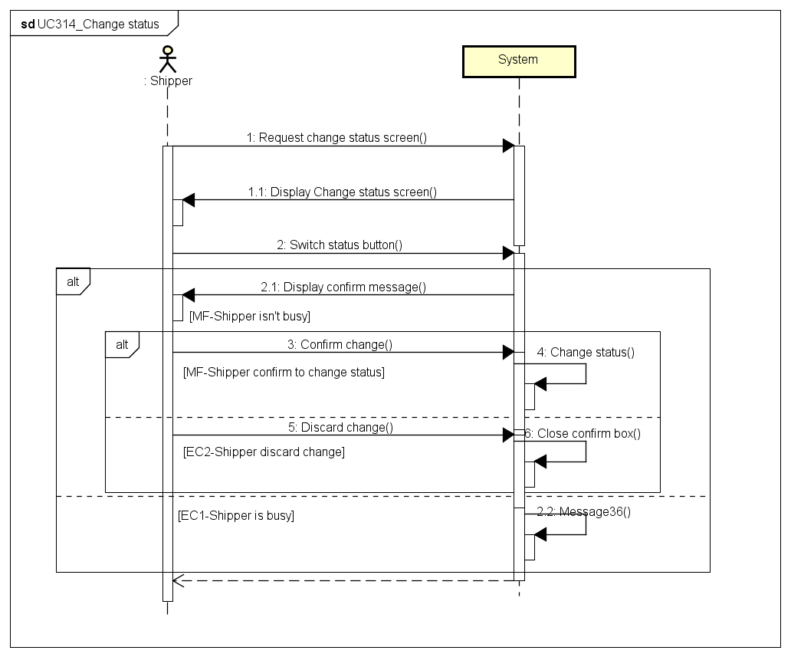

###### *UC315 View History*

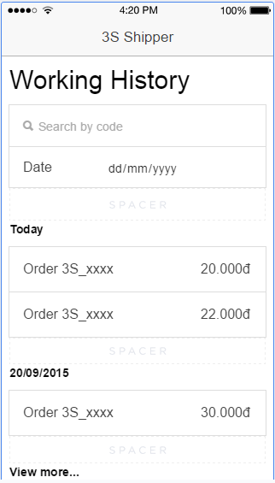

|  |  |  |  |  |
| --- | --- | --- | --- | --- |
| **Use Case ID:** | | 3SP_315 | | |
| **Use Case Name:** | | View history | | |
| **Created By:** | | HuyTDH | **Last Updated By:** | HuyTDH |
| **Date Created:** | | 19/09/2015 | **Date Last updated:** | 26/09/2015 |
| **Actor:** | | Shipper | | |
| **Description:** | | Shipper views his working history to know how much salary and bonus he will get or evidence when problem occurs. | | |
| **Triggering Event:** | | Shipper reviews history | | |
| **Preconditions:** | | Shipper logged in | | |
| **Post conditions:** | | Working history of that shipper will be displayed | | |
| **Priority:** | | High | | |
| **Frequency of Use:** | | Often | | |
| **Main flow** | | | | |
| Step | Actor | Action | | |
|  | Shipper | Shipper chooses “History” from menu | | |
|  | System | System load history saving in device memory | | |
|  | System | System displays working history of that shipper, also includes bellow feature:   * Date filter * Order code filter * List of history orders * “View more” link if there more orders is not yet displayed | | |
| **Alternative Flows:** | | | | |
| AT1 | At step 2, working history in device was cleared and shipper has to load from server | | | |
| Step | Actor | Action | | |
| 2.1 | System | System shows message “Can’t find working history. Reload from server?” | | |
| 2.2 | Shipper | Shipper tabs on “Reload” | | |
| 2.3 | System | Load history log from server and save to device | | |
|  |  | Go to step 3 of main flow | | |
| N/A | | | | |
| **Exceptions:** | | | | |
| N/A | | | | |
| **Includes:** | | N/A | | |
| **Special Requirements:** | | Default will display last 20 orders Click “See more” will load 20 more orders | | |
| **Notes and Issues:** | | History will be save in device memory Shipper don’t need internet to load history | | |

**Sequence Diagram**

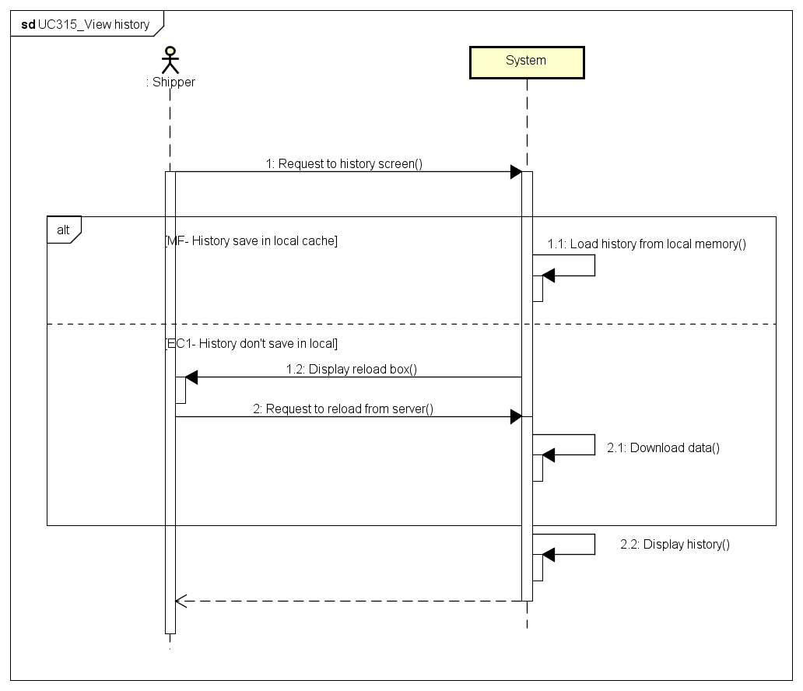

# 2. NON – FUNCTIONAL REQUIREMENTS

## Usability

User interface should be clear and easy to use.

* Use material design style with light colors
* User can complete each function in less than 10 actions

## Performance

- Time delay for find shipper who nearest with place of delivery is less than 10s.

- Time delay on web application for tracking state of shipper on map is less than 5m.

- Server can handle least 2000 clients concurrently.

- Other functions of server perform well while have many order running on application.

## Reliability

- The application is available 24/7.

- Find the way to go to places of receive and place of delivery are at least 90%.

## Maintainability

- Web application is easily to maintain without any crashes. Source code is readability, organized into groups of skeleton (modules) and complies with coding convention.

- Android application is easily to be updated and synchronize with Web application without any crashes. Source code is readability, complies with coding convention.

- System’s architecture has to be design to be easy to extend.

1. **Security**

- Information of admin/ root admin / data on server is secured.

- Information of store and shipper on server is secured.